Ravi

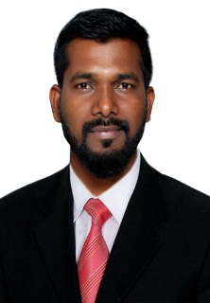
ravi-397135@gulfjobseeker.com Dubai –UAE

OBJECTIVE

To acquire a demanding Accounts position in an organization where I can utilize my skills and work with efficiency, effectiveness

EXPERIENCE

1.5 Year Mumbai – India

- Application of receipt to the respective invoices.
- Ensuring timely bank payments.
- Working on unidentified receipts on daily basis.
- Regular follow up with allocated clients for payment collection.
- Providing information to external/internal/state auditors as and when required, on timely basis
- Updated statements of accounts to clients as per the agreed SLA s/timeframes.
- Making follow up through email for invoices details.
- Prepare MIS reports related to Accounts Receivable.
- Reconcile accounts receivables receipts.
- Sending unidentified and unapplied reports to the clients.
- Managing balance sheets and profit/loss Statements
- Rising invoices in Oracle ERP.

Process Associate
2.3Year Bangalore–India

- Updating accounts right from journal entry to finalization of accounts and preparation of financial statements viaSAP
- Preparation of monthly bankreconciliations
- Handling/Responding to client across variousgeographies
- Responsible for month end reporting to the AR users and onshore team
- Responsible to assist with the bank rec and credit control with their queries
- Responsible for weekly internal audit

ACADEMICS

Master in Business Administration (finance)
July 2014-Mar2017 Bangalore –India

Bachelor in Commerce(Accounting & Finance)

INTERNSHIP AND PROJECT

Completed project report on “Analysis of net profit and cash from operatingactivity’’

ACHIEVEMENTS

- Achieved Best Team PlayerAward
- Achieved Best Teamaward
- Top Performer Award

PERSONAL PROFILE

Date of Birth : 10th FEB 1993.
Nationality : Indian
Visa Status : Visit Visa

LANGUAGE

English Marathi Hindi

Applications/Software

  - SAP
  - Oracle
  - Outlook2010
  - Advanced Excel

July 2012-Mar2014 MUMBAI –India

