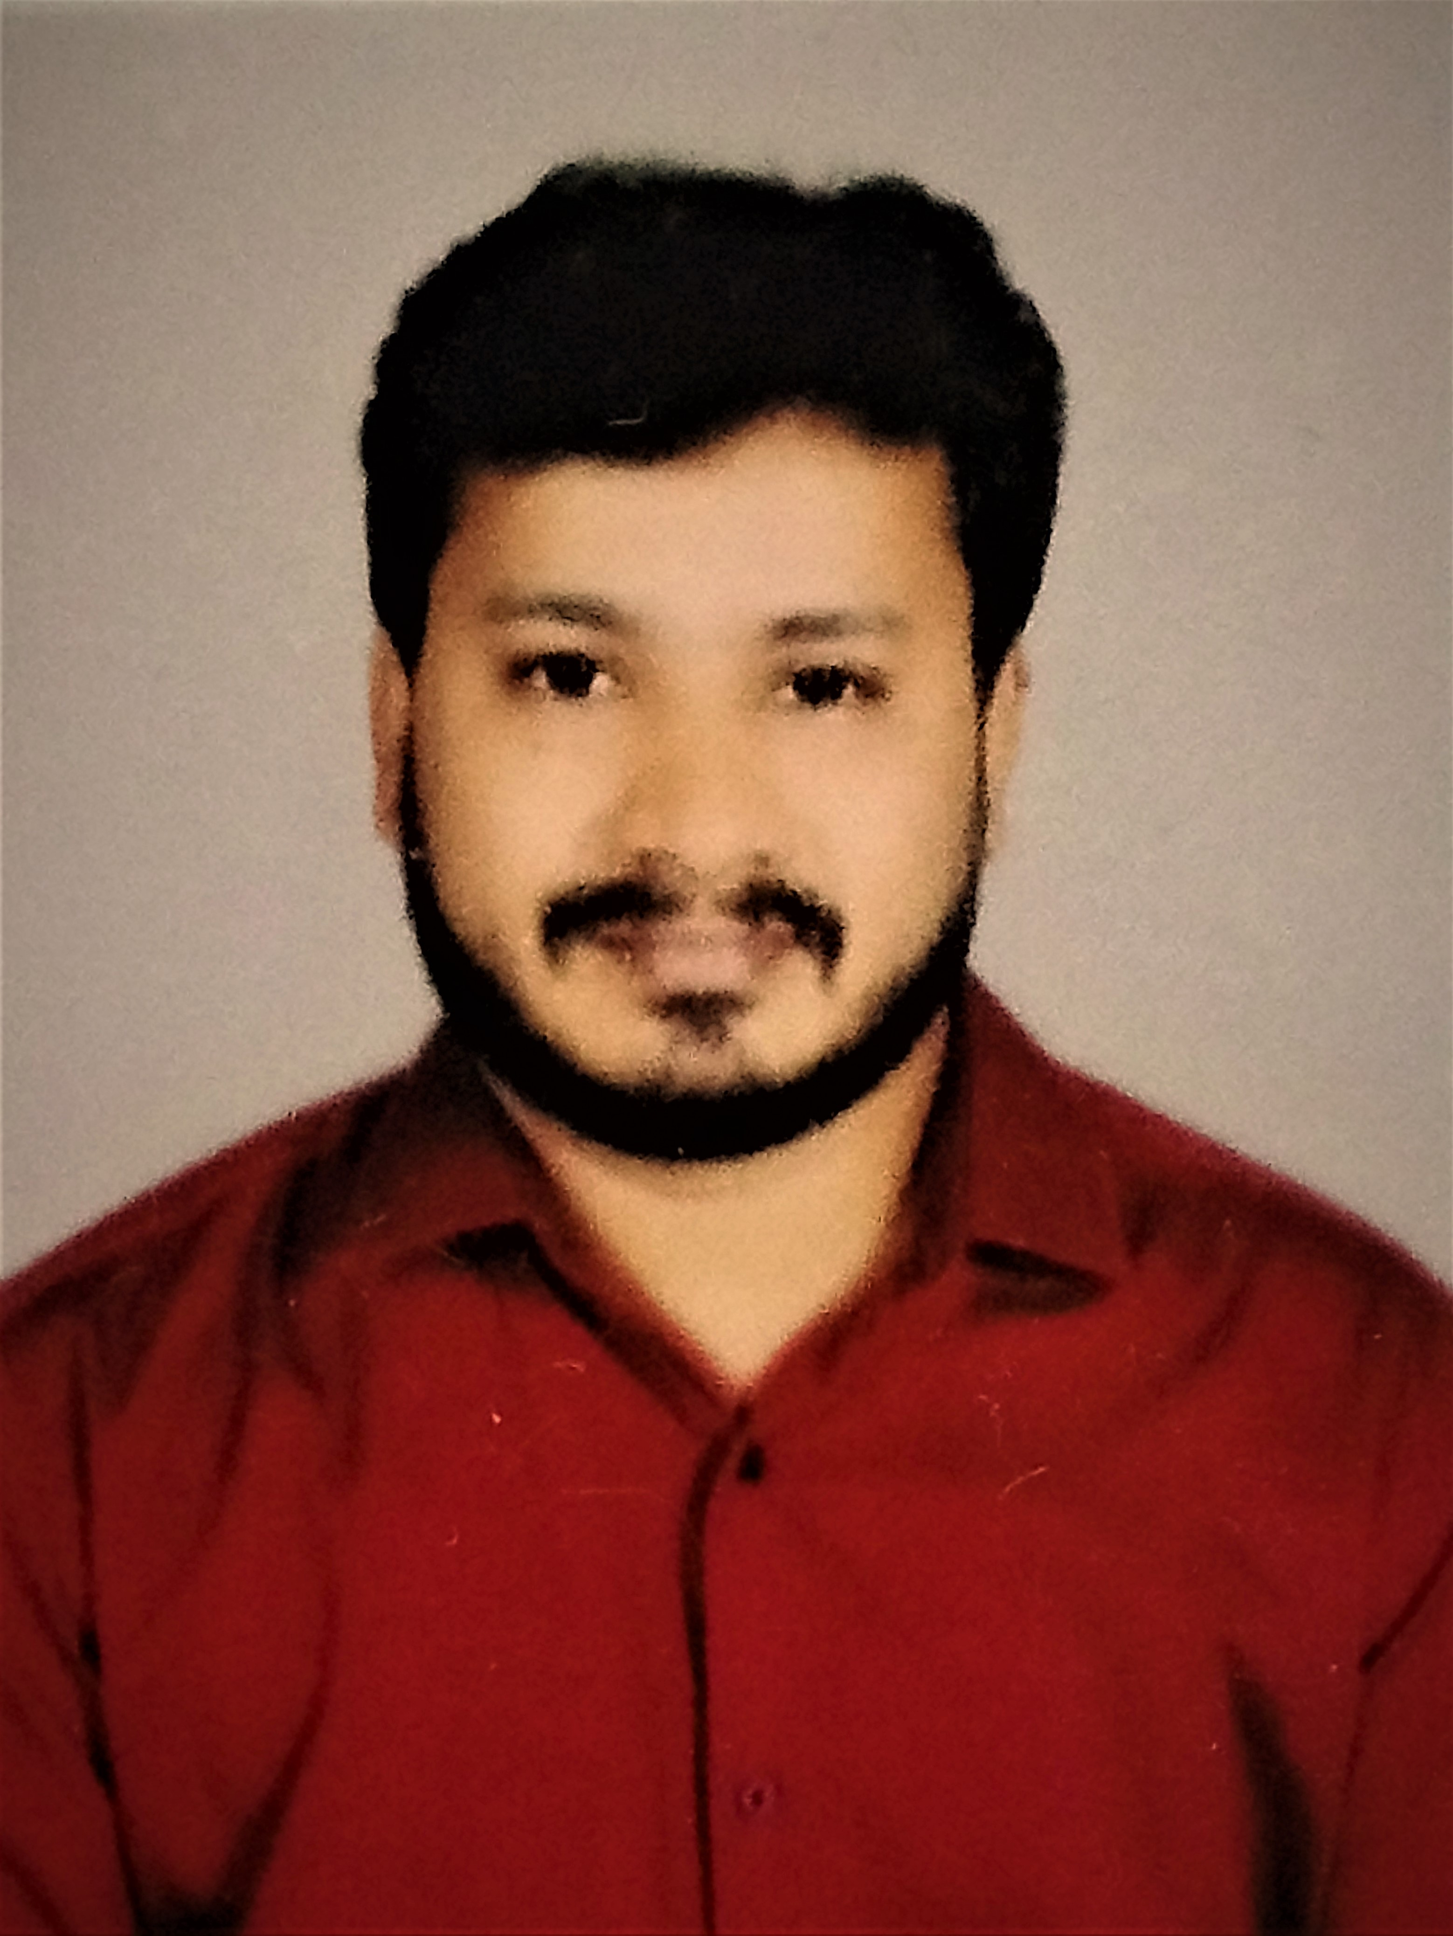

Skilled 3D Visualizer with experience in developing high quality and a solid understanding of AutoCAD and rendering processes. Possessing the visualizing expertise and technical ability required to work closely with designers to create visually correct renderings. Good hands on 3D max and knows how to take real view render, modelling, lighting, texture and visualization.

ABOUT ME**:**

SUDHEER

INTERIOR DESIGNER

WORKEXPERIENCE:

ACADEMICEDUCATION:

CONTACTME

Public Relations Officer And Co - Ordinater

**Medicos Academy**

As A Administration Department

**3Ds max Free lance Designer**

**Bachelors Degree**

B.com ( General )

AcharyaNagarjunauniversity

KakaraparthiBhavanarayana College

**Vijayawada,AndhraPradesh,India**

Email:

[Sudheer-397137@gulfjobseeker.com](mailto:Sudheer-397137@gulfjobseeker.com)

PROFESSIONAL

QUALIFICATION:

**Interior Designer**

Auto cad ,3Ds Max

**Graphics Designer**

Photo Shop,Illustrator,Indesign

AWARD&ACHIEVEMENT:**Best Design Award**

2015

Lorem ipsum dolor dit amet, comsect etuer asipiscing elit enean commodo ligular eget dolor.

**Best Design Award**

2013

Lorem ipsum dolor dit amet, comsect etuer adipiscing.

**REFERENCE**

Sr. Art Director

Designer Coo[ertive Company

PH-123456789

Mail id youridname@gmail.com

PERSONAL SKILLS:

**Creativity:**

**Organisation:**

**Team Work:**

**Communoication:**

LANGUAGES

English

PROFFSSIONALSKILLS:

**Auto cad :**

**3ds Max :**

**Illustrator :**

**Indesign:**

**Photo Shop :**

Hindi

Telugu