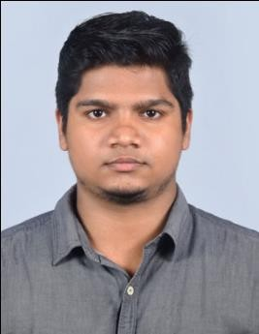
JOSEPH

Career Objective

To apply the knowledge acquired throughout my professional studies and work experience for the improvement and the continuous learning, with the purpose of contribute to the growth of the company with devotion and hard work.

Key Skills

- Natural leadership and teamwork skills
- High level of professionalism
- Active listener
- Confident
- Excellent Engineering/infrastructure background with Excellent computer skills.
- Quick learner

Educational Qualifications

- Course : BE - Civil Engineering
College :Vinayaka Missions KirupanandaVariyar Engineering College, Salem University :Vinayaka Missions University
Year : 2013-2017
CGPA : 6.8

- Course : H.S.E
School : C.J.M.A.H.S.S Varandarappilly, Thrissur, Kerala Year: 2011-2013
% of Mark : 74

- Course : SSLC
School : C.J.M.A.H.S.S Varandarappilly, Thrissur, Kerala Year: 2011
% of Mark : 86

Technical Skills

  - AutoCAD Classic
  - Revit
  - QS
  - Staad Pro
  - MS Office &Powerpoint
  - Windows xp,7,8

Certification
  - Diploma in Civil Quantity Survey at AIMZ Institute of Technology, Affiliated to CTDS, Thrissur.
  - Revit Architecture Training Program at SCET
  - Industrial Visit at Bangalore Metro under Graduate Program.
  - Industrial Visit at Kerala Water Authority, (Water purification Plant), Peechi , Kerala.

Projects

  - Analysis And Design of Theatre.
    - Conducted site survey with seniors and analyzing data to execute civil engineeringprojects.
    - Calculating requirements to plan and design the specifications of the civil work required.
    - Ensured safety by monitoring the site.
  - Residential Projects.
  - Villa Project, Thrissur.
  - Commercial Building, Thrissur.
  - Hospital Renovation, Thrissur.
  - Ananya Auditorium, Thrissur.

Experience

  - 2 years experience at AVS Villas Private Limited, Thrissur as Assistant Civil Engineer.

Personal Details

  - Date of birth : 08-11-1995
  - Nationality : Indian
  - Mother Tongue : Malayalam
  - Religion : Christian
  - Marital Status : Single
  - Languages Known : English, Hindi, Malayalam, Tami
  - Personal Contact : joseph-397167@2freemail.com
  - Reference : Mr. Anup P Bhatia, HR Consultant, Gulfjobseeker.com 0504753686

Declaration

I do hereby confirm that the information given in this form is true to the best of my knowledge and belief.

Joseph Yours truly

