Zeeshan

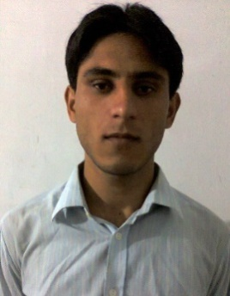

E-mail: zeeshan-397171@gulfjobseeker.com

Address: Abu Dhabi,UAE (Visa Status__visit visa)

Career Summary

A spring to be a part of Dynamic organization having motivational working environment, and looking for responsible and challenging assignments that will foster my advancement and long term relationship in an organization where my experience, education and talent could make significant Contribution towards corporate objectives.
Education

Masters in Computer science | 2016 —2018
University Institute Of Information Technology PMAS Arid Agricultural University
Bachelor in Computer Science | 2014— 2016
University of Gujrat , Pakistan
Intermediate in Computer Science | 2012— 2014
Govt. Degree College , Pakistan

Master Projects

I have worked on the following semester projects:

- I have designed a network model for a enterprise to control manage and provide the network access to all the employees as well customers.(Project Simulated in CISCO Packet Tracer )

- I have designed a Database for HRMS. Done in Oracle 10g.

• I have designed a website using simple HTML and CSS with an admin panel using online cars sale and purchase.

PHP. The project

was on

- I have designed a Web base Business Directory, Which store new and show the results on the basis of previous stored Business to the registered users.

- I have designed a Web Application ( School Management System) in C# (asp.net)

Areas of interest

- IT Section
- Software Development
- Core Development
- System Programming
- Data Sciences
- Software Testing
- Website Development

TOOLS USED

- Development

- Visual Studio 2008-17

- Eclipse

- Net Beans

- Android Studio

- Dream Viewer

- WordPress
- Database
- SQL Server

- My SQL

- Oracle 10g, 11g

- Microsoft office

- Microsoft Excel

- Networking

- Ettercap
- CISCO Packet Tracer
- Wireshark

Languages:

- C/ C++
- C#
- PHP / Laravel
- Assembly
- HTML5 / CSS3

- JAVA
- Java Script
Platforms:

- Window XP, 7 , 8 , 8.1 , 10

- Ubuntu

- Kali Linux

