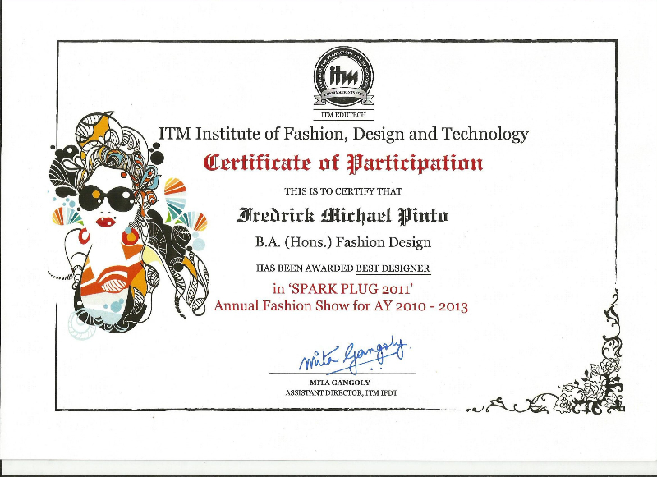 |  | 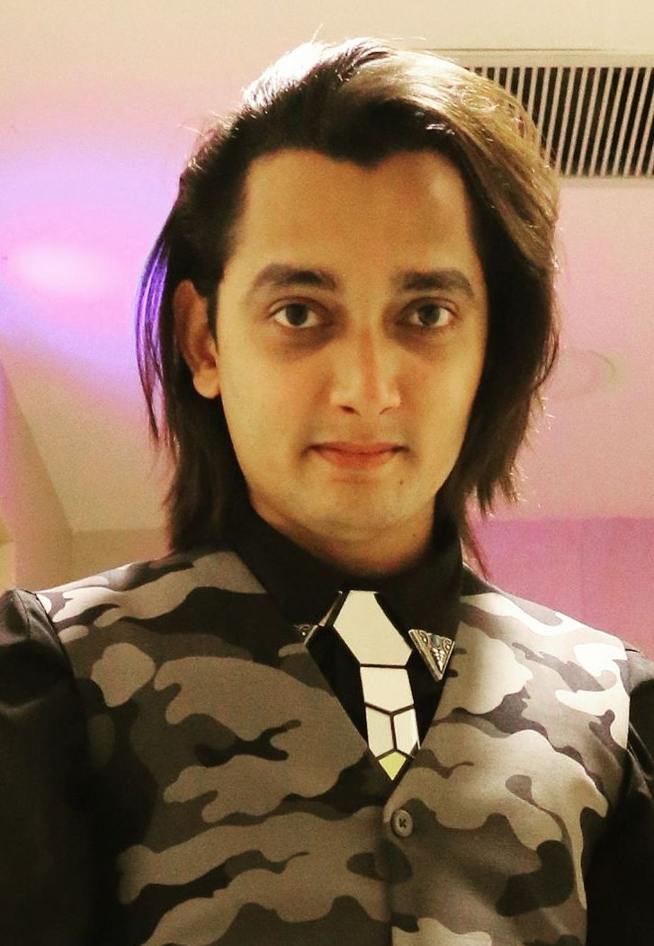  CAREER OBJECTIVE  To achieve a platform as a professional designer that can effectively utilize my knowledge and have to experience that offers opportunities for development and to be successful in all challenging tasks that are given to me. A skilled aartist of learning and creating new concepts quickly, working well under pressure, and communicating ideas clearly and effectively and also effectively overcoming objections to sales in a calm and convincing manner.  Profile  Fashion Designer, with a keen interest to work as a Fashion merchandiser, Garment Production Manager, Fashion retail /sales /Store Manager.  PROFESSIONAL SKILL  ACADEMIC QUALIFICATION  - S.S.C. from Gujarat Board 2008  - H.S.C. from NIOS Delhi Board 2010  PROFESSIONAL QUALIFICATION  - Degree -BA Honors in Fashion Design 2013 (Nottingham Trent University)  Institute Of Fashion, Designing And Technology (ITM- IFDT) Mumbai [2010-2013]  Name of the Degree- B.A (HONS) in Fashion Design  Courses Include:  - Illustration  - Corel Draw, Photoshop  - Draping  - Textiles  - Fashion Management  - Garment construction  Relevant Projects:  - Fashion show collection (Portfolio & Garments)  Achievements : Best Designer Award in Spark Plug 2011 (ITM -IFDT fashion show)  : Participated in Spark Plug 2013. (ITM -IFDT fashion show)  Experience  INTERNSHIP PROFILE  - Worked as an Assistant Designer/Stylist for Styling outfits for Celebrities of Master Chef Junior and Dance India Dance (DID) Super- Moms and also styling outfits for few advertisements. (Duration 3 Months) (July-oct 2013)  - Worked as an assistant designer for styling outfits for the actors Celebrities for a Bollywood movie, (NFDC: Cinemas of India)  oct2013 - July 2014  EXPERIENCE PROFILE  - Worked as an Designer cum Garment Merchandiser / Production manager :- for a clothing Brand “ in Mumbai, India. (Sept 2014 – oct 2017).  OTHER QUALIFICATIONS:  - Certificate of Honor for Exhibition in Drawing. 2003.  - Gujarat State Art Teacher Association in Painting Competition. 2004-05.  - Elementary Drawing Grade Examination. Grade A. 2005.  - Intermediate Drawing Grade Examination. Grade A. 2006.  Personal details.  DOB : 02/02/1991  Status : Single  Languages : English, Hindi, Gujarati.
  Area of expertise  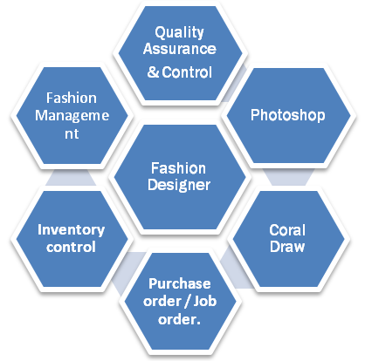 | Knowledge purview  

