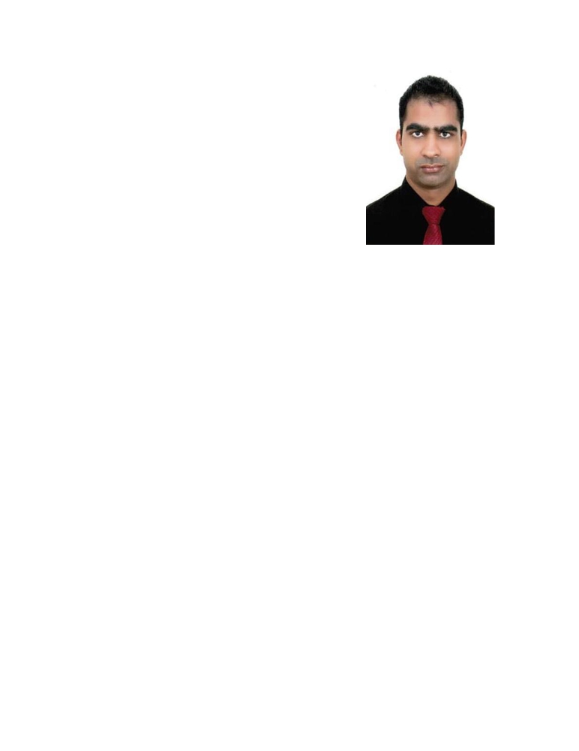

PRADEEP

Position Desired:
Store Manager (current) / Assistant Manager / Head Cashier / Floor In-charge / Store In-charge / Floor Supervisor

Professional Objective:
To continue my career with an organization that will utilize my management, supervision & administrative skills to benefit mutual growth and success.

Personal Information:
Date of Birth: April 08,1990
Marital Status: Single
Nationality: Indian

Language Known: Arabic, English, Sindhi, Hindi

Educational Information: Atrey Senior Secondary Public School
Graduation completed in Rajasthan University
(Jaipur)

Professional Information:
Company: ALMAYA GROUP- Dubai, UAE
Position: Branch Manager
Period: May 2009 to present

Responsibility:
• Understanding the customer requirement.
•Communicating with staff and getting the feedback/demand of the
products
•Getting the requirement for the replenishment and placing/planning the
order.
• Sending orders to the concern supplier
• Inquiries/Negotiate about new Products to the Suppliers as per the
Customer demand/requirement.

•

•
•
•
•
•
•
•
•
•

•

•
•
•
•
•

Decide the Retail Price as per the cost and market scenario to achieve the
business goals.
Planning to make new promotion item every week with decent price Making shelf rentals price as par space and size
Operating all store with planning
Checking the displayed items as merchandising guide line Checking the staff’s grooming , VM & shop area
Managing the staff’s duty roster
Handling the customer complaints
Handling the staff complaints
Giving training to the sales about customer service , product knowledge and how to manage the expiry items as well
Negotiation with the merchandisers regarding the promotion items and FOC Items
Giving briefing to the team every morning
Giving recommendation to the staff who make best performance Reporting the daily and monthly report to the H/O
Analyzing the sales data report daily and monthly
Creating the JD format for the sales staffs

Company: SAGAR HANDICRAFT STORES Jaipur - Rajasthan, India

Position: Sales Man

Period: April 2006 to Jan 2009

PERSONAL SKILLS
Hardworking, Disciplined and Enthusiastic
Good Communication and Interpersonal Skills

Knowledge of basic Computer MS Word Excel Ability to prioritize the wor006B
Handle work under Pressure.

Certified Holder of UAE Driving License
Issue Date: 28/01/2016
Expiry Date: 27/01/2026

Personal Contact : : pradeep-397205@2freemail.com
Reference : Mr. Anup P Bhatia, HR Consultant, Gulfjobseeker.com 0504753686

I hereby assure you that all of the above mention is true and correct to my best of knowledge and belief.

Pradeep
Applicant

