Jamal-397221@gulfjobseeker.com

Dubai - UAE

PERSONAL DETAILS

DOB: 12/9/1993

Nationality: Jordanian

Place of Birth: Al Ain - UAE

Marital Status: Single

COURSES

- Course International Computer Driving License (ICDL).

- (International Diploma in IT Skills) Dec 2015.

Jamal
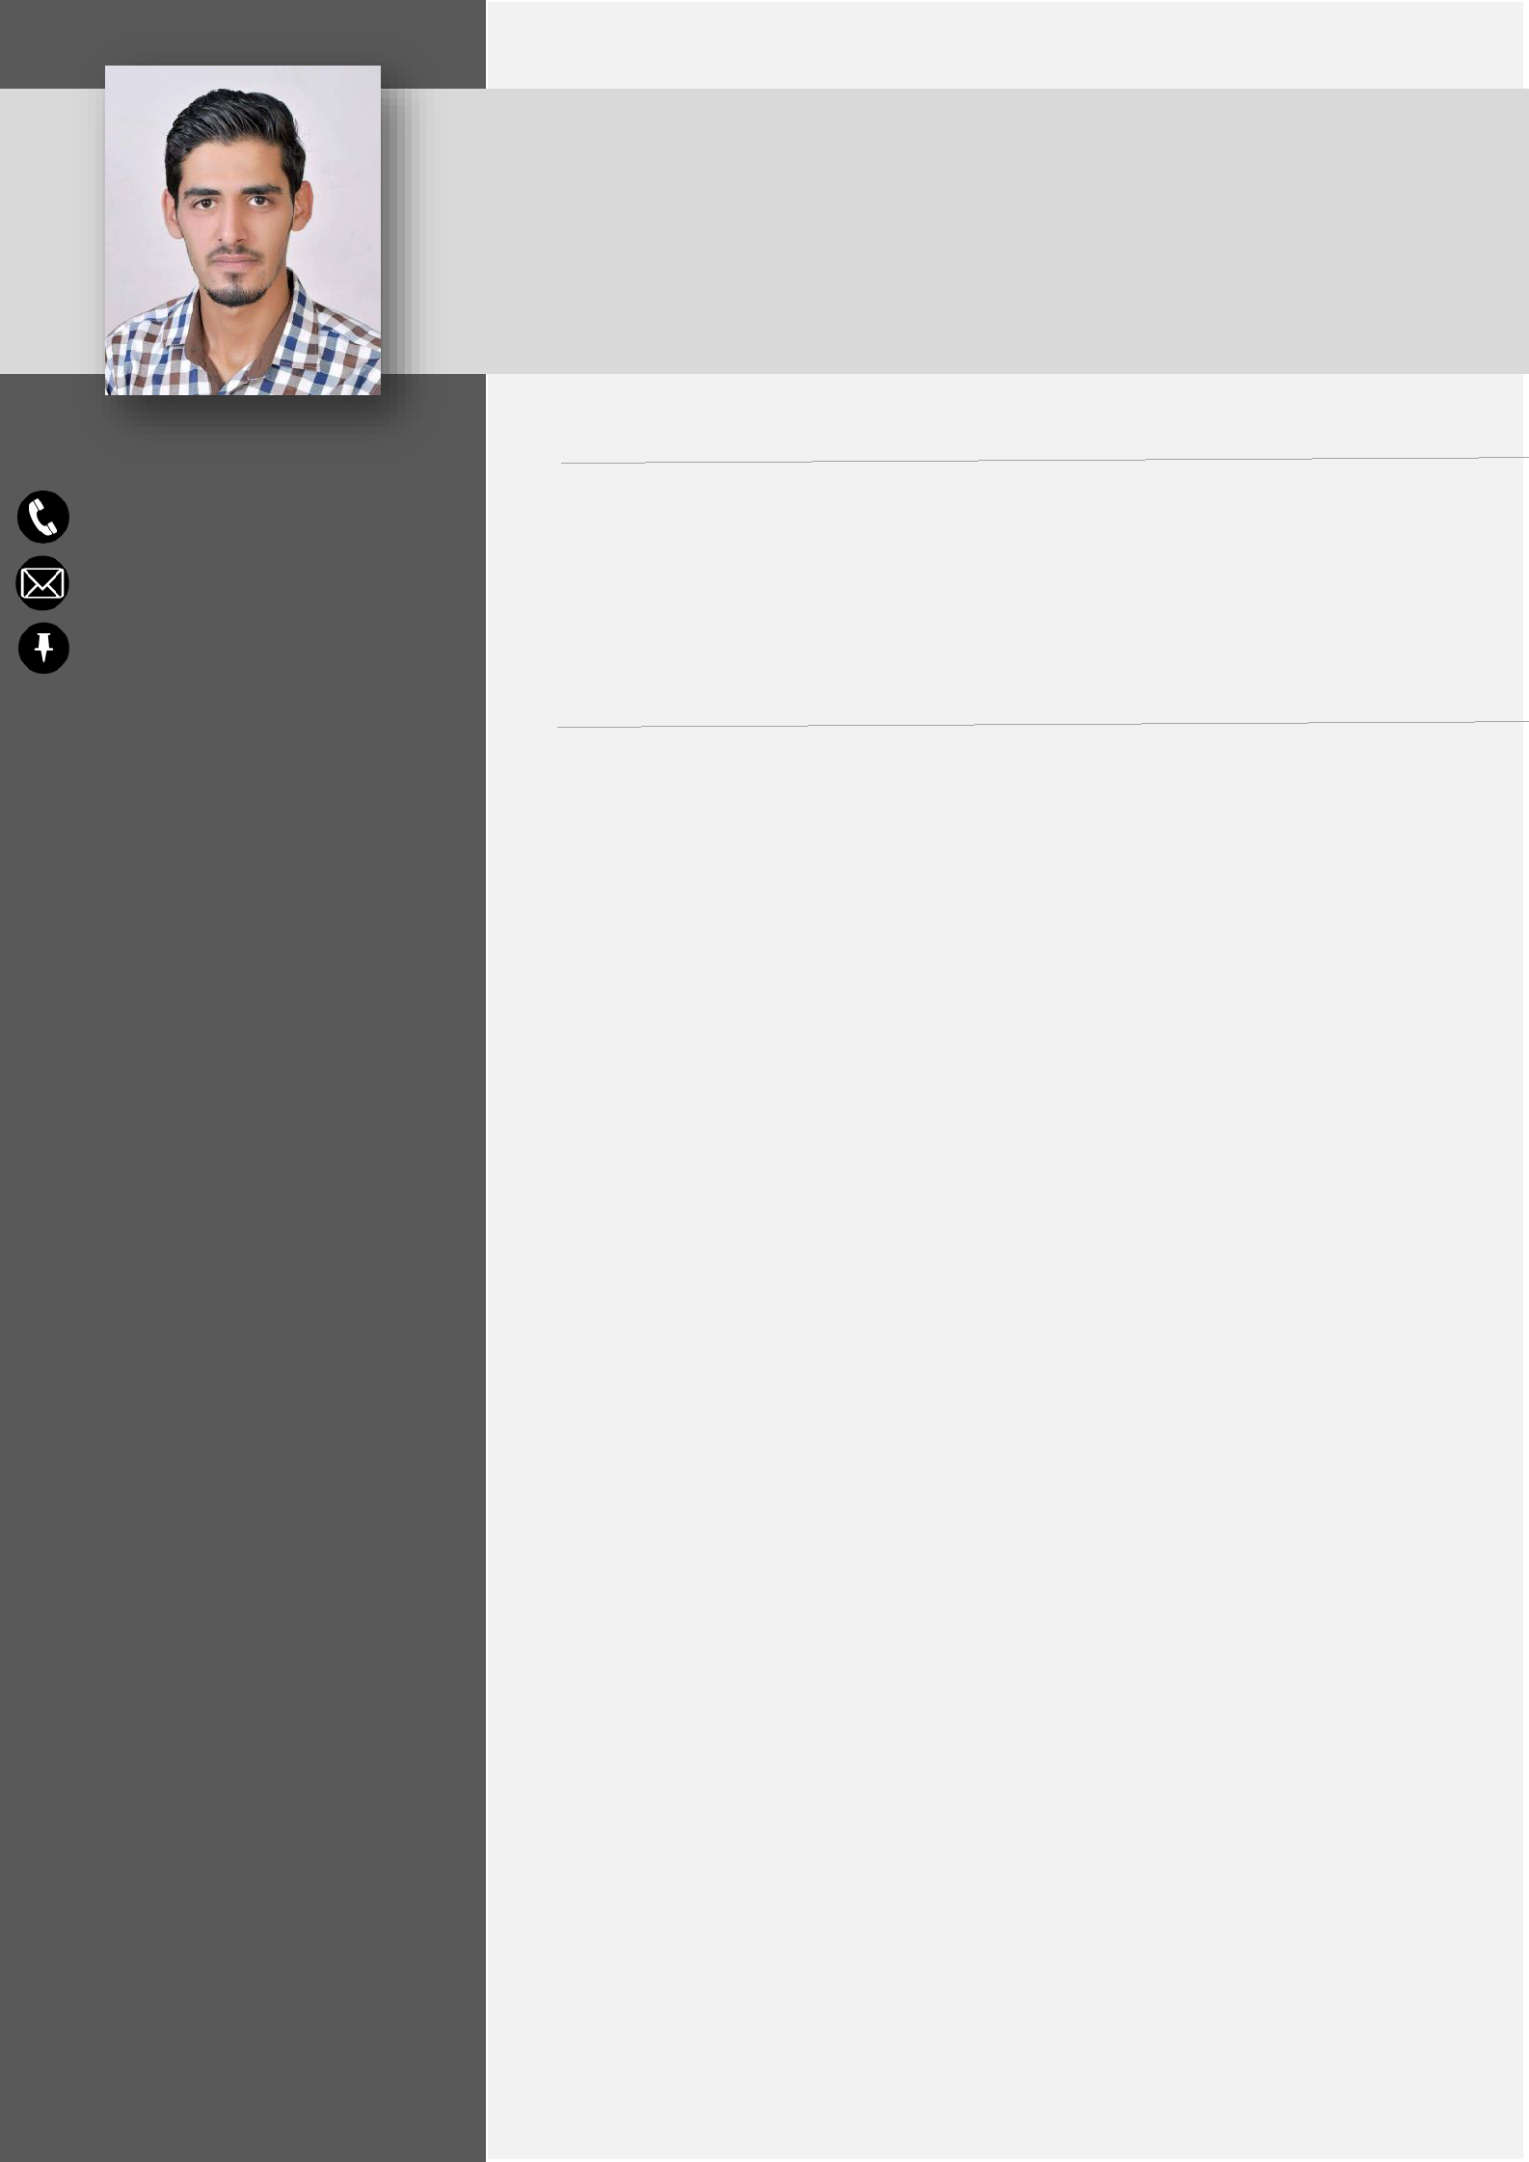

Customer Service – Sales - Telesales

OBJECTIVES

I’m seeking full-time employment in the field of customer service and sales department with a dynamic team of competent people. This will foster my professional and creative skills and help me advance in my career effectively utilizing my acquired skills and diverse experience.

EXPERIENCE
Marketing Research “Part Time” | SEP 2019 - OCT 2019
- Amman - Jordan

- Contacting with customers and conducting a questionnaire on the telecommunications and internet sector in Jordan

- Create a database of research records

- Interpret data, formulate reports and make recommendations

- Remain fully informed on market trends, other parties researches and implement best practices

Customer Service Call Center | NOV 2017 - JUL 2019
Irbid - Jordan

- Identify and assess customer’s needs to achieve satisfaction

- Manage large amounts of incoming calls

- Resolve service problems by clarifying the customer's complaint

- Keep records of customer interactions, process customer accounts and file documents

- Resolve complaints from users of Careem application through calls or chat messages

- Communicate with service supply in case there is a system access problem

Salesman | JUN 2017 - OCT 2017
Ice Kitty – Carrefour - Irbid - Jordan

- Greet customers as they arrive, assist customers and building customer service satisfaction.

- Organize the store and ensure safekeeping.

- Maintain inventory record.

LANGUAGES

Arabic – Native

English – Fluent

KEY SKILLS

- Communication

- Decision Making

- Time Management

- Self-motivation

- Conflict Resolution

- Leadership

- Adaptability

- Teamwork

- Creativity

COMPUTER SKILLS

- Microsoft Office (Word, Excel and PowerPoint)

- Slack Program

- Genesis

- Telegram (Customer Service Chat)

Showroom in Charge | JUL 2014 - JUN 2017
Al Zaeem Internet Shop - Irbid - Jordan

- Assist customers when they have trouble or questions using computer software such as: Microsoft Office, games and all software programmes that are being used

- Possess knowledge on popular online and LAN games

- Provide services such as encoding, printing, downloading and all other operations provided

- Provide ultimate service to customer and ensure customer satisfaction.

Salesman | MAR 2012 - MAR 2013
Men’s Fashion Store - Irbid - Jordan

- Greet customers as they arrive in the store and provide them with information

- Assisting the customer in well with a friendly and good service

- Maintain the shop and monitor compliance of the administrative policies and procedures

EDUCATION

Jadara Private University - Irbid, Jordan

- Bachelor’s in Management Information System completed and passed 5 years at Jadara Private University, from Fall 2011 to Spring 2016

- High School, Zayed Al Awwal Secondary School - Al Ain, UAE, 2010

