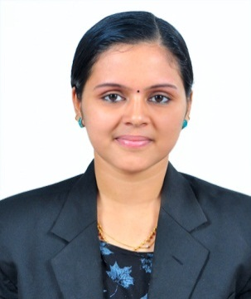
CURRICULAM VITAE(School Counsellor)
Sreelekshmi
Email: sreelekshmi-397236@gulfjobseeker.com

PROFILE
An optimistic, hardworking graduate of Masters in Social Work and specialized in the field of Medical & Psychiatry. Having good communication skills (both in English and Malayalam), able to work both as a member of a team and independently, possessing leadership abilities with a passion to work for and with people.
EXPERIENCE( 6.5 Years )
- Worked as School Counselor in Doha Qatar (From 27th April 2014 - 26th Feb 2019)
- Worked as School counselor at BhavansNewsprintVidalaya ,Kottayam, Kerala (10/09/2012 to 31/03/2014)
CAREER OBJECTIVE
To strive towards to achieve the organization’s goals and vision as my foremost responsibility, grow withorganization in the light of its success.
PERSONAL DETAILS
Nationality : Indian
Date of Birth : 31.01.1990
Computer Knowledge : MS Office
Languages Known : English, Malayalam and Tamil
Marital Status : Married
AREA OF INTEREST
- Working with Children, Cancer patients Mentally Ill patients & HIV positive people
- Group work and Group therapy
- Counseling and guidance.
- Psycho Education
- Community organization
- Program planning & implementation.
- Reporting and Documentation
- Medical & psychiatric social work

EDUCATIONAL QUALIFICATION
- Master in Social work(Medical & Psychiatry) under Madurai kamaraj University in the year 2012 from kodaikanal Christian college
- Graduation B.A (Economics) under Kerala University in the year of 2010 from NSS College Pandalam
- Intermediate in Humanities under Kerala Higher Secondary Board in the year of 2007
- SSLC from education department of Kerala in the year 2005
ADDITIONAL QUALIFICATION
- Diploma in Project management (Madurai Kamaraj University in the year 2011)
- Diploma in Tourism Marketing (Madurai Kamaraj University in the year 2012)
- Field work exposure from SCARF INDIA FOUNDATION (Schizophrenia Research Institute,Chennai)
- Shreyas Social Service centre,(NGO,Wayanad)
- ThirumalaiCharitableTrust,Chennai.
- Government Hospital,Kodaikanal,
- Passam Trust Hospital and Mercy Home (Old Age Home,Kodaikanal)
PROJECTS UNDERTAKEN
- “A Comparative Study on knowledge and behavior concerning alcohol among higher secondary students in private and government school particular reference to Kodaikanal”
- “A study on Pedophilia among the hotels in Kodaikanal”
- A study on female infanticide in Uslampatti, Tamil Nadu”
DECLARATION
I hereby declare that above details are correct and true to the best of my knowledge and belief.
SREELEKSHMI

