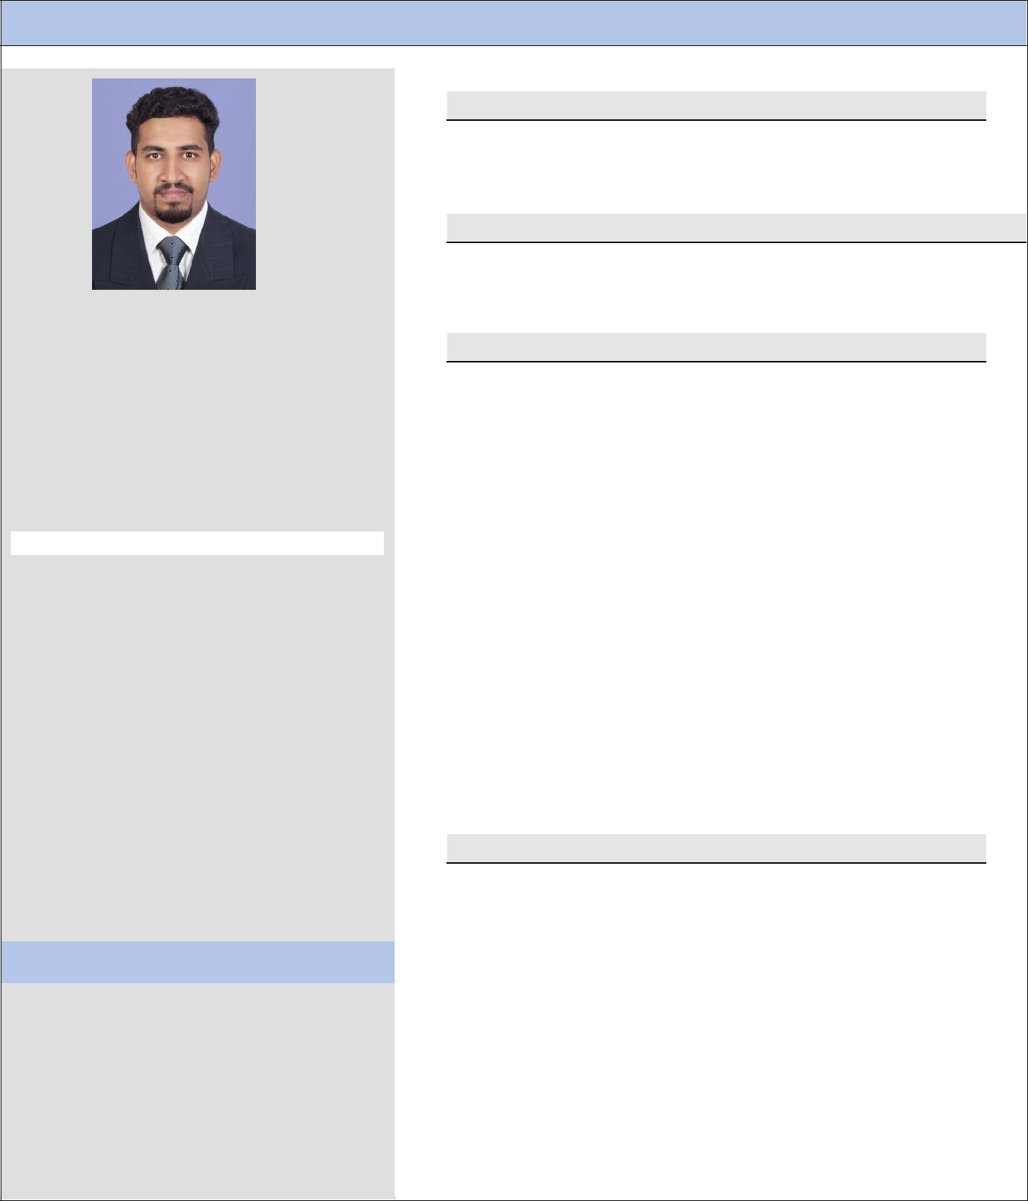
 |  |  |  | CURRICULUM VITAE
❖

PROFESSIONAL SYNOPSYS
 |  |  |  | • Civil Engineer with 8 plus years of extensive GCC and
 |  |  |  |  | Domestic experience in high - rise building projects.
 |  |  |  |  | ❖ PROFESSIONAL SYNOPSYS
 |  |  |  | • Bachelor of Engineering in Civil Engineering (2007 –
 | ARUN |  |  |  | 2011) , Anna University Chennai
 | Civil Engineer |  |  |  | ❖ PREVIOUS EXPERIENCE
 |  |  |  |  | •
 |  |  |  |  |  | (20/02/2017 to 30/12/2019)
E-mail |  |  |  |  | • | Position :Project Engineer
Arun-397252@gulfjobseeker.com |  |  |  |  |  | Al Hashm trad&cont LLC,Muscat (18/12/2014 to
 |  |  |  |  |  | 16/01/2017)
 |  |  |  |  |  | Position : Site Engineer
 |  |  |  |  | •ProMax Management Consultants, Cochin
 |  |  |  |  |  | (11/08/2014 to 06/12/2014)
Personal Data: |  |  |  |  |  | Position : Site Engineer
 |  |  |  |  | •Fern Valley Builders, Cochin.( 15/11/2012 to
Expiry Date |  |  | : 27-12-2028 |  |  | 06/08/2014)
Nationality |  |  | : Indian |  |  | Position : Site Engineer
Religion |  |  | : Christian |  | • | Creators constructions(P) LTD,Cochin
Marital Status : Married |  |  |  |  |  | (02/05/2011 to 08/11/2012)
Driving License :
 |  |  |  |  |  | Position : Site Engineer
Indian Driving License
D.O.B: 07/04/1989 |  |  |  |  | ❖ LIST OF MAIN PROJECTS
Place: Kerala,India
Language Known : |  |  |  | ▪ | Al Hashm Trading & Contracting LLC, Muscat
English, Hindi, Malayalam, Tamil
SOFTWARE SKILLS |  |  |  |  | • | Commercial and Residential building at Ghala |  |  |  |  | -
 |  |  |  |  |  | OMAN
• | AUTO CAD |  |  |  | •
• | MS OFFICE |  |  |  |  | Commercial and Residential building at Qurm |  |  |  |  | -
• | PDF XChange Editor- QS |  |  |  |  | OMAN
 | VISA STATUS |  |  |  | • | 20 villa project in Asaiba - |  |  |  | OMAN
 | Visit visa
 | Total working experience:
 | 8 Plus years

    - ProMax Management Consultants, Cochin

      - Office Plaza at KINFRA Hi-Tech Park,Kalamasserry,Cochin-175000 SFT. 3 Basement+G.floor+3 Floor

    - Fern Valley Builders, Cochin

      - Fern Kensington, G+14, Apartments = 111 Units

- JOB RESPONSIBILITIES

  - Execution of works in line and level as per drawing.

  - Prepare Bar bending schedule for Pile, Pile cap, Tie beam, Lintel, Beam, column, Slab, Corewall etc. and also properly inspecting steel binding.

  - Prepare M book and properly inspecting Concrete works and other Masonry work.

  - Experience in finishing works and Interior-fit-out of Multi stored building and villas.

  - Responsible for leading a team consists of more than 50 people.

  - Responsible to give instructions and guidance to sub-contractors and other team members.

  - Ensure proper co-ordination of work at site and verifying the output.

  - Prepared and reviewed engineering plans, specifications, project schedules, and structure drawing etc.

  - Maintained effective working relationships with field crews, contractors, vendors, outside agencies, the public and city staff members.

  - Billing & Estimating quantities:

  - Day to day monitoring of works, Maintaining records, daily progress reports & checklist, Supervision and inspection of works, Ensure quality assurance.

References:

- Available on Request

Declaration:

I hereby declare that the information furnished above is true to the best of my knowledge.

(Arun)

