`
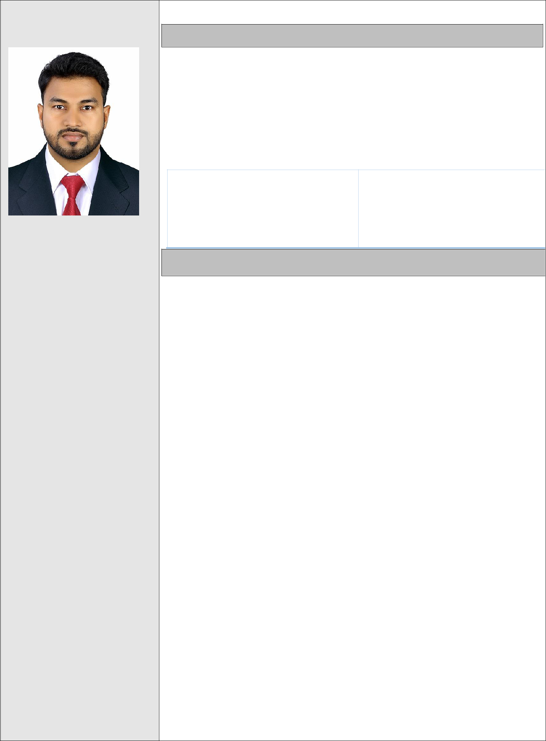

RAHMATHUL

Driving License

More than 4 Years Experience in UAE.

E-mail:
Rahmathul-397278@gulfjobseeker.com

Languages:

- English

- Hindi

- Arabic

- Malayalam

- Tamil

- Kannada

Career Objective:

Seeking a challenging career where my educational background & skills can be applied

- further developed not only technically but a person as a whole, and currently looking forward to combining skills and expertise within a position where I can improve my skills, build my career.

AREAS OF EXPERTISE:

• P R O Management. |  | • | Admin. Support.
• | H.R Management. | • Planning and execution of
• | Internet and E-mails. | • | the Plans
• | Customer Services. |  | Good interpersonal Skills
- Co-ordination Management.

Career History:

Public Relations Officer / Tas’heel Admin Officer in Dubai, UAE

Since: (9th Feb 2018) To (18th Jan 2020)

Key Responsibilities:

- Training new Local Emirati Candidates, Assisting Customers with Solutions and trying to Solve Immigration and ministry of labor related issues.

- Assist all customer general inquiries concerning labor and immigration matters.

- Assist all customer general inquiries concerning new amnesty scheme of government and providing genuine information to the customers regards new government law and schemes to get rid of fines, absconding’s and overstays

- Dealing with the customers, and providing them with all their needs and demands with accuracy.

- Typing all kind of application such as quota, offer letter, transfer work permit, replace work permit, inside and outside country E-visa payment, change status, emirates id, medical, health insurance, labor contract, contract submission, modification contract and visa stamping etc.….

- Visiting to immigration for making modification or rejecting application. In case any error done by employee and providing solution to the customer

- checking violations, absconding or temporary ban through system and guiding customers to take further steps

- Assisting customers to hold their family visa at the time of cancelation and helping to the paper work.

`

Interests & Activities:

- Traveling: Independent.

- Reading: Persuasion, creativity

- Surfing the net: Learning and researching Ability.

PUBLIC RELATION OFFICER at

GENIUS BUISNESSMEN SERVICES AND DOCUMENTS CEARING LLC –– DUBAI

Duration: (21st nov-2015) to (5th oct-2017)

Key Responsibilities

- Checking all companies labor employee list to renew their visa on time avoiding fine or penalty

- If company got block Due to WPS, or expire labor card, etc and providing solution to the clients

- Collect all appropriate documentation necessary for visa and permits required to be Prepared.

- Checking the occupational health card expire date and renewing on time and maintaining proper records to avoid violation and fines Responding to staff queries on Visa/ Labor/ Passport related services.

- Assist to all general inquiries concerning labor and immigration services.

- Makes sure all Visas, and trade Licenses are updated, follow-up official approvals and permits, to prevent unnecessary violations.

- To proactively manage the timely renewal of all Employment Visas

- Assist employees in renewing visas for their immediate dependents.

- To assist all sponsored staff and their dependents in the medical check process.

- Send employees a notification on documentation required prior to their visa expiry
- Manage the visa checklist as when the rules on visa changes

- Assist the company and the employees with visa arrangements in Embassies.

- To submit required documentation to the banks and process bank transactions as Advised by Finance.

- Typing all kind of application for Tas’heel and immigration, Submission of correct documentation to the Ministry Of Labor for visa process

- Arranging documents and explaining other P.R.O about problems in the documents and sending them in to the related departments to fix the problems

- Preparing the payment vouchers for daily work regards visa process and maintaining the daily report to the accounts
- For urgent services visiting to immigration for visa stamping
- Visiting to ministry of labor office to settle employee complaints

- Visiting to immigration if block or update the visa information if its required.

`

Personal Data

- Date Of Birth: 01/12/1993

2.Gender: Male

3.Nationality: Indian

6.Marital Status : Married

Training and workshop:

- Ms. Office (Excel, Word, PowerPoint, Access)

- Internet and E-mail (using all kinds of browsers and mail clients)

- Basic C++ Programming

- Basic and Advance IT Knowledge

- Entry for Electronic Archiving.

Academic Qualification:

- Completed Bachelor of Business Management (BBM) from Mangalore University in the year of 2014

- Completed Pre University College (PUC) from Rosario PU College in the year of 2011.

- Completed SSLC from Govt. High School Mangalore in the year of 2009.

Technical Education:

- Basic Courses in Computers (Microsoft Office & Internet).

Professional Skills:

- Excellent Communication skills.

- Excellent listening, presentation, and writing skills.

- Excellent social skills and a strong awareness of intercultural issues.

- Excellent problem identification ability.

- Leadership and management ability.

- Positive attitude and aptitude to learn.

- Attending team meeting and sharing best practice with colleagues.

- Always optimistic and getting my best knowledge from mistakes.

Courses:

- Completed Master of Human Resource Development (MHRD) at Mangalore university in the year of 2014

- Football national summer camp (Mangalore Football association)

Driving License:

- UAE Driving License.

Extra Curricular Activities:

- Honor and awards in high School and college level athlete (relay ruining race, football)

- Played national level football match under Mangalore University

