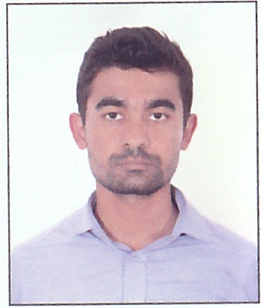
Kemish
Email Id: kemish-397287@gulfjobseeker.com

Profile
A multi-skilled, hardworking and efficient Customer Service with a proven track record of ensuring the smooth functioning and running of all sales activities. Able to follow standard operating procedures and work in a methodical and tidy manner.

Objectives
Enthusiastic and energetic individual seeking sales associate position utilizing my 2 years of experience providing a positive shopping experience to diverse customers. Excellent track record of effective merchandise presentation, prompt and courteous customer care, persuasive selling skills and accurate transactions.

Work Experience
Position : Sales Associate
Duration: 2 years

Accomplished Duties & Responsibilities
- Greeted customers, responded to questions, improved engagement with merchandise and provided outstanding customer service
- Achieved established goals
- Directed customers to merchandise within the store
- Increased store sales
- Maintained superior product knowledge
- Maintained an orderly appearance throughout the sales floor
- Introduced promotions and schemes to customers
- Always kept updated about the knowledge of the company products, services and policies
- Handled customer complaints
- Turned a frustrated customer into a happy customer, while adhering to company policies
- Maintained a professional appearance
- Cooperated with other co-workers to ensure smooth customer service
- Maintained perfect attendance during my working period
Academic Qualification
- S.L.C. From the Board of Nepal (with distinction)
- +2 passed.

Trainings
- Customer Handlings & Satisfaction training
- Cost Control training
- Work space cleaning training
- Customer Psychology training

Skills
- Good communication skills
- Fluent spoken and written English
- Self-confident and leadership skills
- Good knowledge of Ms-Word
- Fast typing ability
- Solution finding ability
Personal Details
Name: Kemish
Date of Birth: 19th Nov, 1993
Place of Issue: Nepal
Religion: Hindu
Marital Status: Single
Visa Status: Visit
Conclusion
I hereby attest that the above information is true to the best of my knowledge and belief.

Kemish

