CURRICULUM VITAE
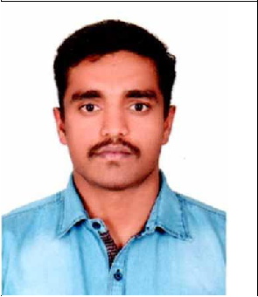

RAJKUMAR

Email: rajkumar-397293@gulfjobseeker.com

CAREER OBJECTIVE

To enhance a career that tests my professional abilities , add value and more an attempt to achieve organization and individual goals also to further enhance my skills through looking as meet the challenges in any giving chance.

PROFESSIONAL● WORK EXPERIENCE

- Last working as Inspection and maintenance team

- SINCE 10th Nov 2016 to Dec 2019.

JOB RESPONSIBILTIES:

- Inspection of team members schedule and allotting work Site and pass, Air compressor and gangway.

- Traction motor greasing and cleaning, Door inspection, Gear unit earth brush measurement.

- Worked as a construction site supervisor with SD Builders, Tamil Nadu, India from June 2014 to Dc 2015.

JOB RESPONSIBILTIES:

  - Construction building supervising labours, maintain stocks and material receiving

  - Draw new building drawings using Autocad

- Completed in SIRA training

- Auto Cad (2D &3D Modeling)

- Familiar with all Windows Platforms (MS Excel , MS Office)

- Basic Fire and Safety for industrial work

Examination | Institution | Board/University | Yearof | Percentage
Passed |  |  | Passing
Diploma Civil | SKAPC Pollytechnic | Government polytechnic | 2013 | 63%
Engineering | College, Manamadurai. | college
 | Tamilnadu,
 | India
HSC | Government Hr.SecSchool | State Board | 2010 | 71.83%
 | Thiruppachethi | of
 | , TamilNadu. | Tamilnadu
SSLC | Government High School | State Board of | 2008 | 62%
 | Vellikurichi,Tamilnadu. | Tamilnadu
✓ Member of | Team and Participated Science and environment awareness
programe.

- Participates school volleyball playing game.

✓STRENGTH

- Can work in any situation and ready to accept people as they are

- Always willing to learn new things and good patience

- Workaholic , sincere and straight forward and better time management

 | Date of Birth | : | 03.06.1993
 | Gender | : | Male
 | Marital Status | : | Single
 | Nationality | : | Indian
 | Languages Known | : | English, Hindi,Telugu and Tamil
 | PASSPORT DETAILS
 | Issue date |  | : | 08.05.2015
 | Expiry date |  | : | 07.05.2025

DECLARATION

I hereby declared that above information is true and correct to the best of my knowledge and belief.

DATE: Rajkumar

