Neethu

PharmacyTechnician

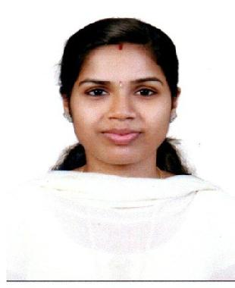

Email:
Neethu-397302@gulfjobseeker.com
With DHA License

Career objective | Looking for a pharmacy technician position with depth
 | knowledge of:
 |  | pharmacy procedures, and can be aptly used to enhance the
 | efficiency of the healthcare organization.
Experience |  | • Community Health Centre
 |  | Feb 2018 – Feb 2019 Kerala, India
 |  | • Lisa Hospital Thiruvambady Calicut
 |  | Nov 2016-Jan2018
 | College Of Pharmaceuitical Sciences ,Govt Medical
Education | College Kottayam-Diploma in pharmacy
 |  | August 2016
 | Kottayam, kerala
 | Govt HSS Neeleswaram Calicut
 | March2013
 | Kozhikode,Kerala
 | Sacred Heart HSS Thiruvambady
 | March2011
 | Kozhikode,Kerala

^{Certificates} ● DHA, Dubai Health Authority, September 2019

- Registered Pharmacist, Kerala state pharmacy council, 2016

- Pharmacist trainee, CHC Mukkam Calicut 2016

Page 1 of 2

Skills

Personal details

Languages

Declaration

Professional skills:

- Prepares medication by reviewing and interpreting physician's order.
- Detecting therapeutic in-compatebilities.

- Dispenses medication by compounding, packing and labelling of pharmaceuticals.
- Patient counseling.

- Management of LASA medicines.

- Management of FIFO medicines.

- Inventory management.

- Management of high alert medicines.

Personal skills:

- Time management.

- Adaptability.

- Patience.

- Strong mathematical skills.

- Leadership skills.

Date of birth: 20 October 1995

Gender: Female

Marital Status: Married

Nationality: India

English

Hindi

Malayalam

I, Neethu, hereby declare that the information contained herein is true and correct to the best of my knowledge and belief.

Neethu

Page 2 of 2

