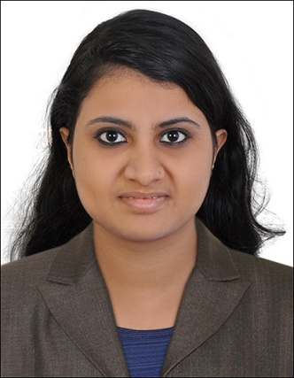

SHRUTI

MECHANICAL ENGINEER

Email:
Shruti-397379@gulfjobseeker.com
Location: Dubai, UAE

Languages:

- English

Speaking, Reading, Writing
- Marathi
Speaking, Reading, Writing
- Hindi

Speaking, Reading, Writing

- Malayalam Speaking

Nationality: Indian

VISA STATUS: Dependant Visa
Validity: 19/03/2022

Technical Skills:

Working knowledge of MS Office:
Excel, Word, Powerpoint, Outlook

PROFILE
MECHANICAL ENGINEER WITH 2 YEARS’ EXPERIENCE

- Worked as Mechanical Engineer in India

- Worked in the mechanical design department of pressure vessels,heat exchangers,piping,oil and acid tanks.

  - Worked for Alpha Fisco L.L.C Project-Oman.

  - Worked for Indian Oil Cooperation Ltd project-BOM and transmittals of pressure vessel and tanks.

  - Worked for Sulpher Melting Plant OCP,Morocco.

  - Handled SAP Vedanta,Gamsberg project-South Africa.
  - Knowledge about P & ID drawings.

  - Pursued BE in Mechanical Engineering from Mumbai University.

  - Excellent time management skills with demonstrated ability to prioritize and handle multiple projects in face-paced environment.

  - Worked in time sensitive projects.
  - Ability to manage short-term deadlines.

  - Ability to function as a team player and alternatively work independently to achieve objectives

  - Conduct meetings with client.

  - Trained team members in BOM, BOQ,P & ID, piping and transmittals.
  - Good management and coordinating skills.

  - Ability to manage the flow of day-to-day operations by prioritizing the work.

  - Good in client handling.

Roles and responsibilities

- Prepared BOM of pressure vessels, tanks, heat exchanger.
- Prepared ‘General Arrangement’ of piping.
- Preparing datasheets for pumps, valves, and tanks.
- Designed routing of pipe for Alpha Fisco L.L.C Project-Oman.
- Prepared line list ,BOQ of pipes.

- Accurate record keeping.
- Prepared Mechanical Data Sheets (Equipment list).
- Prepared transmittals for various projects.
- Drawing piping Isometrics.

- Evaluating vendor offers and preparing comparisons for inclusion of best vendor proposals in estimates.

- Preparing pre-bid queries and obtain clarifications from client.
- Prepared piping plan drawings.
- Guided team based on management direction

- Coordinating with various technical and commercial departments for workable inputs.

- Monitored progress of work and reported issues to senior manager.

- Attended meetings to discuss projects with clients, contractors and other engineers.

- Worked closely with project managers and engineers to ensure project requirements were fulfilled and budgets were honored.

- Ensured the deliverables are error free according to project requirement.

- Assisted in determining materials and supplies based on goals and budgets.

- Contributed to best-in-class execution of objectives and customer satisfaction excellence through continual review and development of tools, support materials and quality improvements.

- Maintaining folders of all the working projects properly and systematically.

- Completed special projects and handled highly confidential reports and documents for Vice Presidents.

- Co-ordinated with design and workshop production team to ensure product met reliably high quality level.

- Responsible to maintain healthy group dynamics.

EDUCATIONAL QUALIFICATION
Course | Board | Year of | Institution | Percentage
 |  | Passing |  | /CGPA
BE | Mumbai | 2017 | Bharat | 6.30/10
MECHANICAL | University |  | College of
ENGINEERING |  |  | Engineering
12th | HSC, | 2012 | V.K.Krishna | 64%
 | Maharashtra |  | Menon
 | Board |  | College.
₁₀th | SSC, | 2010 | Holy Cross | 82%
 | Maharashtra |  | Convent
 | Board |  | School

