CURRICULUM VITAE
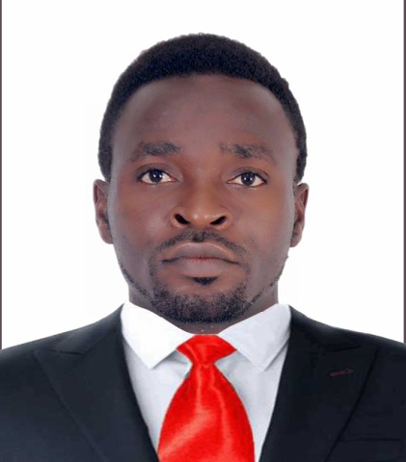
Name: Scott
Nationality: Cameroonian
Marital Status: Single
Sex: Male
Visa Status: Cancelled visa
Address in UAE: Ajman
Email: scott-397393@gulfjobseeker.com
ELECTRICIAN

PERSONAL SUMMARY
Seeking a challenging position as an electrician to work in an environment, contributing enthusiasm, dedication, responsibility, and good work ethic, combined with a desire to utilize my electrical skills obtained through experience as an electrician for 4years.
CAREER HISTORY
ELECTRICIAN – February 2014-January 2017
JOB DESCRIPTION
- Test solid-state circuitry to determine defective components in analog and digital equipment along with defective parts replacement.
- Install improvements and major upgrades to electrical plant and subsystems.
- Conduct infrared analysis and field equipment examination using specialized thermo graphic imaging and digital cameras.
- Design and modify motor power control apparatus circuits.
- Read and interpret blueprints, schematics and wiring diagrams.
- Prepare schedules and coordinate activities with varied electrical divisions and sections.
- Plan and prepare work orders or instructions utilizing blueprints, sketches and drawings.
- Ensure accurate and apt completion of all protective maintenance duties.
- Fabricate and test all electrical harnesses for space flight or non-flight applications and EGSE.
- Ensure to populate printed circuit boards.
- Integrate and test EGSE and space flight or non-flight applications for electronic board assemblies.
- Evaluate electrical as well as operational problems.

Personal:
- Ability to function effectively in stressful situations.
- Can work well in a team-oriented environment.
- Ability to interact effectively at various social levels and across diverse cultures.
- Able to add, subtract, multiply, and divide in various units of measure.
- Willing to work shifts, morning, nights etc.
- Possessing a friendly, approachable personality.

Languages:
English (Fluently)
French (Good)
ACADEMIC QUALIFICATIONS:
Government High school Advanced Level certificate (muyuka, Cameroon)
REFERENCES:
Up on request

