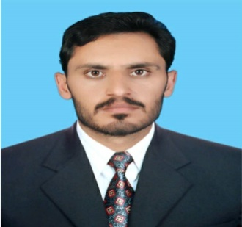
Jamshaid
Mechanical Engineer
Email address: jamshaid-397400@gulfjobseeker.com
Nationality: Pakistani

CARERR OBJECTIVE:
Seeking a progressive and challenging career using my inner strengths, professional skills, and creative thinking to the development of the company and ultimately gain future

WORK EXPERIENCE
Site Engineer:Jan 2019- Dec 2019
Accomplishments:
- Ensure, inspect and report quality of work carried out at a site
- Manage Workers and team allocation for different work on different Sites
- Preparing WBS, BOM, Gantt chart and other various activities for the project.
- Working on different drawings and makingSchedules.

Trainee Engineer:Apr 2018-Sep 2018
Organization:GASCO
Accomplishments:
- Making maintenance schedules and plans.
- Prepared quotations, submittals, invoicing and other important documents.
- Supervised preventive and corrective maintenance, Planed & overseen all repair and installation activities.
- Compressors, engines, Pumps, valves and Pipelines maintenance.
Internships:
- Oil and Gas Development Company Limited Pakistan.
- Surrani Construction Company

EDUCATION:
2013-2017 Bachelor of Mechanical Engineering Grade/CGPA
University of Engineering &TechnologyPeshawar Pakistan 2.66

2009-2011 HSSC (Pre-Engineering) Percentage
Government College Peshawar 85%
CERTIFICATES:
- REVIT MEP
- Confined Space Awareness
- PRE-Requisite for PTW USERS
- Permit to work for PTW USERS
- H2S Awareness and Escape (Level 2)
- Task Risk Assessment
Skills and Competence
- Auto Cad( 2D Drawings and 3D Modeling), Pro-E, Revit
- MS Office
- Project Management(Primavera P6) and Engineering
- Fundamental of HVAC and MEP
- Ability to interpret Engineering Drawings and specifications
- Creativity and design thinking
- WBS and Gant chart preparation
- Proactive and willing on to take new challenges
- Problem solving and result oriented
- Provide cost estimate for materials, equipment or laborers, work effectively under Pressure
- Troubleshoot equipment to solve Problems
- Effective verbal and communication skills
- Ability to work in a team
- Capable of working in demanding situations and meetingdeadline.
Interest and Hobbies
Painting, reading, traveling and sports
Languages
English, Urdu, Pashto
References
References will be provided on demand

