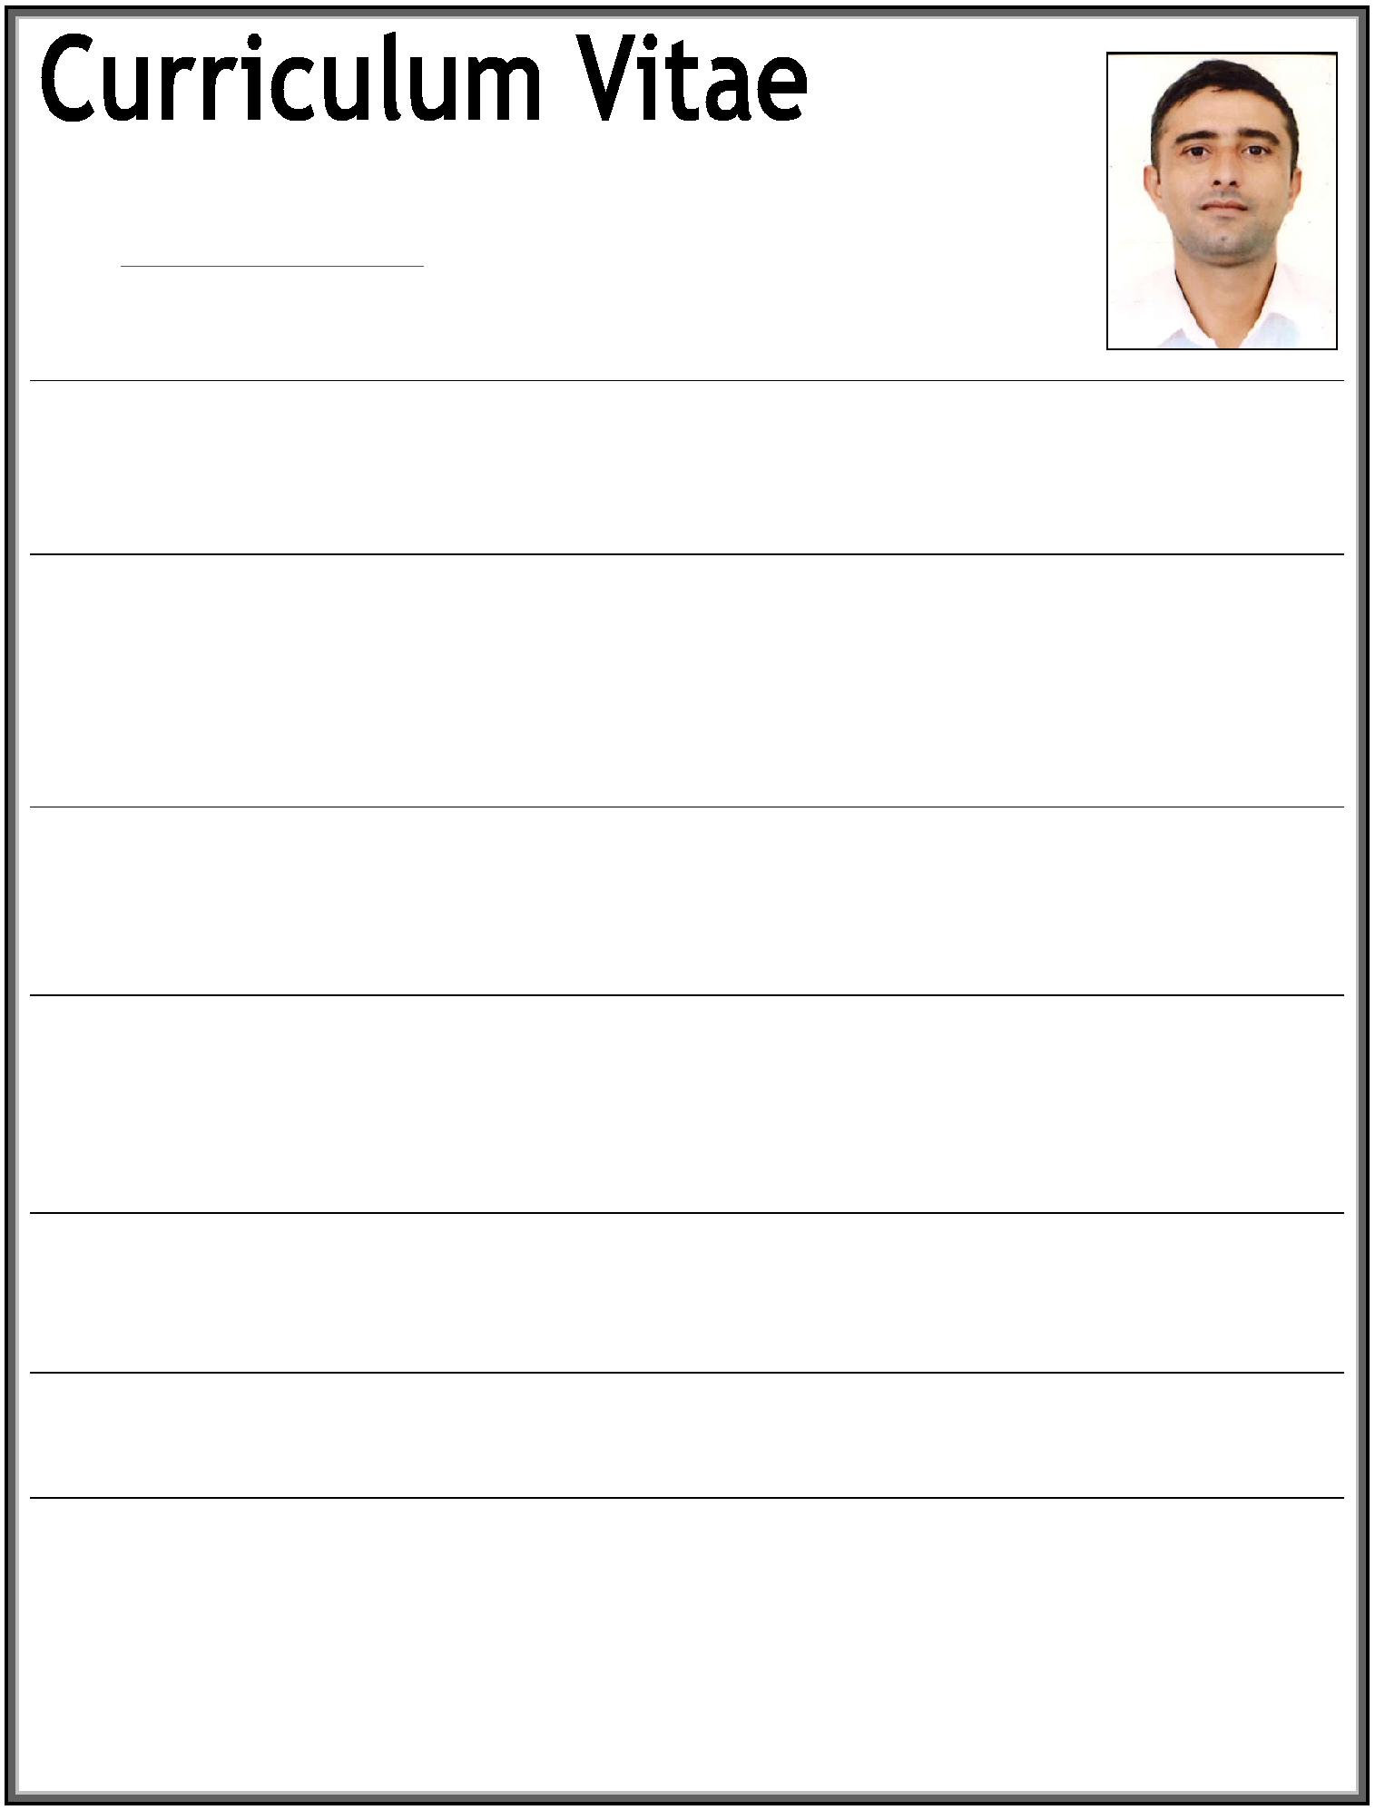
BIJAY

E-mail: bijay-397422@gulfjobseeker.com
(Dubai-UAE)

Profile:

A Suitable position with an organization where I can utilize the best of my skills and abilities that fit to my education, skills and experience a place where I Can encourage and permitted to be an active participant as well vital contribute on development of the company

Personal Details:

 Nationality | : | Nepalese
 Date of Birth | : | 30th Aug, 1987
 Religion | : | Hindu
 Gender | : | Married
 Height | : | 5.8”
 Weight | : | 78 kg

Language Known:

 English | : | Reading, Writing & Speaking
 Arabic | : | Basic Speaking
 Hindi | : | Reading, Writing & Speaking
 Nepali | : | Mother’s Language

Passport Details:

 Date of Issue | : | 10TH Feb, 2013
 Date of Expire | : | 09t5h Feb, 2023
 Place of Issue | : | Nepalese
 Visa Status | : | Employment Visa

Educational Qualification:

- Bachelor in (Business Studies)-BBS from “ Tribhuvan University”-(Nepal) 2013
- Higher (+2) Educational Certificate from (HSEB-Nepal) 2006

- (SLC) High School Certificate from-(Nepal) 2003

Computer Skills:

- Internet & Emails
- Others Basic Computer Knowledge

Work Experience:

 COMPANY | : | ALLIED SECURITY SERVICES PVT LTD
DESIGNATION | : | Security Guard
Duration | : | 03 Years (2009 to 2012)
Location | : | Nepal
- Greeting Customers

- Investigating Fraud Insurance calms

- Providing a warm welcome for customers.

- Patrol industrial and commercial premises to prevent and detect signs of intrusion and ensure security of doors, windows, and gates.

- Monitor and authorize entrance and departure of employees, visitors, and other persons to guard against theft and maintain security of premises.

- Write reports of daily activities and irregularities, such as equipment or property damage, theft, presence of unauthorized persons, or unusual occurrences.
- Call police or fire departments in cases of emergency, such as fire or presence of unauthorized persons.

- Circulate among visitors, patrons, and employees to preserve order and protect property.

 COMPANY | : | SAHEL MART COMPANY GORNATHA
DESIGNATION | : | Store crew (Supermarket)
Duration | : | 02 Years (2015-2017)
Location | : | Saudi Arabia

 COMPANY | : | BHATBHATENI DEPARTMENTAL STORE
DESIGNATION | : | Store helper (2017 to 2019)
Duration | : | 02 Years
Location | : | Nepal
- Check inventory records for accuracy

- Compile reports on various aspects of changes in production or inventory

- Keep records of items shipped, received, or transferred to another location

- Find, sort, or move goods between different parts of the business

- Ability to maintain work schedules and uphold work standards

- Knowledge of standard practices, procedures, and equipment used in the receipt, storage,

- Requisitioning and disbursement of supplies and materials

- Knowledge of training and supervising techniques and employee policies and procedures.

- Knowledge of the occupational hazards and safety precautions applicable to the work.

 COMPANY | :
Duration | : | July, 2019 Still Present
Location | : | Dubai-UAE
Location Experience in UAE:
- Presently working as a “General Assistant” (Dubai-UAE)

Skills:

- Good Communicational and interpersonal skills

- Hard working Team Member

- Very Energetic result oriented and organized.

- Courageous true towards the duties.

- Have a high respect for customer’s service.

- Always keep on smiling under pressure.

- Efficient and well behaved person.

- Extremely hardworking self motivated and able to work independently.

- Keep excellent inter personal relations with colleagues and ready to help them.

Declaration:

I hereby certify that the above information are true and correct according to the best of my knowledge & My Experience.
Bijay

