ADRESS
AL Ain, Abu Dhabi, UAE

EMAIL

Reem-397448@gulfjobseeker.com

LANGUAGES

Arabic

English

HOBBIES & INTERESTS

Reading
Sport

Movies

REEM
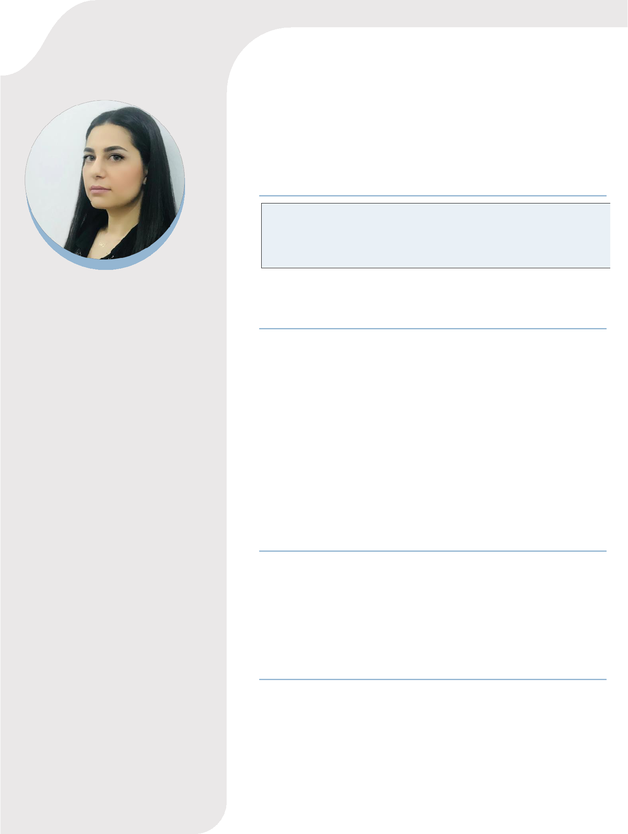

Pediatric Specialist

Dedicated Pediatrician with HAAD license, Arab Board Certificate and Syrian Board Certificate. Aiming to Extend my ability to serve the community with my knowledge and skills.

EDUCATION

- Master’s Degree Certificate in Pediatrics
Damascus University, Faculty of Medicine
11/2010 – 11/ 2017
- Syrian Board certificate in Pediatrics
Syrian Commission for Medicine Specialties
11/2010 – 11/2017
- Arab Board Certificate in Pediatrics
Arab Board of Health Specialization

11/ 2010 – 07/ 2017
- Bachelor of Medicine (MBBS)
Damascus University, Faculty of Medicine
09/ 2004 – 10/2010

HAAD LICENE

- Health Authority of Abu Dhabi (HAAD- Pearson Vue)
Passed exam at 30/01/2020.

- Health Authority of Abu Dhabi License

Approved at 10/12/2019.

CLINICAL EXPERIENCE

- Pediatric Specialist

Damascus, Syria between 7/4/2017 - 30/12/2019 my duties were:

- Covering Pediatric ER/Clinic dealing as MRP with all sick case including CPR as BLS/PALS protocols, as well vast varieties of ER case like DKA, Acute and Chronic renal failure, GIT Bleeding, Seizures, dehydration ..etc. and admitting the needy case as MRP to continue treatment in the pediatric wards till discharge.

SKILLS

- Skilled pediatrician with more than 4 years of experience in the pediatrics practice field.

- Available anytime for emergencies

- Good team-work communicate

- Sense of responsibility

- Dedicated and motivated to cure patients

- Compassion & Empathy

- Professionalism

- Strong attention to detail

- Able to multitask efficiently and effectively

- Solid documentation and assessment skills

- Solid assessment and documentation skills

- Great interpersonal skills

- Excellent communication skills (written and verbal)

- Highly organized

  - Covering PICU department where we had very sick kids (ventilated, CHF, Coma .. etc.)

  - Attending deliveries in labor department as MRP and resuscitation newborns as per NRP protocol, intubating and inserting UVC/UAC including very premature case and CDH, PPHN, HMD, etc.

  - Covering NICU department dealing with most of critical neonatal diseases.

- Pediatric Resident at Al madina Hospital
Damascus, Syria between 1/1/2015 – 7/4/2017

  - I spent 2.5 years in Pediatric Residency, where I was responsible for PICU, NICU, ED, In-Patient units.

- Pediatric Resident at University Children Hospital

Damascus, Syria between 8/11/2010 - 7/11/2014

- I spent four years in residency as Arab Board Council program, and I rotated in the following units :( PICU, NICU, ED,

OUT-Patient clinics, Hematology/Oncology, Gastroenterology, Pulmonology, Cardiology, Neurology, Nephrology, Rheumatology and Infection diseases units).

RESEARCH EXPERINCES

- A retrospective study of the pathogens, predisposing factors and complication of septic arthritis in Syrian children between neonate and 13 years old from 1/1/2009 to 31/12/2014 at University Children Hospital (07/2017).

- Antibiotic resistance in Syrian children with septic arthritis.

- Case report about milk- induced pulmonary disease (Heiner Syndrome) at University Children Hospital at 09/2017.

INVITED TALKS, CONFRENCES

- Attend Cystic Fibrosis Day in University Children Hospital, Damascus, Syria (2017).

- Attend Asthma in Pediatric conference in University Children Hospital, Damascus, Syria (2016).

- NRP workshop in AL Mujtaded Hospital, Damascus, Syria (2014).

