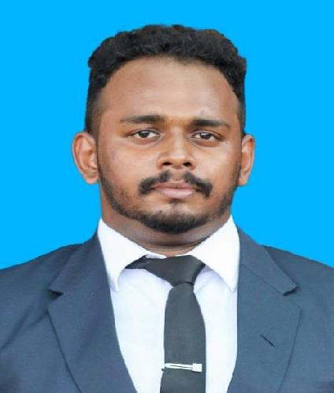

QUANTITY SURVEYOR

ABOUT ME

Proactive, Fast learning and motivated individual looking for
secure an employment opportunity that allows for

further development of competencies and problem solving skills. Seeking to apply

knowledge on Quantity Surveying applications and to build a long term career in the construction industry with opportunities for career growth.

SKILLS

COMMUNICATION

ORGANIZATION

TEAM PLAYER

CREATIVITY

SOCIAL

 | PERSONAL DETAILS
Name | Nawas
Civil status | Single
Sex | Male
Nationality | Sri Lankan
Email | Nawas-397459@gulfjobseeker.com

WORK EXPERIENCE

Quantity Surveyor
Duration: 24th January 2018 – 31st January 2020
Project Name: OPEC fund for international development, Rehabilitation and Improvement of Peradeniya – Badulla – Chenakaladi road, Package 01 Badulla – Passara (130+800 -150+800)

Activities performed:

Preparation and Checking of measurements for Interim payment certificate.
Extracting Cross section quantities for earthworks Taking off site measurements.
Preparation of progress report charts & progress video
Inspection of public complaints and dispute resolution
Supervision of site works including structural works, Asphalt laying,
etc.
Document controlling and maintenance.

Quantity Surveyor at Provincial department of Buildings (Uva)
Duration: 27th July 2017 to 19th January 2018
Project Name: Construction of multipurpose building in Badulla town
Activities performed:

Taking off measurements of structural works preparation of measurements Supervision of site works
Preparation of Labor Supply and Sub contractor Bills Assistant senior quantity surveyor in related activities
Pre contract and Post contract documents Management

PROFESSIANAL QUALIFICATIONS

Completed BTEC Higher National Diploma in Quantity Surveying and Construction Economics by Edexcel (UK) at British College of Applied Studies
Completed Certificate progremme of English in construction industry at British College of Applied Studies

EDUCATION | SKILLS

School
UVA College Badulla (Primary)
Badulla Central College (Secondary)

Educational qualification

General certificate of education Ordinary Level (Sri Lanka) 2009 (Sinhala Medium)

General certificate of education Advanced Level (Sri Lanka) 2013 Bio Science Stream (Sinhala Medium)

Additional qualification

Was a prefect in Badulla Central College Member of School Debate Team
Represented School & District Cricket Teams under 15, 17 & 19 Levels

Extra-curricular activities

Participation of Edexcel expo 2016 held at British college of Applied Studies October 2016

Ability of preparing measurements using AutoCAD

Preparation of bill of quantities (BOQ) Using MS Excel

Fully Competence in MS Office package and MS

Project

Ability to do measurement of work and preparation of interim and final payment certificates and settlement of other contractual claims

Familiarity of Professional Standards documents including New Rules of Measurement 2 (NRM 2), Standard Method of Measurement 7 (SMM 7) and Civil Engineering Standard Method of Measurement 4
(CESMM 4)

Proficient in Sinhala, Tamil and English

Public speaking and presentation skills

Strong verbal and written communication

I Hereby Certify That, This Resume correctly describes me, My Qualifications and My experience to the Best of my knowledge and belief. Therefore I take the Opportunity that every task given to myself can be handled with honesty, Dedication and Care with all responsibilities.

Rasheel

