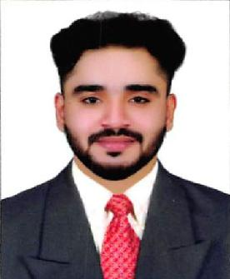

SHAHEER
E-mail: shaheer-397471@gulfjobseeker.com

Career Objective

Intend to build a career with leading corporate of hi-tech environment with committed and dedicated people, which will help me to explore myself fully and realize my potential. Willing to work in challenging and creative environment.

Profile

Knowledge

- Office administration principles, including record keeping and filing system
- Data entry (English, Arabic) Skills with 40-50 Words/Minute

- Knowledge in all Windows operating systems (WindowsXP, Windows7, Windows8, Windows8.1).

- Knowledge in Windows office automation tools like Word, Excel, Power point etc.
- Knowledge in programming language like, Visual Basic, C++

Professional Experience

Designation:

Typist General

Duties and Responsibilities

  - Knowledge and typing of all online visa applications of Immigration and concern departments

- Preparation and typing of all Visa Applications related to Dubai Immigration like family visas and partner visas or others
- Emirates id and Medical typing

- Health Insurance typing

- Assisting in PRO jobs and activities.

- Handling the Customers and guide them as per thieir demand

- Verifying and correcting the applications before processing.

8. Typing in English and Arabic language

Academic Details

  - 2013-2015: Bachelor Of Business Administration Degree (BBA-CA) – 61% A J K College of Arts and Science Coimbatore From Bharathiyar University,

- 2011-2013: HSC – 66% Anangannadi Higher Secondary School, Kerala

- 2009-2010: SSLC – 62% (Grading System), Anangannadi Higher Secondary School, Kerala.

TechnicalQualifications

• | Operating Systems | : Windows XP ,Windows 7,Windows 8
• | Data Entry | : English,Arabic
• | Software | : MS Office(Word, PowerPoint,Excel,Access),Teamviewer

Personal Skills

- Strong client facing skill
- Work confidently within a group
- Confident and Punctual
- Ability to learn new technologies

Roles&Responsibilities

- Providing IT support to computer users within the office
- Maintain detailed and accurate records

Strengths

• Hard working.
• Loyal.
• Confident.
• Free and Frank.

Personal Details

Date of Birth | 13/02/1995
Gender | Male
Marital Status | Single
Nationality | Indian
Mother Tongue | Malayalam
Language Known | English, Malayalam, Tamil, and Hindi
Passport Details
Date of issue | 01/10/2015
Date of expire | 30/09/2025

Declaration

I do hereby declare that all the information furnished above are true and correct to the best of my knowledge and belief.

Place : Shaheer

Date :

