CURRICULAM VITAE

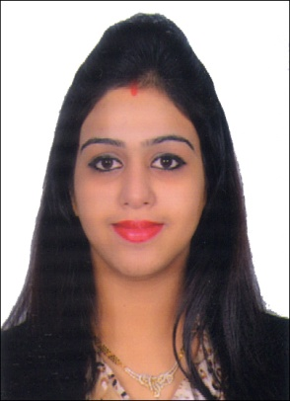
NEHA

E-mail: neha-397513@gulfjobseeker.com

CARRIER OBJECTIVE

Passionate kindergarten teacher with over 5 years experience implementing instructional strategies that actively engage young children in meaningful learning experiences to develop their fullest potential. Areas of expertise include:
- Creation of a stimulating and challenging learning environment through the effective use of different instructional techniques and instructional media.

- Working knowledge of a wide range of assessment strategies consistent with learning content and objectives.

- Successful differentiation of instruction and assessment to meet the varying needs of a diverse group of children.

- Timely identification and appropriate referral of children who need additional assistance.

- Comprehensive knowledge of curriculum and instruction best practices within early childhood education including the integration of technology to support learning.

- Effective classroom management through the application of fair and consistent standards, routines, encouragement and appropriate sanctions.

- Development of collaborative and productive working relationships with parents, children and other teachers to support the progress of the children.

EDUCATION BACKGROUND
- B.ED (English & Social studies) from Maharishi Dayanand University in the year 2019
- I-CAD 1yr diploma from International Centre of Art and Design in the year 2011.
- BA (English) from Shobhit University in the year 2011.
- English 1yr Diploma from International Baccalaureates
- Intermediate from International baccalaureates, Phnom Penh, CAMBODIA in the year 2008.
- High School from CBSE School in the year 2006.

WORKING EXPERIENCE:

- Worked as a kindergarten Teacher from 9th April 2019 to 9th march 2020.

- Worked as a Teacher and Play Group In charge in Udgam Play School, Kalkaji from 16 February to 30th march.

- Worked as Teacher and Coordinator in Little Millennium Pre School, Kalkaji from September 17 to February 18.

- Worked as a lecturer for "COMPUTER AIDED DESIGNS" in New Delhi YMCA from December 2013 to February 2015.

- Enhanced my skills as a pre-school teacher in Udgam Play School, KALKAJI from April 2011 to March 2012.

ROLES AND RESPONSIBIITIES:

- Instruct a multi-cultural class of 35 children in language, numbers, natural and social science, music, art and life skills

- Design and implement standards-based weekly lesson plans based on up-to-date educational best practices

- Use a variety of instructional materials, digital content, technology integration and creative learning activities to support achievement of learning objectives

- Evaluate performance using formal and informal testing, anecdotal data and formative assessment

- Analyze data to create individualized learning plans for each child

- Encourage children to develop self-confidence and a sense of responsibility through self-directed activities

- Establish a collaborative relationship with parents through regular conferences, parent involvement activities and written communication

- Work effectively with other staff in planning and enhancing curriculum and school objectives

KEY SKILLS
- Ability to get involved with the children easily
- Planning
- Classroom Management
- Good teaching skills
- Explaining power
- Polite and approachable
- Have patience
- Differentiation
- Technology
- Extrovert
- Observation

EXTRACURRICULAR ACTIVITIES

- Experience of teaching Dance and English to Orphan children in phnom penh, Cambodia.

- Got IB ENGLISH Certificate.

- Won the first prize in designing clothes for fashion show.

HOBBIES

- Painting

- Cooking

- Listening Music

PERSONAL QUALITIES:

Enthusiasm for Children

Communication Skills

Respect of Differences

Creativity and Flexibility,

Good Listener, Organized

Patience and Humor, Knowledgeable

Organized, Committed to life long-learning

PERSONAL INFORMATION:

- Date of Birth : 1st August 1990

- Nationality : Indian

- Religion : Hindu

- Languages Known : English, Hindi, Punjabi

DECLARATION:

I hereby declare that above information given by me is completely true according to my best knowledge and belief.

Date:
Place : United Arab Emirates

(NEHA)

