CONTACT
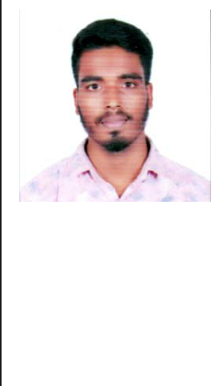

SAMIULLA

Samiulla-397515@gulfjobseeker.com

PERSONAL DETAILS
Date of Birth | : | 10/06/1998
Marital Status | : | Single
Nationality | : | Indian

OBJECTIVE
To pursue a challenging career and be a part of progressive organization that gives a scope to enhance my knowledge and utilize my skills towards the growth of the organization.
EDUCATION
2019-2020 Cadd center
Master diploma in building design

80-/-

2015-2019 Jawaharlal nehru technology and science university B.tech/civil engineering

67-/-

2013-2015 Narayana junior college

Board of intermediate

79 -/-

2013 International merit high school

Secendoty school of education

9.3/10 (GPA)

AREA OF

SPECIALIZATION
AutoCad 2d and 3d.

Revit architecture.

Building estimation and costing.

Etabs.

3ds max.

SKILLS
Strong communication and leadership skills

Competence in Cad.

An analytical mind with strong problem solving ability.

PROJECTS |  | Building estimation of concrete design.
 |  | 1.Specification of work and material about quality,proportions and constructional
 |  | operation.
 |  | 2.Quantity of materials and their costs.
 |  | 3.cost of labours and their wages.
 |  | 4.Location of site of work and the distance of source and conveyance charges.
 |  | 5.Overhead and establishment charges.
 |  | 6.Profits.
EXPERIENCE
19/08/2019 - |  | Cadd center
11/01/2020 |  | AutoCad draughtsman
 |  | I have been training in cadd center(banglore) as an Autocad draughtsman since 6
 |  | months,through which i had learn the principles of architecture design and i have
 |  | completed my MASTER DIPLOMA IN BUILDING DESIGN through softwares like
 |  | AutoCad,revit architecture,Quantity surveying,3ds max and Etabs.
STRENGHTS |  | Decision making and analytical problem solving.
 |  | Flexibility and adaptability to work in any environment.
 |  | Honest and punctual.
 |  | Quick learner and creative minded.
DECLARATION |  | I, samiulla khan hereby conform that the information given above is true to the best of
 |  | my knowledge.
 |  | DATE :
 |  | PLACE :
 |  | Samiulla

