PERSONAL PROFILE

Highly energetic marketing and sales professional with 6 years of experience in the industry. Commited to deliver best in class and proven in leadership quality to keep up the economic culture of the organisation

CONTACT DETAILS

Email: shajeer-397521@gulfjobseeker.com

PROFESSIONAL SKILLS

Sales Management-Competent Marketing Management-Competent Human Resource management-Competent Analytical Skills-Competent Critical Thinking-Competent

Decision Making-Competent

OTHER SKILLS

I am multilingual and can speak English,

Hindi,Tamil and Malayalam fluently . I am also an avid reader,music listener and an hiker

ACADEMIC PROFILE

B.com

NORTH EAST FRONTIER TECHNICAL UNIVERSITY(2018)

HIGHER SECONDARY EDUCATION

ZAMORINS HIGHER SECONDARY SCHOOL(2009)

SSLC

HILL TOP PUBLIC SCHOOL(2007)

SHAJEER
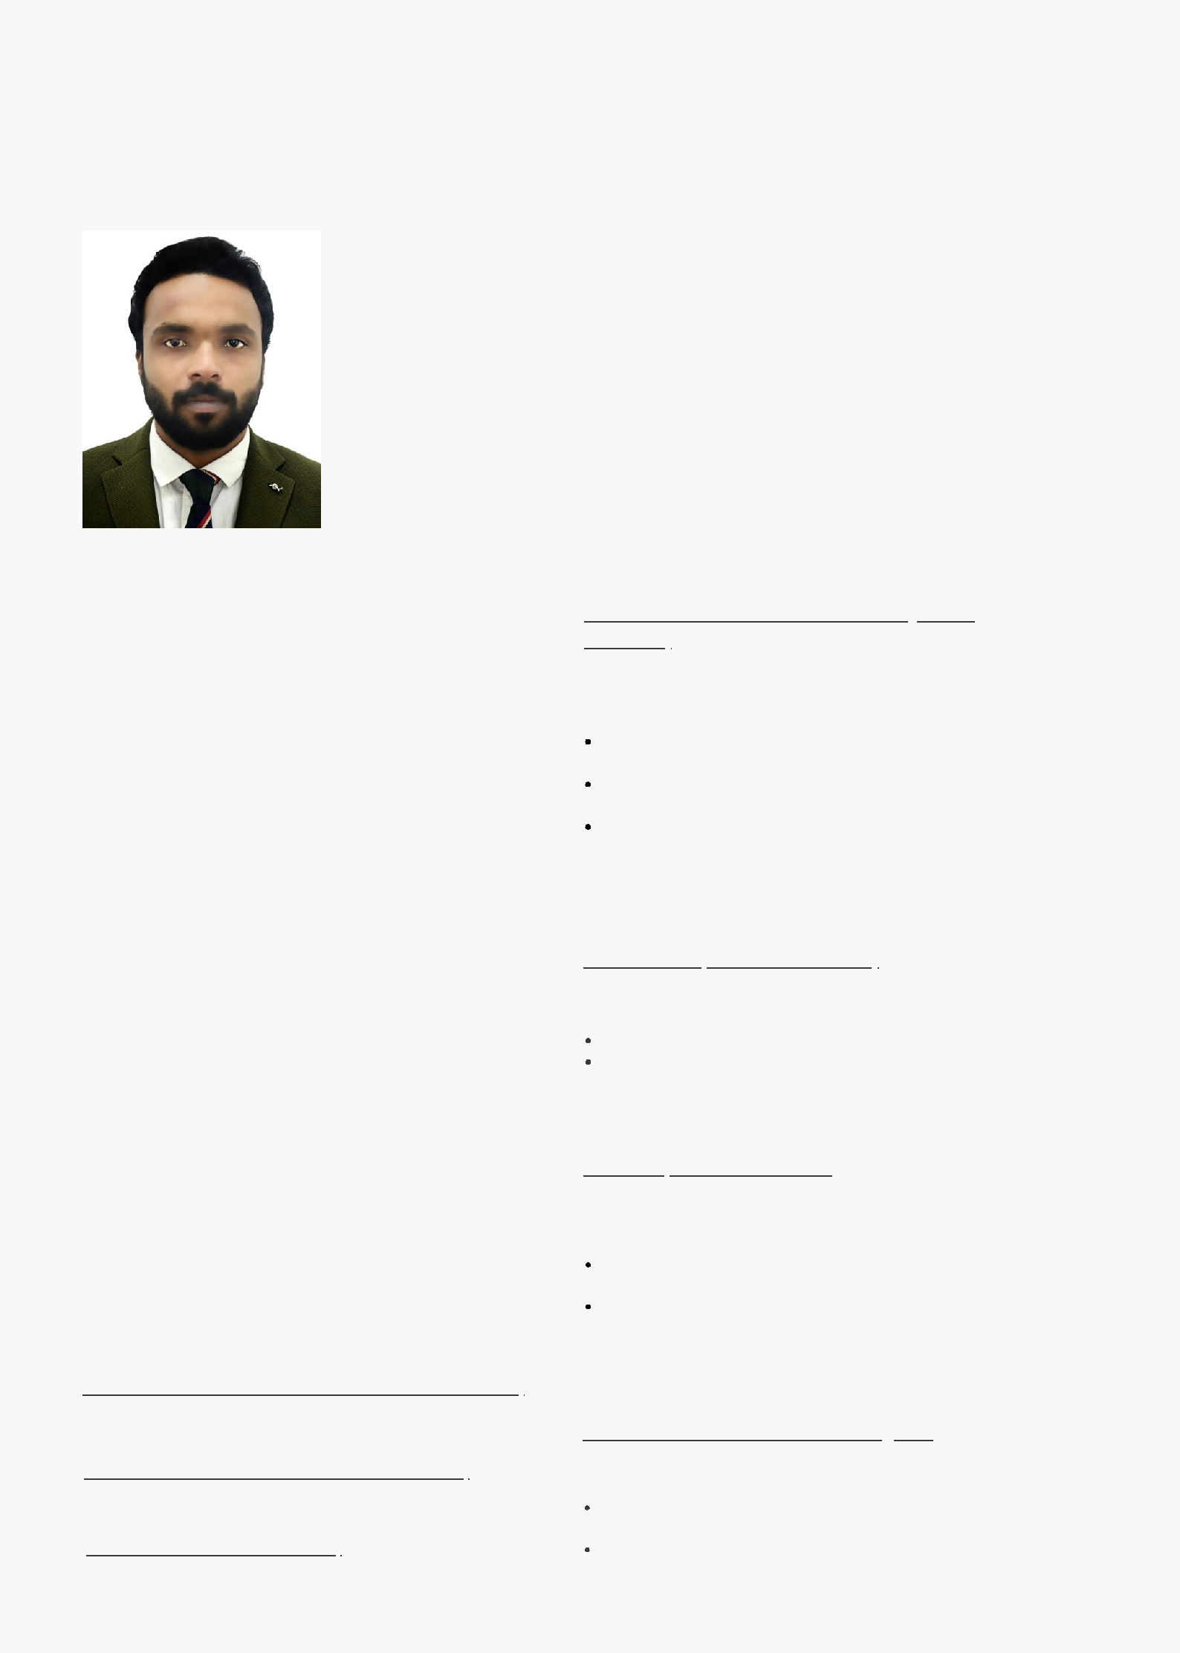

PHARMACUETICAL SALES PROFESSIONAL

EMPLOYMENT HISTORY

Territory Manager

(May 2017-Sep2019)

Job responsibilities;

Planning and achieving Sales targets product(Gynec and ortho) wise and value wise

Marketing research,customer care and territory service assigned

Preparation of strategic distribution plan of the assigned territory for the year

Organizing Educational programs for Doctors and medical professionals

Marketing Executive

Lupin Pvt.ltd(Jan 2016-Apr 2017)

Job responsibilities:

Planning and achieving sales target

Market research and patient survey on brands used Conducting Educational conferences for doctors in territory

Territory Manager

Cipla Ltd(Aug 2014-Jan 2016

Job responsibilities;

Planning and achieving Sales targets product wise and value wise

Marketing research,customer care and teritory service assingned

Preperation of strategic distribution plan of the assigned territory for the year

Territory Manager

Kiosence Health Care (Mar 2013-Aug2014

Job responsibilities:

Planning and achieving sales target Organize and implement doctor and patient services

Offer volunteering in major Psychiatric Hospital

