Hayat
Electronics and Communication Engineer 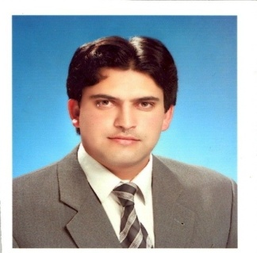
Email: hayat-397527@gulfjobseeker.com

Saudi Engineering Council Membership

OBJECTIVE To convert all my knowledge and ideas into practical and implemented form and enhance
my technical as well as managerial skills by acquiring job in a reputable, growth oriented
Organization, which provides constant personal development.

QUALIFICATION

BACHELOROF SCIENCE AND ELECTRONICS ENGINEERING

JOB EXPERIENCE
I worked as a trainee Engineer at Pakistan Telecommunication Authority ( PTA) for six (6) months.
I worked as an Engineer in Mobilink (Communication Company) for three months.

I WORKED AS A TRAINEE ENGINEER (Upto 6 Months) AT OILAND GAS DEVELOPMENT CORPORTAION LIMITED COMPANY PAKISTAN (OGDCL).

I HAVE AN EXCELLENT KNOWLEDGE ABOUT PLC, SCADA AND CCTV CAMERA AND
NETWORKING.

CURRENT JOB EXPERIENCE
Currently I am in Riyadh KSA
(From 1-1-2014 up to Now)

SEMESTERS
Projects
Electronics II: USB Charger
Mobile phone charger capable for charging mobile phone from computer’s USB port.
Functionality of the charger was to change 5 volts DC to 9 volts DC.
Discrete Signal processing:
Signal manipulator
Matlab implementation, with user friendly interface, capable of adding, subtracting,
scaling, convoluting, and other similar operations that with a given input signal.

Principles of communications: FM transmitter
An FM Transmitter capable of working between fm frequency range(86-108) MHz
Electronics I: Dark/Light Detector: An LDR is used to detect Light or Dark as it works
when light falls on it.
Design and Programming Skills
• MATLAB
• KEIL
• C++
• Micro wind
• Schematics
• Electronic workbench
• PS Pise
• Proteus
•Verilog/VHDL
Computer Skills
• MS word
• Power point
• Excel
• Photo shop
• Ulead video studio
• Windows Xp/Vista/7
Proficiency in Languages
- English: Read, Write, Speak
- Arabic: Read, Write, Speak
- Urdu : Read, Write, Speak
- Pushtu: Read, Write, Speak
Achievements
& Awards
• Got (NICT R&D) Scholarship for B.S at COMSATS Abbottabad campus Pakistan.

Note:Original documents will be provided on Demand.

