RISHABH
Address : Dubai, UAE

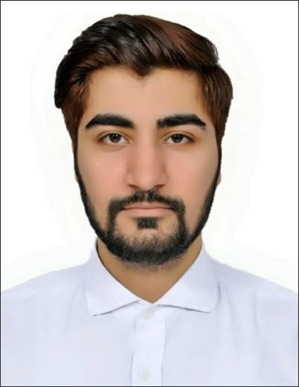SUMMARY
LANGUAGE
- ENGLISH
- HINDI
 DUBAI, UAE
 rishabh-397626@gulfjobseeker.com
✶ INDIAN

SKILLS
- Creative
- Multitasking
- Reliability
- Data Analytics
- Safety Management System
- Business Development
- Management
- Customer Service
- Microsoft excel
- Communication
- Customer Satisfaction
- Service Quality
A professional who is a firm believer to create a niche for my self and grow with the organisation.
Coming from background of customer service, banking, logistics, inventory and business development I trust that self belief and hard work always leads to success.
I have always thrived in fast paced, challenging, collaborative and innovative environment in addition my skills, attitude and behavior will surely let me excel in the job opportunity an entity has to offer.

WORK EXPERIENCE

2019 - 2020 AL QUSAIS - DUBAI SENIOR CUSTOMER EXECUTIVE
- Handling patients, referral sources, and administrative department inquires
- Communicating with insurance companies and/or prior authorization requests
- Entering patient information into a customer information system
- Ensuring customer satisfaction and assisting them with issues/concerns related to their health
- Serving as a backup when other employees are out due to absent staff members
- Making decisions as needed off-hours or without supervision to ensure an uninterrupted supply of product to customers
- Developing the knowledge of customer needs and trends to improve customer satisfaction and loyalty
- Becoming educated in qualifications of multiple insurances to ensure clean order intake

2018 - 2019 DELHI INTERNATIONAL AIRPORT LTD - DELHI, INDIA SENIOR CUSTOMER EXECUTIVE
- Responsible for handling front office desk and administration duties, including greeting guests and offering them a location, answering phones, handling airline inquiries, and sorting and distributing mail. Mail also schedule meetings and travel for GMR.
- Extensive knowledge of airline procedures. Adept at customer service relations especially in fast-paced environments where efficient operations are essential to an airline’s reputation. Experienced with flight booking and problem solving.
- Routinely greeted passengers and handled processing procedures.
- Made in-person and online reservations for passengers.
- Prepared daily reports of customer activity.
- Tracking flight arrivals and departures and posted related information online.

- Made regular announcements concerning flight arrivals and departures.
PERSONAL DETAILS
Date of Birth: 28th June, 1994 Marital Status: Single

ACHIEVEMENTS & AWARDS
- Service legend award of IGI Airport T3, appreciation was awarded by Videsh Kumar Jaipuria- Head of Terminal Operations & Quality Head. DELHI INTERNATIONAL AIRPORT LTD - GMR is recognition for exhibiting execptional Customer Service at IGI Airport, Delhi - India
- Awarded a best employee team leader of the month - 4 times at SBI Cards.
- Worked to address customer service issues and sought positive resolutions.
- Responded to customer inquiries in person online and on the phone.

2016 - 2018 STATE BANK OF INDIA CARDS, DELHI - INDIA TEAM LEADER
- This is front-line sales position in cobrands cards sales team, and is responsible for driving business, achiving monthly sales sales target and acquiring new customers through consultative selling of our premium cards products via defined Retail channel of acquisition.
- Responsible for finding and engaging with new customers through referrals, networking, and cold calling. I was often in charge of penetrating a specific corporates, client, or Retail area.
- Timely execution of all sales activities leads, campaigns, referrals and any self generated leads.
- Tracking and reporting sales performance including pipeline, acquisition results and market conditions.
- Set appointments, listen to the customer needs and sell most appropriate premium product.
- Ensuring all performance and quality standards are met viz. business targets, controls and compliance.
- Engaging with premium customers to build relationship, and delivering a positive customer while acquiring new customer.
- Managers in sales strategy development.
- Keep informed of new products and services.
- Recruit, Train, and Coach the sales team.
- Delegate targets and monitor performance of team by setting deadlines.
- Set sales targets and motivate sales team

and prepare sales reports.

2015 - 2016 RR INDUSTRIES, HYDERABAD - INDIA BUSINESS DEVELOPMENT MANAGER
- Experience in purchase of material required for solar - Electrical, Control panels, Invertors Structures,.etc
- Increased production by introducing 2 No's CNC lathe machine and 1 No. CNC Milling machine for automobile spares.
- Payment cycle handling and issuing payment in time to the vendors as per the mentioned dates in purchase order.
- Introduced 2 new vendors and increased required stocks for 10-12 months as per the company ability and market requirements (Solon, Andromeda, A&T power systems, etc..)
- Handled negotiations - Executed a project in ITC Limited, Hyderabad (Vacuum Handling System).
- Handled negotiations - Mondelez International Sri city, Nellore, Andhra Pradesh (Vacuum Handling System).

EDUCATION

2017 - 2020 SWAMI VIVEKANANDA SUBHARTI UNIVERSITY, MEERUT
- INDIA

MBA - Master of Business Administration
Result Awaited

2012 - 2015 MANAV BHARTI UNIVERSITY, SOLAN - INDIA
Bachelor of Commerce - B.COM

2007 - 2012 GURU NANAK PUBLIC SCHOOL
Commerce with Maths

