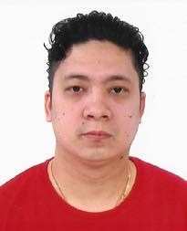CURRICULUM VITAE

Objectives: -
Looking forward to a reputed organization to enhance my skills and caliber for the development and improvement of my enthusiast field to promote the business sector in vise versa well.

Personal Details: -
Name |  | Mr. Pankaj
Nationality |  | Indian
DOB |  | 11 August 1986
Marital Status |  | Single
Gender |  | Male
Religion |  | Hindu
Languages known |  | Both English and Hindi fluently
Contact Details |  | email: - pankaj-397650@gulfjobseeker.com

Education Qualification: -School Level Certificate completed

Other Qualification and Training: -
Completed Basic Food Hygienic training (HACCP) through Abu Dhabi Municipality.

Work Experiences:-
Sl.no | Years of Work | Names of the company |  | Position
1 | 2003 -2005 | KIC Food Products Pvt. Ltd | Commi – 3
2 | 2005 -2006 | Chopstick Restaurant | Commi – 1
3 | 2006 – 2009 | Oasis Chinese Restaurant | Assistant Cook
4 | 2009 – 2011 | Flavour Of China | Assistant Cook
5 | 2011 – 2012 | Shirke Group of Company (M.C.A. Club) | D.C.D.P
6 | 2012 -- 2015 | Oasis Chinese Restaurant | Chef
7 | 2015- until Now | Restaurant | CDP

Declaration: -
I hereby mentioned above detail is completely true and genuinely prepared through my best knowledge possibly.

Note: - Original documents will be provided as per require.

