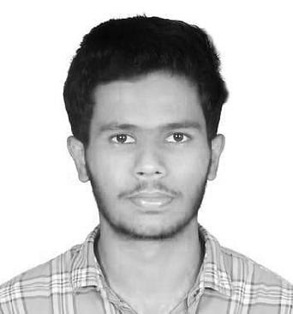
SHABEER
GRAPHIC, MULTIMEDIA DESIGNER,

Email:

Visa status

Shabeer-397654@gulfjobseeker.com

Visit visa

​PROFILE

Being part of the Media industry was always my dream and I have followed this dream with all the passion. I am creative specialized in Video Editing , Graphic Designing & Digital Marketing My undying love for creative work is what is driving me forward as I am eager to learn more in my career

​ ​SKILLS

★ Graphic Designing ★ Infographics

★ Video Editing
★ 2D Animation

★ Motion Graphics
★ Branding

●

●

Adobe After Effects Premier Pro

●

●

Adobe Illustrator
Adobe InDesign

●

●

Adobe Photoshop MS Word

PROFESSIONAL EXPERIENCE

​ KERALA
​Kerala India​ | 2017 – 2019
MULTIMEDIA DESIGNER

- Perform graphic designs using corporate standard software.

- Prepares work to be accomplished by gathering information and materials.

- Plans concept by studying information and materials.

- Illustrates concept by designing rough layout of art and copy regarding arrangement, size, type size and style, and related aesthetic concepts.

- Obtains approval of concept by submitting rough layout for approval.

- Ensures operation of equipment by completing preventive maintenance requirements; following manufacturer’s instructions; troubleshooting malfunctions; calling for repairs; maintaining equipment inventories; and evaluating new equipment.
- Developing storyboards for the initial stages of production.

- Create models, drawings and illustrations by hand or electronically.

- Join images with background graphics and special effects

- Ensure synchronization of frames and audio.

- Collaborate with production crew (designers, directors etc.).

- Develop storyboards for the initial stages of production.

- Maintain up-to-date knowledge about latest graphic design techniques.

- Ensure compliance with company guidelines and design standards.

- Maintain and follow best practices for versioning control, naming convention and organization of graphic files.
- Create and deliver motion graphics in various media including web, mobile, etc.

- Prepare design plan, concept and layout for motion graphic project.

VHTnow - BANGALORE
​Karnataka INDIA​ 2017-2017 (2 month)
MULTIMEDIA DESIGNER (INTERNSHIP)

- Developing and producing multimedia pieces for use on websites, in multimedia presentations, and for interactive displays and exhibits.​.

- Work with our creative teammates.

- Collaborating with marketing and public relations teams to determine appropriate visual, textual and animated elements of projects

- Follow the company's brand guidelines.

- Present to senior management.

- Develop an overall video brand messaging strategy.

- Conceptualizing visuals based on requirements.

- Develop illustrations, logos and other designs using software or by hand.

- Illustrates concept by designing rough layout of art and copy regarding arrangement, size, type size and style, and related aesthetic concepts.

- Create Project Mock-Ups Based on Project Scope

- Use Computer Programs to Create Animation, Audio, and Visual Effects

- Perform Edits Based on Feedback from Stakeholders.

- Creating digital images for the purpose of animation

- Transferring audio/video files to be edited and manipulated digitally

- Creating animated sequences using computer software.

- Ensure synchronization of frames and audio.

- Join images with background graphics and special effects.

- Read scripts and story lines to understand animation requirements

- Maintain and follow best practices for versioning control, naming convention and organization of graphic files.

- Edit raw video footage and add effects/elements to enhance motion graphics.

- Work with editors, producers and other designers to resolve technical and/or design issues.

- Work with art and creative teams to understand project scope and objectives.

PORTFOLIO LINKS

Behance

https://www.behance.net/shabeershadd01

Vimeo

https://vimeo.com/user100746530

EDUCATION DETAILS

Bachelor of Commerce

University of Calicut, INDIA

LANGUAGES

Arabic ​Typing, Reading

English ​Typing, Reading, Speaking

