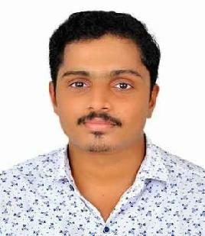
CURRICULUM VITAE

VISHNU

E-mail: Vishnu-397663@gulfjobseeker.com

CAREER OBJECTIVE

To work in an organization where I can deliver best of my abilities and thereby benefit the organization, adding to its values, try my level best to input my inbuilt ideas in order to increase the efficiency and effectiveness of the organization.

EXPERTISE SUMMARY

- Exceptional versatility and adaptability.

- Dedication and drive as a hard-working individual.

- Good communication and team-building skills.

- Ability to handle the situations in pressurized environment.

- Quick learner and Adaptive to changing environment.

- Positive attitude.

ACADEMIC PROFILE

QUALIFICATION |  | BOARD/UNIVERSITY | YEAR OF | PERCENTAGE
 |  |  | PASSING
M.Com(Master | of | Kannur University | 2019 | 69.06
Commerce)
B.Com(Bachelor | of | Kannur University | 2017 | 58.75
Commerce)
Plus Two |  | Kerala Higher Secondary | 2014 | 84.16
 |  | Examination Board
SSLC |  | Board of Kerala | 2012 | 75

WORK EXPERIENCE

Worked as an Audit Assistant at Bangalore from June 2019 to November 2019.

COMPUTER PROFICIENCY

- Tally ERP9

- MS Office, MS Excel, MS PowerPoint

- Peachtree

- Computerized Financial Accounting

PROJECTS

- A study on the performance appraisal system with special reference to Loknath Weavers Kannur.

- A study on the level of awareness and effectiveness of ‘ASAP’ (Additional Skill Acquisition Programme) among higher secondary students with special reference to Iritty Taluk.

- Study on the living facilities of fishermen’s in the district of Kannur under the supervision of Kerala Sasthra Sahithya Parishath.

CERTIFICATIONS

- Certification in Computerized accounting.

- Certification of participation in Training on Youth Leadership and Community Development.

- Commodity online Institute of Financial Trading

PERSONAL DETAILS

Nationality Date of birth Marital Status Language Known Subject of Interest Passport No Driving License Living in

: Indian

: 04 August 1996

: Unmarried

: English, Malayalam, Hindi

: Accounting and Financial Management, Income Tax

: Dubai, UAE

DECLARATION

I Vishnu P K do hereby declare that the particulars furnished above are true to the best of my knowledge and belief and if given an opportunity I shall do my duties to the utmost satisfaction of all concerned.

Date:

Place: Iritty

VISHNU

