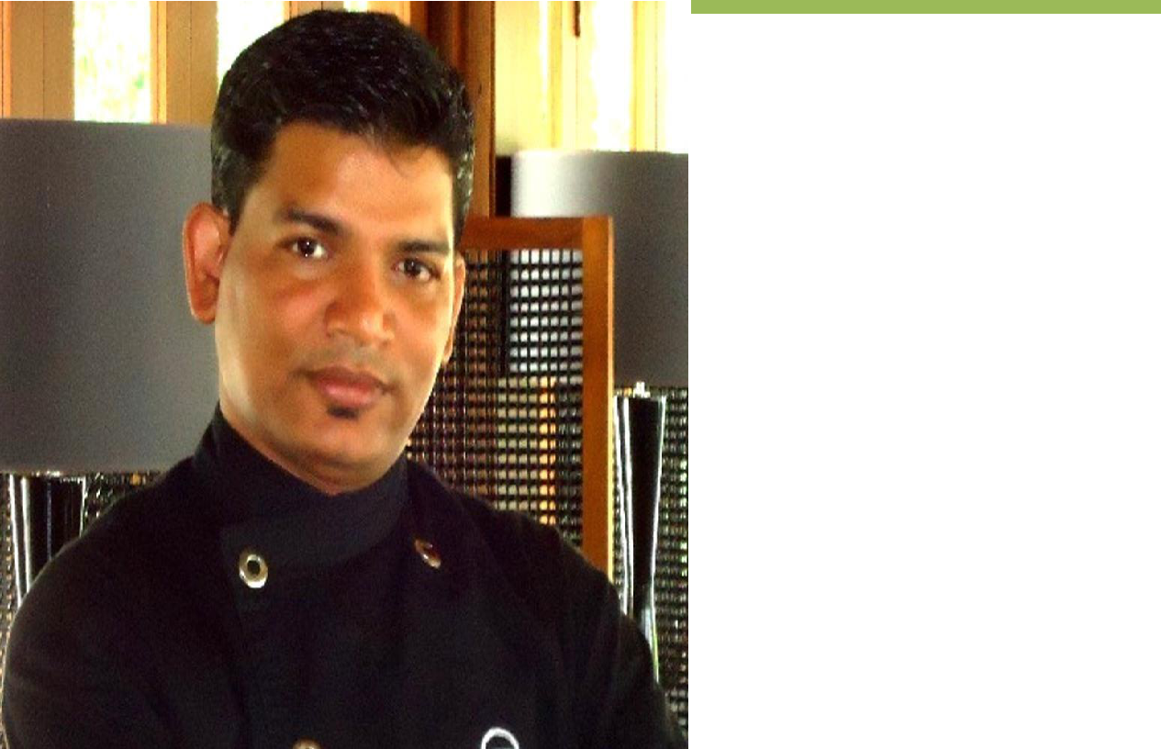

Sovan Chef

One man with a passion can do more than a hundred men with an interest

 | PERSONAL DETAILS
Name |  |  |  | Email
Sovan |  |  |  | Sovan-397685@gulfjobseeker.com
Qualification |  |  |  | HACCP Certification
MBA in Administration &Finance |  |  |  | USPH
Bachelor Degree |  |  |  | UK Public Health
Diploma in Hotel Management |  |  |  | SGS Singapore
Marital Status |  |  |  | Safe Serve USA
Married

Communication

English, Hindi, Bengali, Oriya, Nepalese & basic knowledge of French culinary term

CAREER IN NUTSHELL

Consultant Executive Chef, Maldives.
Since December 2019
Executive Chef, Palladium Luxury hotels & Resort, Spain.
Worked from June 2018 to November 2019
Executive Chef with Sandal Resorts and unit of Sandal Resort International, Jamaica, West Indies Since Nov’ 2014 to April 2018

Pre-Opening Executive Chef with Royalton White Sand Resort, a unit of Blue Diamond Hotels & Resorts, Canada May’ 2013 to Oct’2014

Pre-Opening Executive Chef with units of Carlson-Rezidor Hotels & resort Radisson Blue Hotels, Delhi, India March ’2011 to April’2013

Executive Sous Chef with Pre-Opening Alila Diwa Goa, Goa, India
July ’09 to Feb’2011
Pre-Opening Executive Sous Chef with Kandooma, A unit of HPL Hotels, Singapore

Feb ’07 to May’09

Sous Chef with Hotel Taj Fort Aguada, Goa, India
Oct ’05 to Dec’06

Jr. Sous Chef with Pre-Opening Queen Marry 2, Cunard Ocean Liners Southampton, United Kingdom Nov ’03 to Sep’05

Demi Chef De Parte with Bruj Al Arab World most Luxurious Hotel (Jhumerah International Hotels), Dubai Aug ’01 to Oct’03

OBJECTIVE TO MYPROFFSSION

Passion for food, innovation and eagerness to continuous learning with multinational Culinary Exposure allows me to be a Chef. Coordination, cooperation, planning and Execution helps me to be a perfect balanced Leader. Developing system, policy, procedure has given me sharpness on my Knife. Being calculative on Finance, Human psychology, and non-materialistic happiness has imparted me Extra edges on my Career Path.

MY FORTE

A gold and silver medal winning Executive Chef with two decades of successful experience. Highly adaptable and accomplished in all cuisine types. Possess proven versatility with experience in hotels and resorts, Adept at developing and working within budgets. Expert in productivity while controlling food, operational and overhead costs. Can flawlessly execute in the culinary arts, management, training, standardization, sales and marketing plans and customer relations.

Comprehensive understanding of the global culinary world, and of what drives sophisticated traditional to contemporary dining experience. As a ‘can do’ attitude person to hit the ground running and is confident that will be able to exceed any employers and guest expectations.

KEY ACCOMPLISHMENT

- Currently Venture with 1076 rooms all-inclusive project, 270 reporting staff, 17 f&b outlets, average no of guest 2200-2500

- In year 2000 have been part of Sheraton’s 1st Landmark project in India (Maratha Sheraton)

- Won One Silver medals & one Gold medal at Dubai world chef’s culinary guilt in year2001

- Have performed at worlds 7th best restaurant Al Muntaha at Burj Al Arab in year2001-2002

- Worked with world 9th best under water restaurant Al Mahara at Burj Al Arab in year2002-2003

- Ventured with one of the most world most Expensive luxury property from 2001-2003 with Burj al Arab,Dubai

- WorkedasPre-openingChefwith6international brand (Sheraton Mumbai, QM2UK, Holiday Inn Maldives ,Alila Goa, Radisson India, Royalton WSRW.I)

- Worked for largest Passenger cruise with 4500 passenger and 1500 crew. And largest restaurant 2400 coverone time sitting.

- Successfully launched Maldives 1st self-sustainable resort project (Kandooma by HPL Singapore) in year2007

- Successfully launched 1st Alila project in India in year 2009 which won 3 times Condo Nestle award & 9th best Honeymoon Resort in Asia.

KEY PERFORMANCE AREAS AS EXECUTIVE CHEF

Managerial
Plan and Budget the food costs for all the F & B outlets
Create a work environment that is high in employee morale and provides constant learning & development and use the feedback from Employee Satisfaction Survey to draw an action plan.

Develop systems and procedures that achieve higher cost efficiency and guest satisfaction.

Recruitment and Performance Appraisal/ Management of the staff in the department.
Develop & Implement the annual plan using Business Excellence Model framework, linking the department objectives to the units overall strategy.

Operational

Establish quality and quantity standards of food preparation & presentation.
Develop and Standardize new recipes in order to add variety to the F & B outlets.

Devise methods for optimal use of raw materials & fuel and maintain the budgeted food cost.
Ensure availability of stock and raw materials through proper planning and co-ordination with the Purchase department.
Monitor adherence to Safety, Hygiene and Cleanliness standards.

Work in association with the F & B Manager in the area of Promotions, Food Festivals, Menu planning & Pricing. Work closely with the Purchase Manager for developing Standard Purchase Specifications, Vendor Development & Evaluation etc.

Co-ordinate with the Chief Engineer for Preventive Maintenance, Procurement of new equipment, Energy consumption etc. Ensure through regular monitoring of guest feedback, prompt, efficient and accurate service to all guests along with the best quality products.

Staff and Schedule staff in order to optimize manpower.
Review the monthly business reports and develop a work plan. .
PREVIOUS ASSIGNMENTS

Executive Chef, 2nd Largest Resort of the company, Jamaica. W.I. Worked Since Nov 2014 to April 2018

The Property
1076 Rooms all-inclusive hotel Project

5-star classifications, Owned by Palladium Group, Spain.
17 Restaurant, 12 bar,4 Banqueting space
270 reporting staff including stewarding

Executive Chef, Flag Ship Property, Sandal Montego Bay, Jamaica. W.I.

Worked Since Nov 2014 to April 2018

The Property

315 Rooms all-inclusive hotel Project

5-star classifications, Owned by Sandal Resorts International, Jamaica, W.I
14 Restaurant, 8 bar, 2 Banqueting space
127 reporting staff including stewarding

Pre-Opening Executive Chef, Montego Bay, Jamaica. W.I. Worked Since May 2013 to October 2014
654 Rooms all-inclusive hotel Project

5-star classifications, Owned by Blue Diamond Hotels & Resorts, Canada.

12 Restaurant, 6 bar,2 Banqueting space, 9 wedding gazebos
182 reporting staff including stewarding

Executive Chef, Goa, India.

Worked with Carlson Hotels from March 2011 to April2013

The Property

132 contemporary Rooms with 5-star classifications

Managed by Carlson hotels & Resorts owned by Alcon victor groups 6 F&B outlets including 3 Banqueting halls with 6000 squire ft.

65 reporting staff including stewarding

Pre-Opening Executive Chef, Ludhiana, India.
The Property

83 contemporary Rooms with 5-star classifications

Managed by Carlson hotels & Resorts owned by Alcon victor groups 9 F&B outlets including 3 Banqueting halls with 22000 squire ft. 135 reporting staff including stewarding

Pre-Opening Executive Sous with Alila Diwa, Goa, India.
Engaged at Pre-Opening and currently contributing since July ’09 to Feb’2011

The Property

Owned & managed by Alila Group
of Hotels & Resorts Singapore

6 F&B outlets, 4 Banquet space, 3
bar, and 1 coffee shop

A 155-villa contemporary Resort with 5-star classification

Pre-Opening Executive Sous Chef with Kandooma Resort and Spa, HPL Hotels Unit, Maldives.

Feb ’07 to May ‘09

The Property

A 160 villa contemporary Resort with 4 star classification

Wholly owned & managed by HPL Group of Hotels & Resorts Singapore 6 F&B outlets including an upscale Specialty Restaurant

Sous Chef with Taj Fort Aguada, Goa,India
Since Oct ’05 to Dec ’06

The Property

A 145 room Hotel with 5 star classifications
5 F&B outlets
2 banquet halls with 160 seating capacity
11 Reporting staff

Jr. Sous Chef with Queen Mary 2, Cunard Ocean Liners, Southampton, UK

Since Nov’03-Sep’05

The Property

A 4500 passenger liner, 8 F&B outlets, 3 ball rooms with 2500 seating capacity, 6 Reporting staff

Demi Chef De Partie with Bruj Al Arab (A unit of Jhumerah International Hotels), Dubai Aug’01 till Oct’03

The Property

A 202 suite with 3 presidential suite room hotel with 5 star classifications 11 F&B outlets

3 Meeting Space
Only exclusive fine dines Restaurants

The Property

- 386-room hotel with 5-star classifications

8 F&B outlets

INITIAL ASSIGNMENTS AS COMMI DECUISINE

Commi de Cuisine with ITC Grand Maratha, Mumbai From Apr ’98 tillSep’01

Commi De Cuisine with Hotel Ramada, Hyderabad, India
The Property

A 142-room hotel with 5-star classification, 4 F & B outlets

Gold & Silver Medalist from Dubai Culinary Guilt Safe Serve Food Management, USA

Chef of the Year by JTB, WI Train the Trainer 1 &2, India

Fire Fighting & Evacuation
Personal Safety and Social Responsibilities, UK Personal Survival Technique Oracle, Office, Excel, PPT, Window.

ADDITIONAL ACHIVEMENTS, AWARDS & SKILLS

HACCP Certification by SGS Singapore Environment health and Safety, WI

Manage Mentor through SCU, Harvard University USA.
Crowd Management., UK

First Aider, India
Industry Familiarization (White Star Academy).

Knowledge of Micros (Opera) for 3yrs.

OSHA Certification from SCU, WI

