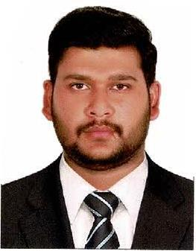
CURRICULUM VITAE

Name | : | Azhar
E-mail | : | Azhar-397702@gulfjobseeker.com

JOB APPLIED FOR (Light Vehicle Driver & Delivery Boy) Motor Cyclist)

CAREER OBJECTIVE:

Seeking a suitable position of a “(Light Vehicle Driver & Delivery Boy) Motor Cyclist)” where my past experience and knowledge would be fully utilized in a career opportunity and to reach great heights. As a self-motivated person, I do have intension to serve any esteemed organization with utmost sincerity that offers challenges to accomplish missions to achieve set goals with optimum perfections on the way to build up a career as a professional.

EDUCATIONAL QUALIFICATION

- Secondary School Certificate (Metric)

WORK EXPERIENCE

- Worked as a “Light Vehicle Driver” in “Abu Dhabi, UAE” for 2 years

- Currently Working as a “Delivery Boy” in “Abu Dhabi UAE” for past 2 years

DRIVING LICENSE INFORMATION
 |  |  | Issue date : | 20/09/2017
Issue place | : | Abu Dhabi | Expiry date : | 18/09/2024
Position | : | Light Vehicle, Motor Cycle

PERSONAL TRAITS:

Can work as a team

Responsible and self-motivated

Ability to work under minimum supervision pressure

PASSPORT DETAILS:

 |  |  | Date of issue | : | 27/02/2020
Place of issue | : | Pakistan | Date of expiry | : | 25/02/2025
Visa | : | Employment Visa
PERSONAL DETAILS:
Date of birth | : | 14/08/1995
Sex | : | Male
Marital Status | : | Married
Language | : | English, Arabic & Urdu
Nationality | : | Pakistan

DECLARATION:

I hereby certify that all the information’s given above are true and correct to the best of my knowledge and belief.

Azhar

