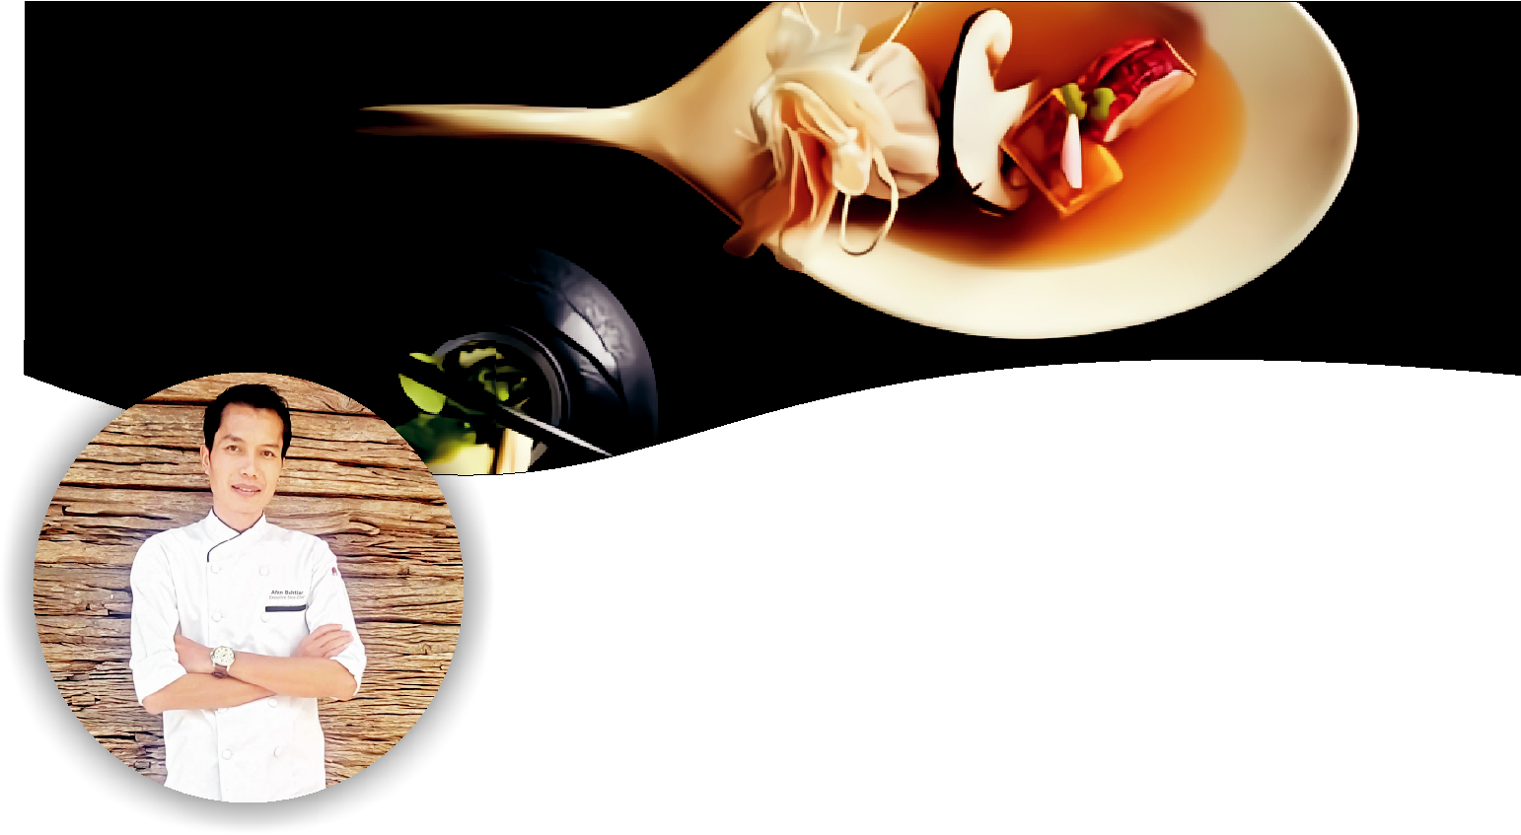

Afen

Objective

Managerial position with the opportunity to affords a greatest utilization of proven experience, skill and abilities to develop personal skill in giving the contribution to the productivity and profitable of the company.

PERSONAL DETAIL

Name : Afen

Sex : Male
Date of Birth : February 19th, 1982
Religion : Christian
Martial Status : Married
Nationality : Indonesia
Country : Indonesia

CONTACT INFORMATION

E-mail : afen-397708@gulfjobseeker.com

LANGUAGE SKILL

English : Fluent

Bahasa Indonesia : Fluent
Mandarin : Intermediate

COOKING SKILL

Classic traditional or Fusion Asian and Continental

EDUCATION

Year 2001 – 2004, Sekolah Tinggi Pariwisata Bandung, Diploma 3

of Tourism, majoring in Food Production Management.

TRAINING AND CERTIFICATION

- Safe Step Training from Ecolab Institution Singapore
- Hygiene & Sanitation Introduction Training
- Fast Track Food Safety For Food Handler
By The Educational Institute (American Hotel & Motel Association) Singapore
- Fire and Safety
- Leadership Training
- Profesion Competency by Indonesia Hotel and Restaurant Association.

BASIC COOKING QUALIFICATION

Salad & Dressing | ; | Advanced knowledge
 |  | and practice
Soup & Hot Sauce : |  | Advanced knowledge
 |  | and practice
MainCourse | : | Advanced knowledge
 |  | and practice
Garnishing & | : | Advanced knowledge
Decoration |  | and practice
Pastry Production | : | Advanced knowledge
 |  | and practice
Banqueting | : | Advanced knowledge
 |  | and practice
Butchery | : | Advanced knowledge

HOTEL and F&B MANAGEMENT

EXPERT ON: Menu planning, menu recipe, menu costing, market analysis, Menu engineering, controlling cost & expenses, budgeting, marketing plan, profit and revenue oriented, staffs management, purchasing, receiving, storing, Negotiation, administrative, training staffs, computer literature.

ACHIEVEMENTS

Dusitd2 Nairobi
pre-opening, bring new system for the F&B operational through improving new structure, new training, new products. Reduce costs and expenses with increasing maximal revenue and profit

Como Metropolitan Bangkok

creating unique thematic F&B concept to upgrade revenue and profit, and unforgettable experience for the guests.

cooperating with tour agents to Increase and generate F&B revenue, creating thematic buffet with authentic Italian theme, creating good chefs to growing their career.

Tunglok Group Singapore

Pre- opening 33 Modern Asian Restaurant outlet around Asia (Japan, China, Hongkong, Vietnam, Thailand, Malaysia, Singapore, Indonesia, India)

CAREER HISTORY ON 5 STARS

HOTELS AND RESORTS

October, 21 2015 – October, 22 2019 (4 years) in Kenya, East Africa

Executive Sous Chef

Assisting the Executive Chef for managing all the operational kitchen, Re-opening SOI restaurant to the new concept as Pan-Asian Restaurant.

Creating menu concept, market analysis, hiring, screening, and training new staffs member. Controlling and managing all food production operational, maintain constantly good team work, guests satisfaction, staffs satisfaction, management satisfaction.

controlling cost and budget for foods, labors, operational assets.
Driving operational to the companygoals.

September, 1st 2013 – September, 1st 2015 (2 years)

Como Metropolitan Bangkok Hotel and Resort (By Como Hotels & Resort), Thailand.

Executive Chef

Controlling and managing all food production operational, maintain constantly good team work, guests satisfaction, staffs satisfaction, management satisfaction, controlling cost and budget for foods, labors, operational assets. Driving operational to the company goals.

February, 5th 2011 – August, 5th 2013 (2 years 6 months).

Tunglok Group (Restaurant Management Chain), Singapore

Cluster Chef / Executive Chef Modern Asian Restaurant

- Work together with Food and Beverage Director to achieve F&B goals.
- Creating the unique concept, innovative, for restaurant business, Creating business plan and budgeting.
- Managing and organizing for opening all restaurant outlets in every region.
- Managing every single kitchen crew in every restaurant outlets.
- Responsible for all aspects financial and otherwise in relation of food cost, staff cost, chemical cost. profit and loss, etc., pertaining to the daily running of the kitchen
- Responsible for menu creation ,improvisation, development, Strict practice of HACC

January, 1st 2009 – January, 1st 2011 (2 years) Como Uma Paro (By Como Hotels & Resorts), Kingdom of Bhutan

Executive Sous Chef

- Handling the hiring and training of staff; bringing in of new taland diversity to improve team.

- Managing staff incentives and appraisals, Handling the staleave rosters and plans, Coordinating the kitchen on a daily basic.
- Responsible for all aspects financial and other wise in relationfood cost, staff cost, chemical cost, etc., pertaining to the drunning of the kitchen.

- Responsible for menu creation, Strict practice of HACCP progra? Attending internal and management office daily meetings.

- Responsible for stock control including stock take and stock reco? Managing banquet and catering.
- Weekly ordering and bulk purchasing of goods for the restauraand production of food.
- Organizing 30 chefs, 1 chief steward and 12 stewards

January, 11th 2006 – December, 11th 2008 (2 years)

BANYAN TREE BANGKOK RESORT, THAILAND
Sous Chef Main Kitchen

December, 10th 2004 – December, 10th 2006 (2years)

THE RITZ CARLTON HOTEL HONGKONG, HONGKONG
Chef De Partie Main Kitchen

SCHOLARSHIP & AWARD

2003 Scholarship Winner, award for academic excellence – Sekolah Tinggi Pariwisata Bandung

2004 Food Display Competition 2nd winner - Sekolah Tinggi Pariwisata Bandung

2006 1st winner Asia Pacific Cooking Competition Hong Kong,

2018 Indonesian Culinary and Culture Ambassador for
Indonesia Republic Embassy in East and South Africa

KEY RESPONSIBILITY

- Prepare culinary items to the highest standards of food production, quality, taste, presentation and hygiene within the hotel; maximizing Associate, Guest and Owner
satisfaction.

- With high integrity, ensure that guests experience the highest quality 5 stars culinary standards.

- Ensure that food quality and standards are maintained at all times when preparing for restaurant and banquet functions.

- Receive and examines food products and supplies to ensure quality and quantity meets hotels standards and requirements.

- As a true Service Associate, meet service expectations proactively, promptly, professionally, with genuine care to attention and detail.

- Consistently prepare culinary items accordin

to established recipes and demonstrat thorough knowledge of food preparation, presentation and service techniques.

- Maintain cleanliness of all kitchen and prep areas, strict adherence to In Good Hands HACCP programs and professional grooming / personal hygiene standards.

- Practice economy where food, paper supplies, electricity and water are concerned and maintain strict control on food portioning and wastage.

- Participate in departmental training initiatives and stay current on international food trends and industry practices.

- Ensures compliance to all hotel policies, standards and core practices. Maintains positive internal and external relationships.

- Professional friendly attitude towards guests and colleagues.

- Actively demonstrate teamwork, safe work practices, open communication, accuracy in transactions, respect, sincerity, helpfulness, courtesy and humility.

