NESAMANI
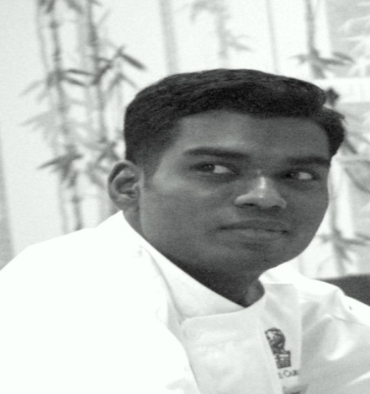
Email id : nesamani-397714@gulfjobseeker.com
CAREER OBJECTIVES
A motivated goal oriented natural team player ready to accept challenges willingly. Looking forward to work in a high profile organization and use my skills and capabilities to contribute to its profitability and growth.
EDUCATION
DHM&CT-Diploma In Hotel Management And Catering Technology.
At Annai fathima college of hotel management-(2004-2007)

PROFESSIONAL EXPERIENCE

CHEF DE CUISINE - September 2019 –Present

Reporting to Executive Sous Chef.

Manage kitchen shift operations and ensures compliance with all Food & Beverage policies, standards and procedures.

Estimates daily production needs on a weekly basis and communicates production needs to kitchen personnel daily.

Assist Executive Sous Chef with all kitchen operations and preparation.

Develops, designs, or creates new applications, ideas, relationships, systems, products, including artistic contributions.

Assists in determining how food should be presented and creates decorative food displays.

Maintaining purchasing, receiving and food storage standards.

Ensures compliance with food handling and sanitation standards.

Performs all duties of kitchen managers and employees as necessary.

Recognizes superior quality products, presentations and flavor.

PREVIOUS EXPERIENCE

Position held: Sous chef (Banquet-All day dining)
Company Name : The leela palace- Chennai
Duration : JUNE 2017– AUGUST 2019
Job description
Responsible for western hot and cold kitchen
• Provided guidance and support to all kitchen staff
• Responsible for special buffet live counter (Brunch-Street food night-Sea food night)
• Gave instructions to cooking workers on fine points of cooking
• Maintained hygiene standards of kitchen and equipment
• Directed and instructed kitchen personnel in their individual tasks
• Prepared individual orders when requested
• Ensured food preparation procedures for quality, uniformity and accurateness
• Reviewed delivered product and ensured appropriate storage

Position held: Sous chef (Ministry of food-All day dining)
Company Name : Hilton embassy golf links- Bangalore
Duration : April 2016 to May2017
Job description
Responsible for western hot Ala carte and buffet
• Ensure that customers are served well and effectively
• Help with the planning of menus and meals
• Maintain high food quality and presentation
• Supervise the preparation and service of food
• created specialized tasting menus for special events and wine dinner
• created Food promotion and special day menu

Position held: Junior Sous chef (Market-All day dining)–Pre opening team
Company Name : The Ritz Carlton - Bangalore
Duration : July - 2013 to April 2016
>$$#,'?'2'BC!'D$$!$,&!%
$!%7''$$7'$$ $!!)$7''!*$)$7$)!$7
$$72'$'!'!%!$!7,&
/00' )%$'!%9%$
Job description
Responsible for western ala carte and buffet
- Presented seasonal menu innovations with recipe and line
- Created weekly cyclic menu and tea menu
- Controlled: food cost, purchases, waste, BOH Scheduling and weekly inventory
- Managed, trained, hired, and developed BOH kitchen staff
- Executed seven menu items including soup, appetizer, bread, and four entrées
- Designed and implemented Sunday theme brunch
- Works well under high pressure situations
- Developed menu along with Executive Chef and chef de cuisine

Position held: Commis 1
Company Name : Madinat jumeirah
Duration : Jan 2012 to Jan 2013
Job description
- Worked in western hot(A’la carte) and associated myself with the continental section, Preparing complex soups, sauces, stakes,
- Maintaining and monitoring strict hygiene practices in the kitchen, following
HACCP regulations and monitoring activities.
Position held: Demi chef de partie–Pre opening team
Company Name : Hilton -Chennai
Duration : June-2010 to Dec 2011
Job description
- Worked in western hot(A’la carte) and associated myself with the continental section, Preparing complex soups, sauces, stakes,
- Maintaining and monitoring strict hygiene practices in the kitchen, following
HACCP regulations and monitoring activities.
Position held: Demi chef de partie
Company Name : Radisson by GRT GRAND -Chennai
Duration : May-2007 to august 2009
Job description
- Started career as Kitchen operation supervisory trainee and promoted as Demi chef de partie
- Worked in western hot kitchen buffet and ala carte
CERTIFICATE
- South Indian chefs association culinary compitition-2018 awarded Gold medal for buffet challenge
- South Indian chefs association culinary compitition-2018 awarded Gold medal for Three course dinner set menu
- Emirates Culinary Guild a Merit Award The Middle East Junior Chef of The year 2012 Dubai ( Practical Cookery-sustainable fish)
- Emirates Culinary Guild a Merit Award The Middle East Junior Chef of The year 2012 Dubai (Three course gourmet menu)
- Young chef culinary challenge -2013 Bangalore FINALIST award. (Three course gourmet meal)
- Worked with El bulli chef JORDI BERNUS for Wine dinner (Chaine committee, YPO,)
- HACCP TRAINING
AREA OF INTEREST;WESTERN (HOT &COLD)

DECLARATION
I hereby declare that the information furnished above is true and correct to the best of my knowledge and belief.
THANKING YOU
DATE; YOURS FAITHFULLY

(NESAMANI)

