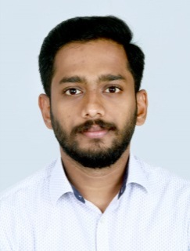
ARUN

Email: arun-397726@gulfjobseeker.com

HIGHLIGHTS
- Strong, creative problem solver who thinks abstractly andcritically.
- Strategic-minded with intense focus on customer needs and strong analytical, time and
project managementskills.
- Experienced in Building Design and operationaldepartment.
- Team player with excellent leadership, communication, and interpersonalskills.
- Passionate and hardworking with strong work ethic and ability to multi-task, prioritize andmanage.
- Efficiently completed B tech degree in CivilEngineering.
- Well versed with Auto cad, MS excel, MS word,PDF.

EXPERIENCE

ProjectEngineer November 2013 –January 2020
- Lead team in a fast-paced, high-intensity work environment where multitasking are essential forsuccess.
- Drawing study and Planning of Execution in various projects.
- Executing effective estimation of Projects.
- Conducts regular Supervision in the construction and site measurements.
- Preparation and regular submission of Projects.
- In each project gives much importance to the quality of work.
- Executes Billing and issuing of payments.
- Conducts regular meetings weekly on safety awareness and safeoperations.
- Present analyses and recommendations to leadership team and departmentheads.

EDUCATION/QUALIFICATION

- Bachelor of Technology inCivilEngineeringGraduation Date: May 2013
Satya Sai Group of Institution, CSJM University, Kanpur.

- Master Diploma in Building Design(AutoCAD)

PERSONAL DETAILS

DateofBirth :13/08/1991
Gender :Male
Nationality :Indian
Languages Known : English, Hindi andMalayalam

DECLARATION

IherebyassurethatalltheinformationgivenaboveistruetomyknowledgeandIbeartheresponsibilityfor the correctness of the above mentionedparticulars.

AJMAN
Arun
TILL DATE

