CURRICULUM VITA
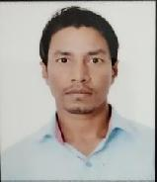

Amit

E-mail : amit-397743@gulfjobseeker.com

CAREER OBJECTIVE:-

Seeking for a challenging position as a Civil Engineer, where I can use my planning, designing and overseeing skills in construction and help grow the company to achieve its goal.

EXPERIENCE | :-Total experience is 2 years.
EMPLOYEEMENT HISTORY: |  | -
PROJECT | :- ENTRAL PARK, MOHALI SECTOR 67 C
CLIENT | :- UNITY GROUP AND HOMELAND HEIGHTS
DESIGANITION | :- SITE ENGINEER
PERIOD | :- 01/06/2018 TO TILL |  |  |  | CENTRAL PARK
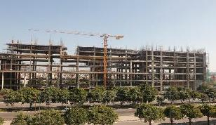

DUTIES AND RESPONSIBLITIES:-

- Site inspection for civil construction work and ensure that the work is as per the project specification and issued for construction drawing/final approved drawing from authorities.

- Proper management of materials and workmanship.

- Ensure that all the works meets the stipulated quality standards.
- Coordinate with sub-contractors for smooth flow of work.

EDUCATIONAL QUALIFICATION :-

- B.TECH (Civil Engineer) :-2014-2018

I have done my B.TECH to SHAHEED UDHAM SINGH ENGINEERING COLLEGE TANGORI, MOHALI, (PTU JALANDAR) , And I got it 69.15% Percent.

- INTERMEDIATE :-

I have done intermediate to BSEB , PATNA.I got it 69.8% percent in Science stream.

- MATRICULATION :-

I have done my Matriculation to BSEB, PATNA. And I got it 79.8% percent.

TECHNICAL SKILL :-

- QUANTITY SURVEYING

- BAR BENDING SCHEDULE

- THEODOLITE AND AUTO LEVEL SURVEYING

- AUTO CADD

- M.S-OFFICE

- STUDY ARCHITECTURE AND STRUCTURAL DRAWING

STRENGTHS:-

- Smart work .

- self-confidence.

- positive attitude and

- Adaptable to new Environment.

HOBBIES:-

- Playing cricket.

- Chess.

- Reading book and

- Net searching

PERSONAL DETAIL

Date of Birth Gendar Marital Status Language

:- 02/12/1995

:- Male

:- Unmarried

:- Hindi , English and Punjabi

DECLARATION:-

I hereby declare that above furnished particulars are true to the best of my knowledge and belief.

Date:-

Place:-

Amit

