CURRICULAM VITAE
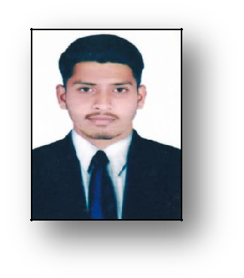

FAIZAL

E-MAIL: faizal-397753@gulfjobseeker.com

CAREER OBJECTIVE:-

To secure a Job in a reputed Organization where I can utilize my experience, Skills and Hard ware towards Organization Development and Further Improving my Skills and Knowledge.

EDUCATION QUALIFICATION:-

S.S.C from State Board of Secondary Education, Karimnagar, Telangana India (2009 2010) - 53%.

Intermediate (C.E.C) From Board of Intermediate Education, Karimnagar, Telanaga India. (2010 2012) - 57.7%

B.COM (C.A) From Sathavana University with "1st DIVISION" In Korutla Karimnagar, India. (2013 2016) - 67.7%.

TECHNICAL QUALIFICATION:-

"Post Graduate Diploma in Computer Applications" From (Nipro Computer) Koratla, Karimnagar, India.
NEBOSH Award in Health and Safety at Work – (HSW).

Kingdom of Saudi Arabia - Driving License.

WORK EXPERIENCE:-

Worked as a "System Operator" For 2 Years in Nipro Computer Education,

Korutla Karimnagar, India.

Worked as a "Customer Relation Officer" for 1 Year One Month in Hinduja Global Solution, musheerabad, Hyderabad. In (KSA Zain Telecom Process).

Worked as an "Shift Manager” in Burger King, From Oct 10th 2016 To Oct 20th 2018 in Riyadh - KSA.

Working as a “Client Service Clerk” or Customer Coordinator From Feb 27th 2019 To Till date In Karama, Dubai - UAE.

STRENGTHS:-

Progressive four years of professional experience in handling billing

Explorer Excellent customer service and communication skills Attention to detail with

Disciplined, self-motivated and optimistic.

The ability to work hard, creative, co-operative and to complete the tasks to the best satisfaction.

Loyalty to the profession and organization that I serve.

Ability to communicate well with the customer to make them satisfied.

PERSONAL PROFILE:-

Date of Birth | : | 11.05.1995
GENDER | : | MALE
Martial status | : | UN MARRIED
Nationality | : | INDIAN
Languages Known | : | English, Arabic, Hindi, Telugu and Urdu.
DECLARATION:-

I do hereby declare that all the information given above by me is true to the best of my knowledge.

Place : - Koratla.

DATE :-

(FAIZAL).

