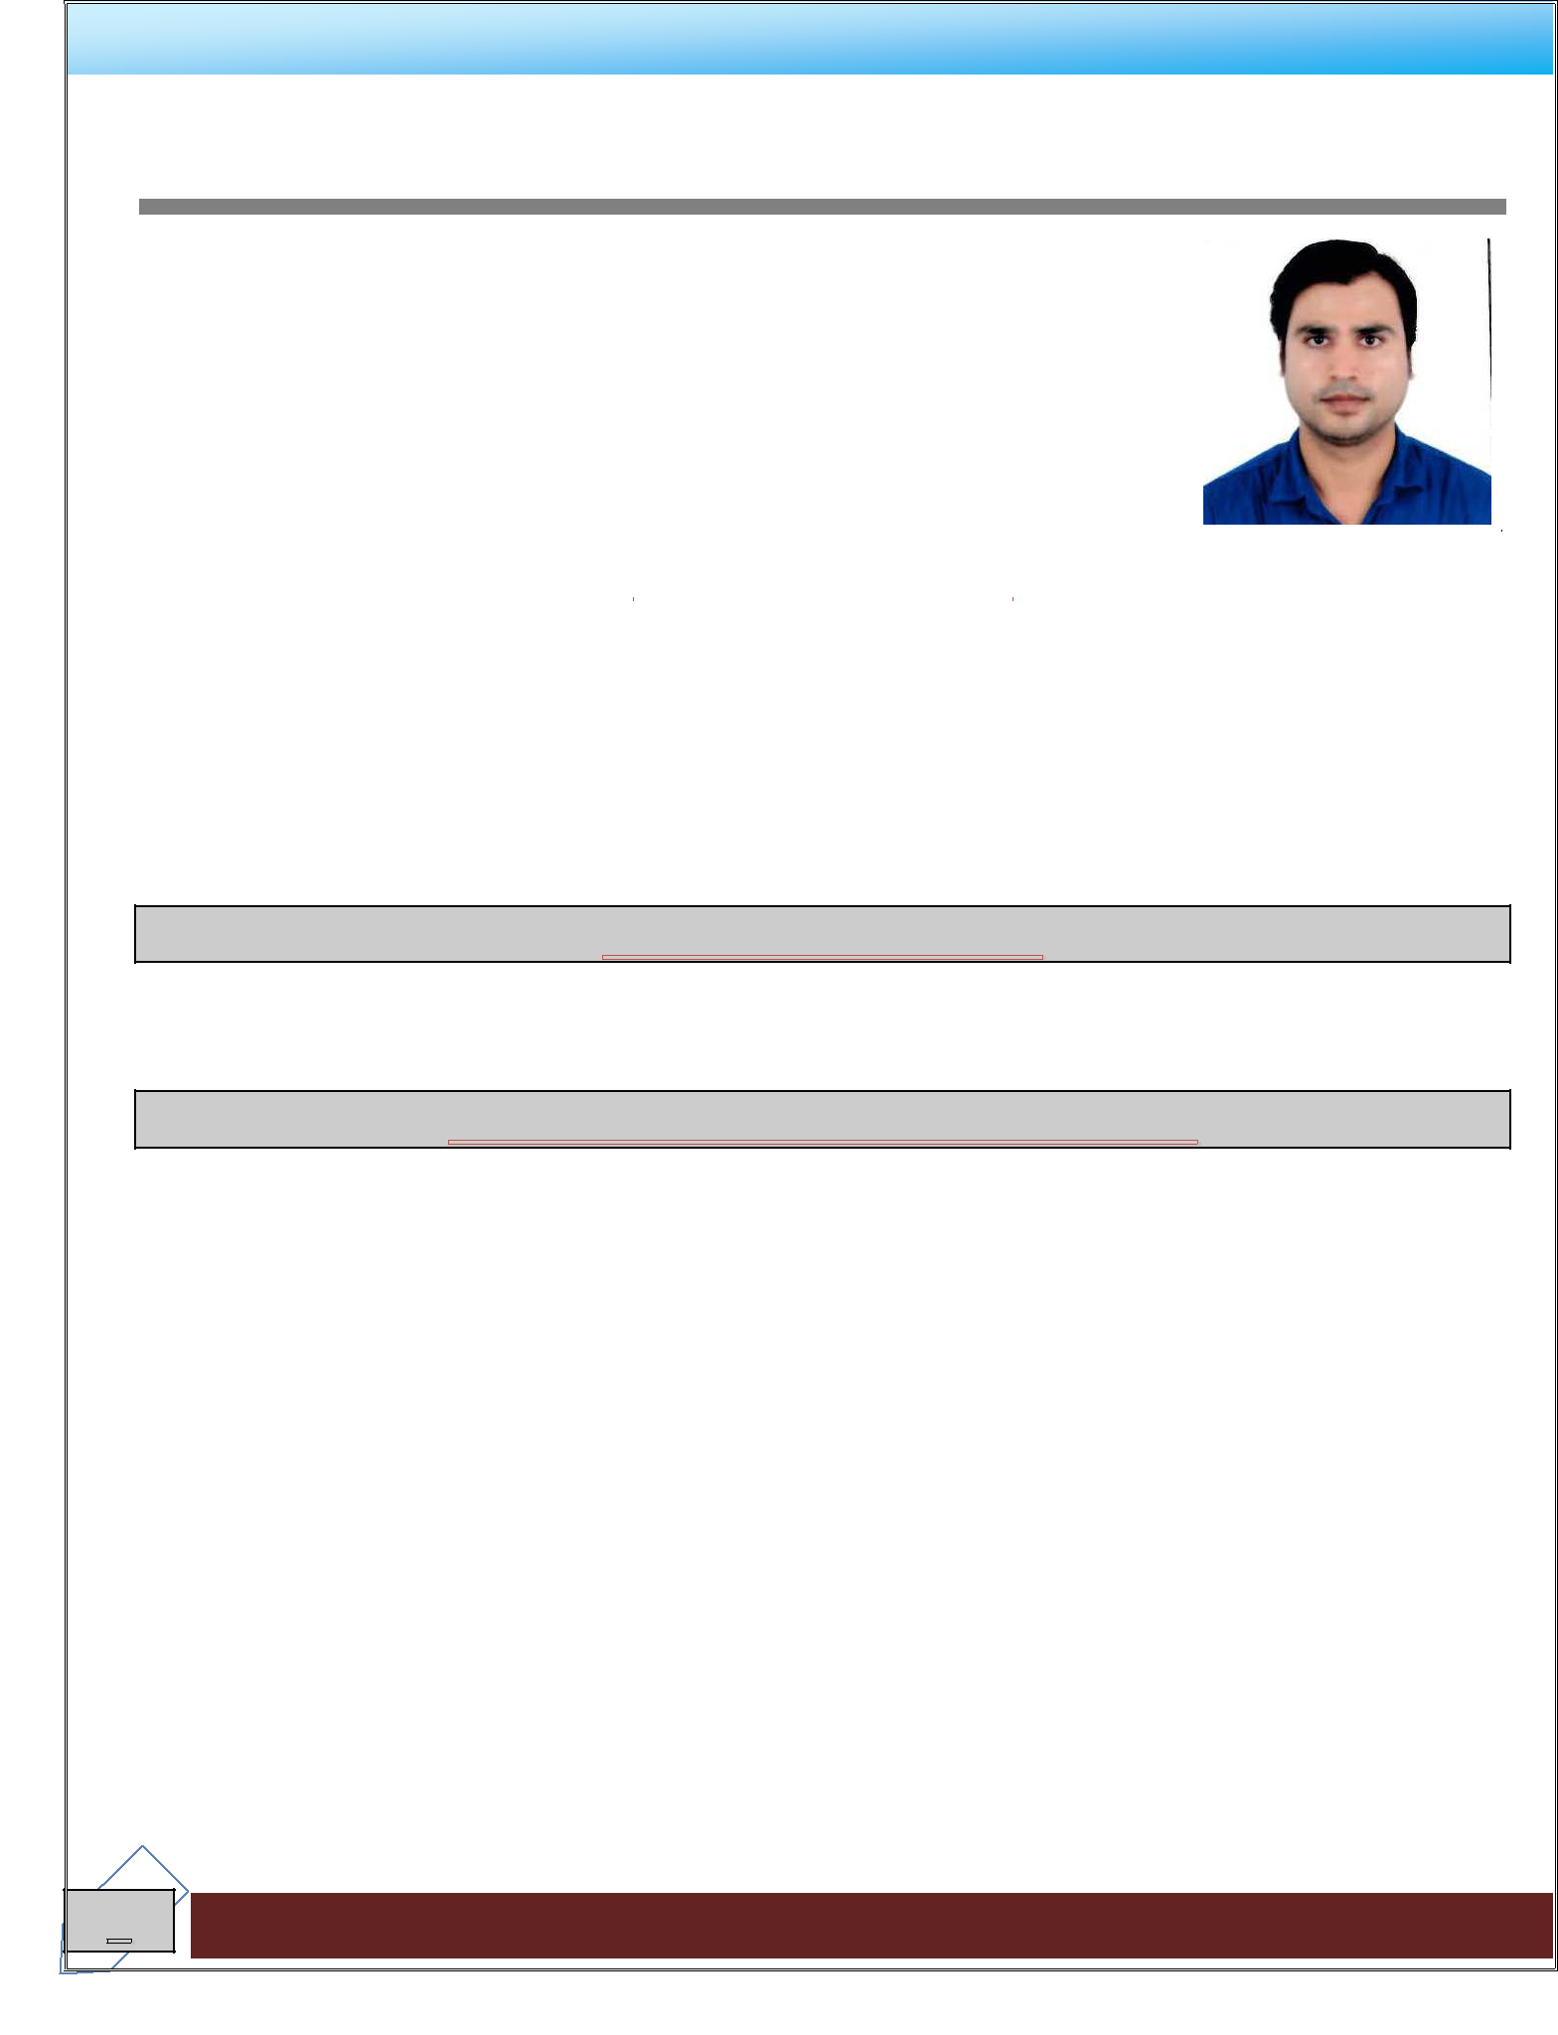
CURRICULUM VITAE

DHARMENDRA

Visa Type | : | Employment
Experience in Account | : | 10 Years
E-mail | : | Dharmendra-397761@glfjobseeker.com
 |  |  | CAREER OBJECTIVE

In Intend to build a career with professionally qualified team and corporate environment with committed and dedicated people that will help me to explore myself fully and realize my potential. By my hard work, sincerity, professional qualification and positive attitude, will contribute very best to the progress of our esteemed organization.

DOMAINS OF INTEREST

- Admin/Facility Management

PROFESSIONAL EXPERIENCE (10 YEARS)

- in Sharjah, UAE Work period: March 24, 2014 till.

- M/S SHOXING BHOOMI IMPORT & EXPORT CO. LTD, Keqiao, China Work period: May 12, 2013 to Feb 7, 2014.

- SQUARE GEMS GENERAL TRADING LLC Dubai, UAE Work period: Feb 15, 2012 to March 25, 2013

- QUALITY COMPUTER’S LLC Sharjah, UAE Work period: Nov 19, 2009 to Jan 11 2012

1

IT SKILLS |  | PERSONAL SKILLS
Windows Platform: | Windows 7, Windows 8, Windows 10. |  | Diligent
 |  |  | Flexible
Application | Tally, Pay soft, Fact, Busy, MS Office |  | Personality
Software: | (Word, Excel, PowerPoint) |  | Be convincing
 |  |  | Management
Expertise | V-Lookup, power Pivot, Pivot, Basic |  | Skills
 | Formulas, Dashboard |  | Conflict
CRM Software: |  |  | Resolution
 | EPICOR |  | Problem Solving
Document |  |  | Skills
Management: | KPI/MMR/QBR, EHS Report, Incident |  | Taking
 | Tracker, Team attendance, Logical |  | Responsibility
 | access report, Invoice tracker |  | Clarity and
 |  |  | Concision
Work environment: Quality computer retail shop company of sales tonner, laptop, computer all computer accessories and providing services.

Job Responsibility:-

a. Account Receivable- Make Invoice and Delivery Note as per the corresponding purchase order. Payment follows up.

- Account Payables- Balance account payable to the general ledger daily. Ensure all billing is accurate and complete.

- Prepare Review, Posting, Checking and scrutinizing cash / credit invoices. And creating Accounts-overall monitoring and controlling of accounts.

- Making purchase order for materials and Handling stock-stock control.
- Maintain Cash book and handling petty cash and daily cash closing.
- Prepare monthly Bank Reconciliation statement & CHQs printing and verifying daily receipts & payments and Bank deposits.

- Handling payroll-WPS – Bank transfer.
- Prepare financial statement-Trial Balance, P&L, Balance Sheet and closing reports, passing closing entries and analysis of financial statement.

- Reporting to Auditor.

- SQUARE GEMS GENERAL TRADING LLC Dubai, UAE

Work period: Feb 15, 2012 to March 25, 2013.

2

Work Environment: Square Gems General work Gem, Diamond & Gold retail office

Job Responsibility:-

a. Accounts Receivables-Balance receivables statement send to General Manager and reconcile the debtors account every month. Payments follow up is the part of my duty.
- Accounts Payables- Balance account payable to the general ledger daily. Ensure all billing is accurate and complete.

- Crating Accounts-overall monitoring and controlling of accounts.
- Making purchase order for materials and per the BOQ in the LPO received. Handling stock-stock control .

- Maintain Cash book and handling petty cash and daily cash closing.
- Prepare monthly Bank Reconciliation statement & CHQs printing and verifying daily receipts & payments and Bank deposits.

- Prepare financial statement-Trial Balance, P&L, Balance Sheet and closing reports, passing closing entries and analysis of financial statement.

- Reporting to Auditor.

Accounting Software: - Gold & Gems

2. M/S SHOXING BHOOMI IMPORT & EXPORT CO. LTD, Keqiao, China

Work period: May 12, 2013 to Feb 7, 2014.

Work Environment: M/S SHOXING BHOOMI IMPORT & EXPORT CO. LTD of Textile & food item export & Import Company.

Job Responsibility:-
a. Accounts Receivables-Balance receivables statement send to General Manager and reconcile the debtors account every month. Payments follow up is the part of my duty.
b. Accounts Payables- Balance account payable to the general ledger daily. Ensure all billing is accurate and complete.

- Crating Accounts-overall monitoring and controlling of accounts.
- Making purchase order for materials and per the BOQ in the LPO received. Handling stock-stock control.

- Maintain Cash book and handling petty cash and daily cash closing.
- Prepare monthly Bank Reconciliation statement & CHQs printing and verifying daily receipts & payments and Bank deposits.

3

g. Prepare financial statement-Trial Balance, P&L, Balance Sheet and closing reports, passing closing entries and analysis of financial statement.
- Reporting to Auditor

Accounting Software: Tally ERP9.

3. INTEGRATED SUBSEA ENGINEERING & SERVICES LLC Sharjah, UAE

Work period: March 24, 2014 till.

Work Environment: INTEGRATED SUBSEA ENGINEERING & SERVICES LLC of marine diving services company.

Job Responsibility:-
FINANCIAL ACCOUNTING

- General Ledger
- Receivables and payables
- Final Accounts
- Bank Reconciliation
- Cash & Bank Book
- Supports Multi Companies, Department, Cost Centre, Warehouse, Salesman
- Multi-Currency
- Post Dated Cheque Handling

- Report Writer

Job Responsibilities

- Received and recorded invoices and arranged payment
- Daily site issue register maintains.
- Co-ordinate to the planning department
- Daily stock ledger maintains
- Sales & Purchase Orders
- Pending Orders
- Pending Deliveries
- Verify day end reports with records of vouchers
- Assist in preparing periodic trial balance & profit & loss a/c
- Established and maintained close relationship with bank authorities and auditors, ensuring
- Compliance with all regulatory bodies & Bank Reconciliation
- Maintain proper control over checkout & cash area of operation

4

- Verified daily records of the cashier

PERSONAL SKILLS

- Well- Versed in Tally ERP9,Busy, Fact, Quick Book & MS Office
- Can work under pressure & meet deadlines
- Can speak English & Hindi
- Highly dependable & can prioritize and organize tasks

ACADEMIC PROFILE:

- B.Com from Rajasthan University, Jaipur (Rajasthan)

- Bachelor Degree in The Institute of Computer Accountants ISO9001:2008 Institute(ICA)

COMPUTER SKILLS:

 |  | : | ERP9, Q-Soft, Pay-Soft, Fact, Busy, Quick book
Accounting Software
Office Application |  | : | MS Office 2003, 2010
Others |  | : | Internet Application & E-mail, Outlook

PERSONAL PROFILE:
Nationality | : | Indian
Date of Birth | : | 02-Sep-1986
Marital Status | : | Married
Language Proficiency : |  | English (Fluent)
 |  | Hindi (Native)
Current Salary | : | 7,000.00
Accepted Salary | : | 8,500.00

Place: Sharjah

DHARMENDRA

5

