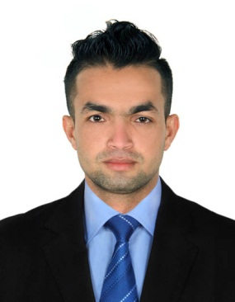
RABIN
E-MAIL ADDRESS: rabin-397765@gulfjobseeker.com

Professional&Educational Qualification

- S.L.C. Nepal (2010
- 12th (higher secondary), HSEB, Nepal (2012)
- B.B.S Management.

Trainings

- Basic computer & accounting training (included MS Office & Tally), We Can institute, Kathmandu, Nepal
- Managing customer service, Uttam Enterprises, Kathmandu Nepal
- Elementary First Aid training, Imperial Marine & Educational Service, Maritime Training Centre, India
- Fire Prevention & Fire Fighting training, Imperial Marine & Educational Service, Maritime Training Centre, India
- Security training for seafarers with designated security duties training, Imperial Marine & Educational Service, Maritime Training Centre, India
- Personal safety & social responsibility training, Imperial Marine & Educational Service, Maritime Training Centre, India
- Personal Survival Techniques training, Imperial Marine & Educational Service, Maritime Training Centre, India

Work experience 1

Worked as a Storekeeper (September 2017 - November 2017) in BeitSetti Restaurant& Hotel, Sharjah, U.A.E.
Responsibilities included:
- Maintain receipts, records, and withdrawals of the stockroom
- Receive, unload, and shelve supplies
- Perform other stock-related duties, including returning, packing, pricing, and labeling supplies
- Inspect deliveries for damage or discrepancies; report those to accounting for reimbursements and record keeping
- Rotate stock and coordinate the disposal of surpluses
- Ensure adequate record keeping and manage all documentation to confirm proper stock levels and maintain inventory control
- Coordinate the handling of freight, the movement of equipment, and necessary minor repairs

Work Experience 2
Presently working as a Sales Person (17th July 2017 to till date.) in Sharjah, U.A.E.

Responsibilities included:
- Present, promote and sell products/services using solid arguments to existing and prospective customers
- Perform cost-benefit and needs analysis of existing/potential customers to meet their needs
- Establish, develop and maintain positive business and customer relationships
- Reach out to customer leads through cold calling
- Expedite the resolution of customer problems and complaints to maximize satisfaction

Work Experience 3
Worked as a sales/marketing Officer (November 2016 - July 2017) in UttamEnterprises , Kathmandu, Nepal

Responsibilities included:
- Marketing of goods
- Sales order Collection
- Delivery Co-ordination
- Payment Collection
- Handling customer complains

Work Experience -4

Worked as an storekeeper/assistant supervisor ( July 2012 - June 2016)JK Wire Harness Sdn. Bhd., JoohorBaru, Malaysia

Responsibilities included:
- Giving training to new employees
- Inventory management
- Production supervision
- Dispatching goods as per DO
- Production planning/assistance as per BOQ
- Stock Checking

Hobbies and Interests
- Playing chess, Football
- Reading Books
- Listening to Music

PERSONAL DETAILS
Current Address : Dubai, U.A.E
Marital Status : Single
Date of Birth : 05-03-1992
Nationality : Nepal
Gender : Male
Religion : Hindu
Language : English, Hindi, Nepali, Malau

Reference
- Available upon request

