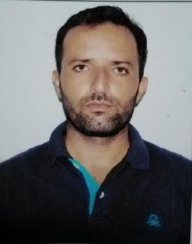

Dilbag

E-mail: dilbag-397766@gulfjobseeker.com

Position applied for -Forklift Operator

CAREER OBJECTIVE:

To gain a challenging position in a well reputed organization that will utilize my talents properly and provide me with the opportunity of enhancing my skill and professionalism.

PROFESSIONAL SKILS
- Motivated and enthusiastic about developing good relations with clients.

- Effective working as a cooperative team member.

- Professional in appearance and presentation. Well organized with excellent Communicatio skill..

WORK EXPERIENCE: Forklift Operator for

01st October 2009 to March2015 & August2017 to till date Working as a Forklift operator (up to16ton)

inADNOC Bab-13 Store Habshan(Supplied by sari general oil field service)

RESPONSIBILITIES:

Working for ADCO Warehouse Management department (Bab-13) as Forklift operator for Material Handling activities, during the period loading and offloading various materials in drilling yard , chemical and warehouse facilities..All given tasks successfully following HSE guidelines .

ACADMIC QUALIFICATIONS:

- Graduation (B.A) from IGNOU Delhi(India)

- 1 year I.T.I Diploma in Diesel Mechanic.

- International English Language Test System(IELTS) from British Council

DRIVING LICENSE:
UAE HEAVY EQUIPMENT OPERATOR &
LIGHT VEHICLE LICENSE.

Issuing Date-21-05-2009
Expiry Date -31-03-2024

COURSES ATTENDED
- Safe slinging.
- Basic H2S Course.
- Safe Equipment Operation Training
- Job Performer Certificate Training(JP)

LANGUAGES:
: English, Hindi & Basic knowledge of Arabic

PERSONAL DETAIL
DATE OF BIRTH |  |  |  | 5TH March, 1985
NATIONALITY |  |  |  | INDIAN
MARUTAL STATUS |  |  |  |  | MARRIED
RELIGION |  |  |  | SIKH
VISA STATUS |  |  |  | EMPLOYMENT
CURRENT LOCATION HABSHAN
PASSPORT DETAILS:
DATE OF ISSUE |  |  |  |  | 25Aug.2015
PLACE OF ISSUE |  |  |  |  | CHANDIGARH
DATE OF EXPIRY |  |  |  |  | 24Aug.2025
DECLERATION:

I hereby declare that the above information is true. I assure my complete dedication and hard work towards the work entrusted to me.

DILBAG

.

