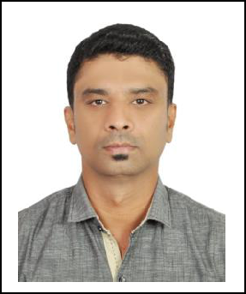
AJMAL
Deira, Dubai U.A.E.

Email: ajmal-397774@gulfjobseeker.com

Visa Status: Residence Visa

Driver’s License Details:
Expiry Date: Nov 22, 2025

Place of Issue: Dubai

CAREER OBJECTIVE

To work in an Organization wherein my knowledge together with my work experiences can contribute growth to the company and provide personal achievement at the same time.

PROFESSIONAL BACKGROUND

Dubai UAE
September 2007 - Till Date
Company Messenger

ELITE COURIER– Dubai UAE
April 2007 – August 2007

Company Messenger

SNAPPY ADVERTISING – Dubai UAE

May 2005 – April 2007
Company Messenger

CARE QUALIFICATIONS:

I have Dubai Valid Two Wheeler Driving License, and also I have good knowledge of street and landmark locations prominent buildings in UAE.

Duties and Responsibilities

- Authorized to send and receive money on Company Owner’s behalf
- Entrusted with any confidential Company documents, cheques & keys to collect/deliver.
- Perform company-related transactions which include but not limited to: exchange of currency, bank

transactions such as deposit & encashment of cheques, arrange payments for telephone, Salik & electric bills

- Deliver and collect documents from different companies related to projects o Responsible for obtaining names & signatures of the Documents Recipients o Take records of all the items being delivered and received

o Basic clerical tasks such as answering the phone calls, receiving incoming mails/letters, sending & receiving fax, policy documents binding and filing.

Key Skills

- Excellent time management
- Completing paper work when collecting and delivering packages.

- Driving safely and allowing for heavy traffic in rushing hours.

- Communicating any problems with management in a timely and professional manner. o Responsible for day to day maintenance of vehicle.

o Responding to customer requests in a polite and cheerful manner. o Knowledge in MS Office (Word and Excel), MS Windows

o Ability to learn assigned clerical & Messenger-related tasks, adhere to prescribed routines and easily understand and follow both Oral and Written instructions

o Trustworthy, Hardworking, Ability to work effectively under pressure
o Responsible, Independent & work without close supervision, always punctual

EDUCATIONAL BACKGROUND

- S.S.L.C. Passed in Boys Higher Secondary School in Tamil Nadu, India.

 I.T.I (Wiring) in TGM institution in Tamil Nadu, India.

PERSONAL INFORMATION

Birth Date | : June 08, 1984
Marital Status | : Married
Nationality | : Indian
Religion | : Muslim
Languages | : English, Malayalam, Hindi & Tamil
Known

REFERENCES

Available upon your request.

