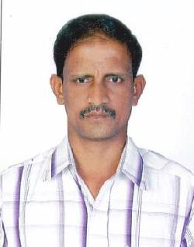

ABDUL

Dubai, UAE

E- mail – abdul-397784@gulfjobseeker.com

Objective : A responsible position in a progressive organization which could provide me with a challenging opportunity for organizational growth.

EDUCATION QUALIFICATIONS

Higher Secondary (passed) from Government of Tamilnadu

PERSON SPECIFICATION – (QUALIFICATIONS, SKILLS AND ATRRIBUTES REQYIRED TO FULFIL THE ROLE)

- Experience of Assisting Senior Management

- Excellent communication skills.

- Flexible in duty

- Timely Delivery

- Good Rapport with Insurance Company, Local Banks, Chamber of Commerce and Port/Customs

- Holding valid UAE two Wheeler Driving License

EMPLOYMENT HISTORY
Modern Computer Land, | Salesman, Delivery of Computer Spare | 1992 - 1994
Abu Dhabi, UAE | parts
Unikai, Dubai, UAE | Messenger cum Merchandiser | 2004 – 2006
Interlink Travels and | Messenger | 2006 – 2008

Tours, Dubai
Trade line LLc, Dubai | Messenger | 2008 – 2012
Bio line laboratory SKS | Blood Collection Report Delivery | 2012 – 2016
hospital, Salem – 16
 | Delivery Driver | 2016 to till date

Present position – messenger – finance division (reporting to head of the department)

Co – ordination for marine / Medical Insurance company

Co – ordination with Chamber of commerce personal for Chamber related jobs Co – ordination with port Customs

Collection and Delivery of Cheques / Documents

Co – ordination with all local bank in and around Dubai With drawl and Deposit of cash / Cheque

Personal details

 | Marital Status | : Married
 | Languages known | : English, Hindi, Tamil, Malayalam
 | Visa status | : On Employment (can be transferable)
 | Driving License Valid | : 04.09.2021
 | I hereby declare that all above information is true and correct to best of my

knowledge and I shall be grateful if you give me a chance to serve you.

Place : Dubai

Date :

-sd-

Abdul

