DARIA
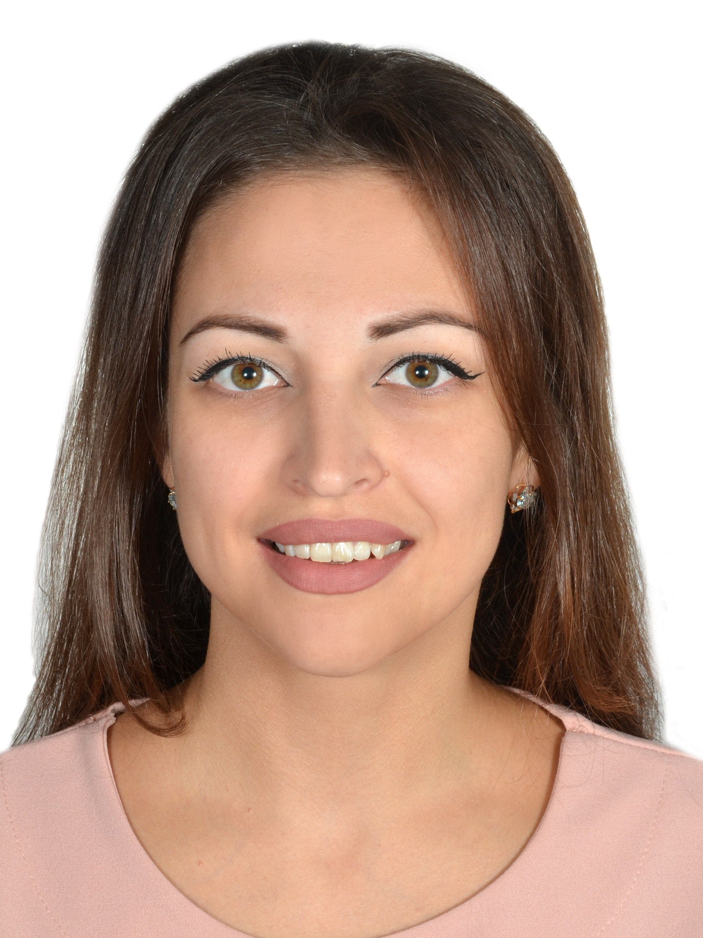
Email: daria-397805@gulfjobseeker.com
Nationality: Russian

__________________________________________________________

OBJECTIVE

To find a fulfilling position where I can apply my skills and knowledge

PROFESSIONAL SUMMARY

Experienced and highly motivated professional with varied work experience as an
• Customerserviceexecutiveof a outstandingclinicinDubai
- Administrator and receptionist of a well-known dental clinic in Moscow
- Customer service specialist and admin of two major Spanish visa application centers.
- Call center agent of a leading telecom company

SKILLS
- Multitasking various admin activities
- Team work and co-ordination between company employees
- Organizing day-to-day operations of the company efficiently
- Efficiently communicating and helping customers
- Microsoft Office (Powerpoint, Excel, Word)

EXPERIENCE

October 2019 – May 2020

Customer Service Executive - Dubai, UAE

Responsibilities:

• Meetingandgreetingpatientsandvisitorsoftheclinic

•Answering the phone calls , consulting patients regarding clinic’s services.

• Making appointments as per doctor’s schedule, maintenance of appointment system.

• Taking messages and making phone calls on behalf of the doctors.

• Electronic data entry of patient details.

• Preparing all documents of the patient for doctor’s consultation.

• Dealing with other departments of the company ( insurance department, diagnostic center)

•Working with medical insurance ,claim forms , preparing reimbursement forms.

• Taking payments by cash,credit cards and issuing invoices.

•Working successfully with doctors, staff of clinic, supporting colleagues.

• Deal with all type of patients in a calm and professional manner.

• Keep clean and presentable reception and waiting area.

February 2017 –May 2019

Customer Service Specialist & Admin |BLS International - Moscow, Russia

Responsibilities:

- Receiving and checking documents for VISA application
- Support customers for preparing VISA in line with the Spanish consulate requirements
- Processing VISA application
- Arranging company services for customers.
- Entering customer information on to a computer database.
- Handling external and internal communication
- Coordinating with the Spanish consulate for processing the VISA applications and
communicate on regular basis for any changes in VISA requirements or any new promotions

- Provide general consultancy to customers regarding travelling in Spain andtypes of
Spanish Visas
- Call the customers to inform them regarding missing documents or visa readiness
- Organizing, arranging and coordinating meetings
- Managing clerical and admin staff on their day to day activity

August 2014 – December 2016

Customer Service & Admin| Interstamp – Moscow, Russia

June 2013 – July 2014

Administrator & Receptionist | Djabanni Dental Clinic – Moscow, Russia

Responsibilities:

• Welcome and greetall patients as well as visitors of the clinic
- Reporting, data entry and keeping track of patients as well as visitors
- Answering phone calls and fix appointments or them based on schedule of the doctors
- Keeping reception are organized and presentable
- Registration of new patients
- Setting up meetings of the doctors
- Making visas and travel arrangements for the doctors
- Assist director and doctors of the clinic in various exhibitions and events
- Sorting and distributing incoming and outgoing post
January 2013 – June 2013

Call Center Agent | Megafon - Moscow, Russia

Responsibilities:

• Receiving and answering in-bound customer calls
- Obtaining and verifying customer information by answering phone calls
- Answering customer questions and providing solutions based on company rules and offerings
- Recommending company service package to suit customer’s requirement
- Maintaining professionalism while handling angry customers by showing empathy and
trying to resolve customer issues
- Booking service requests and selling company services by calling the customers
(Out-bound calls)

EDUCATION

2009 - 2014

North Caucasus Federal University | Stavropol, Russia
Master’s degree in theory of methodology of teaching foreign languages & cultures

LANGUAGES KNOWN

English
Russian
Spanish - Basic

ADDITIONAL INFORMATION

About me
Responsible, punctual and friendly person. Work efficiently with teams, oversee the operations within company, manage groups, coordinate with management and engage in planning according to the needs of the company. Highly motivated and interested to take initiatives to suggest and implement improvements in efficiently organizing company’s daily activities.

