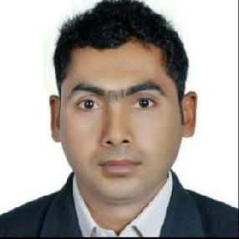
YADAGIRI

Dubai, UAE.

Email: yadagiri-397827@gulfjobseeker.com

Availability: Immediately

OBJECTIVE

Dedicated and dependable Bike and Car driver with more than 12 years’ experience and excellent record of customer satisfaction. Stickler for punctuality and safety. Established history of completing driving jobs through various kinds of territory at various lengths.

EDUCATIONAL QUALIFICATIONS

- SSC (10th) from Board of SSC Hyderabad

PROFESSIONAL EXPERIENCE

- Office Bike Rider and Car Driver for 4 Years Spusht Technologies LLC. (Aug 2008 – Sep 2012)

- Family driver for 4 years Invictus Brokerage LLC (Oct 2012 to Feb 2016)

- Working as Messenger cum Bike rider and Car driver at Al Madina Al Satea cleaning and

Technical services LLC. (Apr 2016 to Present)

SKILLS AND STRENGTH

- Passionate and Excellent knowledge about all UAE routs

- Good communication and Positive attitude

- Hardworking and Flexible

PERSONAL DETAILS

Gender | : | Male
Date of Birth | : | 28th June 1977
Nationality | : | Indian
Marital Status | : | Married
Visa Status | : | Employment (valid till 21st APR 2021)
Languages Known | : | English, Hindi and Telugu
Driving license | : | Bike and Light vehicle (Manual)

I am very much optimistic that if given an opportunity, I shall do everything possible to synergize my knowledge & strength and work with dedication for the Origination.

(YADAGIRI)

