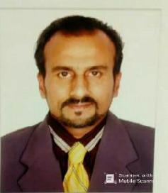

POST OF DRIVER

CONTACT INFORMTION

JAWAD
E-Mail: jawad-397828@gulfjobseeker.com
United Arab Emirates
Ajman

CAREER OBJECTIVE
Seeking opportunities in a globally competitive environment on challenging assignments that shall yield the benefits of job satisfaction and steady-paced professional growth.

PERSONAL INFORMATION

Nationality
Gender
Martial
Residence
Languge

Date of Birth

Pakistani
Male
Married
Pakistan

English, Urdu, Arabic

08_06_1978

visa Status

Employment

EDUCATION

Matriculation (Gujranwala Board Pakistan)

DRIVER FIELD EXPERIENCE

Total 10 Experience in Driving Uae 2 Years Experience with Family.
2 Year Experience In Delivery & 1 Year Experience in a TAXI (AJMAN)

License Details Light Vehicle (Manual)

Issue Date 24.01.2010

Expiry Date 22.02.2025

Page 1 of 1

