Curriculum Vitae
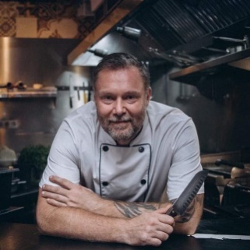
Mr. Ulrich
Email: ulrich-397833@gulfjobseeker.com

1988- 1992: Working at my mothers restaurant in Denmark
1998-1999: kitchen assistant at the concert and restaurant center in Aarhus- Denmark
2000 – 2004: Until 2002 I worked as an apprentice at the 5 * Radisson SAS Royal Hotel in Copenhagen, after that I change apprenticeship to Cafè Ketchup where I finished my chefs trainee education.
2004 – 2006: Greenland – Worked at Hotel Narsaq in south Greenland as a headchef in restaurant Clara.
2007 – 2008: That was my sabbatical away from the industry, and spend a year in Australia and Malaysia.
2008 – 2010: Norway – Was hired to a project in Bergen for the opening on Restaurant Banco Rotto and work there as a 1. Sous-chef at the same time. And in January I was headhunted to the Mexican restaurant “ El Toro” also located in Bergen and they had been without any kitchen and restaurant management for almost a year, when after a 6 months’ time and satisficed customers I left for another project in Las Americas at Tenerife.
2011: Tenerife – Arrived in Las Americas and Scandinavian restaurant with a bad reputation due to the chef at that time. We decided to close the place at turn it in to an Mexican / Mediterranean cuisine. So began on the business plan including great a new website/Facebook/ linkedin, business economic- staff training – supplier agreements ect.

2012: Malta – That was just planed as a little holiday break, but entered a sports pub in a small town called Hal Qormi, I quickly got to know the owner and before I knew it I had signed a contract for 8 months as a consultant/ executive chef In his business.
2013 – 2015: Greenland – Was after that contacted from Hotel qaqortoq ( south Greenland) to help them improve then standard in the restaurant and Cafè. I could not say no to that offer and during that 3 years at the hotel we improved the kitchen turnover by nearly 115% ( guests dining). And in 2014 we had the honor cooking for his royal highness Crown prince Frederik and princess Mary.
2015 -2016 Greenland – Worked as a teacher at the Food College Inuili in Narsaq ( south Greenland).
2017 – 2019 Freelance/ project chef in Malta- Cyprus- Barcelona
2019 (dec) – Headchef in Ireland

PERSONALE SKILLS:
- Skilled chef
- Experienced waiter
- Project oriented
- Business economics
- Microsoft Word – excel - powerpoint etc. devlopment
- Restaurant management (3-5 years )
- Sous/ - head chef ( 12years )
- Pre- opening restaurant as sulervisor.
- Website design
- Trainingtrainess / staff
- HACCP cetificate
- Danish Smiley system
- Banguets
- Pop-up concepts
- The Italien, American, French, Danish, German, Spanish, Mexican, English, Mediterranean, Asien, Nordich kitchen skilles.

DIPLOMAS:

- 2000-2004: diploma as a professional chef from Copenhagen Culinary College -hrs.dk
- 2013- 3td. place at the Greenlandic National Championships for skilled chefs
- 2014 – Kept the title.
- 2015- 4td. place at the Greenlandic National Championships for skilled chefs
- 2016- 3td. place at the Greenlandic National Championships for skilled chefs

