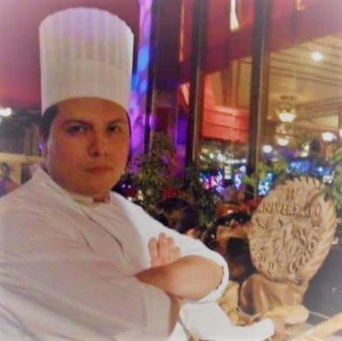 |  | Jose  Executive Sous Chef
Perfil  Profession: Food preparation and preservation technician  Birth Date: March 9, 1988  CORREO ELECTRÓNICO:  Jose-397838@gulfjobseeker.com  Aficiones  Self-learning through books and websites  Practice new cooking techniques and innovate within characteristics  Sport(Play Soccer and a Little Fitness)  English 50% |  | education  Instituto Mexicano de Gastronomía  [August 2005]–[September 2007]  work Experience  Sous Chef  October2019- ¿?  ●Supervision of restaurant openings.  ● Preparation of Menus by the Executive Chef.  ● Responsible for inventories of all consumption centers.  ● Supervision of the dishes with the Chefs of Specialties’.  ● Changes to the presentation of a la carte restaurants.  ● Personnel management and care of the work climate.  Yacht "Maje" Balearics Islands, SpainExecutive Chef  May 2019 - August 2019  Elaboration of Menus for the owners and crew of the boat.  ●Shopping according to the menus of each day.  ● Organization of the kitchen and Refrigerators of the same Yacht.  ● Following the standards of cleanliness that I have worked for years  Hyatt Ziva Los Cabos-Specialties Chef  August 2017-March 2019  ●In charge of the Bon Vivant Restaurant (French Cuisine)  ● Supervision of preparations and elaborations of the Restaurant.  ● Supervision of the Service of the same.  ● Kitchen cleaning supervision.  ● Working with Distinctive H and Cristal.  ● Design of presentation of dishes and their costing.  ● Personnel management complying with all company standards.  ● Training and preparation of recipes with the staff in charge.  Hotel Secrets Huatulco-Chef de Especialidades  January 2016- July 2017  ●In charge of the Restaurant "Bordeaux" (French Cuisine)  ● Supervision of preparations and elaborations of the Restaurant.  ● Supervision of the Service of the same.  ● Support in local events such as the Wine Festival.  ● Support covering shifts in the different Restaurants of the Hotel Secrets.  ● Kitchen cleaning supervision.  ● Working with Distinctive H and Cristal.  Plaza Reforma Hotel Gallery (Las Brisas)Chef de Cuisine  June 2015- January 2016  ●In charge of the afternoon shift, in charge of lunches and dinners, groups.  ●Preparation of menu and buffet for events within the restaurant "Plaza".  ● Supervision and production preparation such for à la carte service and dinner buffets.  ● Cleaning supervision of refrigerators and refrigeration chambers.  ● Working with Distinctive "H"  Brasserie Lipp inside the Marriott Polanco HotelChef de Partie  March 2015-June 2015  ●In charge of the cold line.  ● Preparation of dressings and production of the line.  Restaurant.  Grand Recidences Riviera Cancun by Royal Resorts Chef de Cuisine  February 2014- February 2015  - In charge of the line at lunch  - In charge of the dinner service.  - Preparation and supervision of production such as sauces, dressings, soups and garnishes.  - Support in the preparation of dishes for the restaurant El Faro in its theme nights.(Italian, Mexican, Sea food)  - WorkingwithDistinctive "H"  Au Pied de Cochón Chef de Partie  January 2010-January2014  - In charge of online meat and fish service.  - Support in social and commercial events within the restaurant.  - Preparation and supervision of production for the service.  - WorkingwithDistinctive "H"  Smokey Joe’s Bar Restaurant Cook / Grill  July 2009-December 2009  - In charge of the restaurant's barbecue service, preparation of the menu and weekly suggestion  Chapultepec Golf ClubCook  July 2008- October 2008  ●Preparation of garnishesforbanquets  ● Preparation and preparation of food for Saturday and Sunday buffets (salad bars, cold meats, cheeses)  ● Order refrigeration and freezing chambers with the PEPS system working with the DISTINCTIVE "H  Hotel Camino Real Kitchen assistant / Cook  January 2008-June 2008  ●Working on the restaurant production line  ●Production the other day, such as sauces, dressings, etc.  ● Participation in banquets  Real de Catorce Restaurant and Social Events Cook  May 2007-November 2007  ●Support in social events.  ● Preparation of sauces and dressings for the service and social events.  Mc Donalds México, S.A. de C.V. Employing  September 2006- December 2006  - Development of store sales products  - Helping in store cleaning  - Training: "Mexican Institute of Gastronomy"  - Food preparation and preservation technician

