SEEKING A PRODIGIOUS PLATFORM TO GAIN WORK EXPERIENCE IN THE CORPORATE WORLD AND GRASP ANY SORT OF SKILL THAT PROVE VALUE TO THE COMPANY. PRONE TO EXTEND SOME OF MY TRAITS THAT I HAVE DEVELOPED OVER THE YEARS IN THE FIELD OF SALES & MARKETING.

PERSONAL DETAILS

DOB- 12/10/1996

Place of birth- Dubai, UAE.

CONTACT

Email: ganesh-397839@gulfjobseeker.com

HOBBIES

- Debating

- Public speaking -Globetrotting

SKILLS

-Communication and networking -Basic office applications -Leadership traits
-ANSYS and CAD plotting ability

OTHER DETAILS

VISA status- ACTIVE employment visa

UAE driving license- In Process Availability to join – Immediately

GANESH

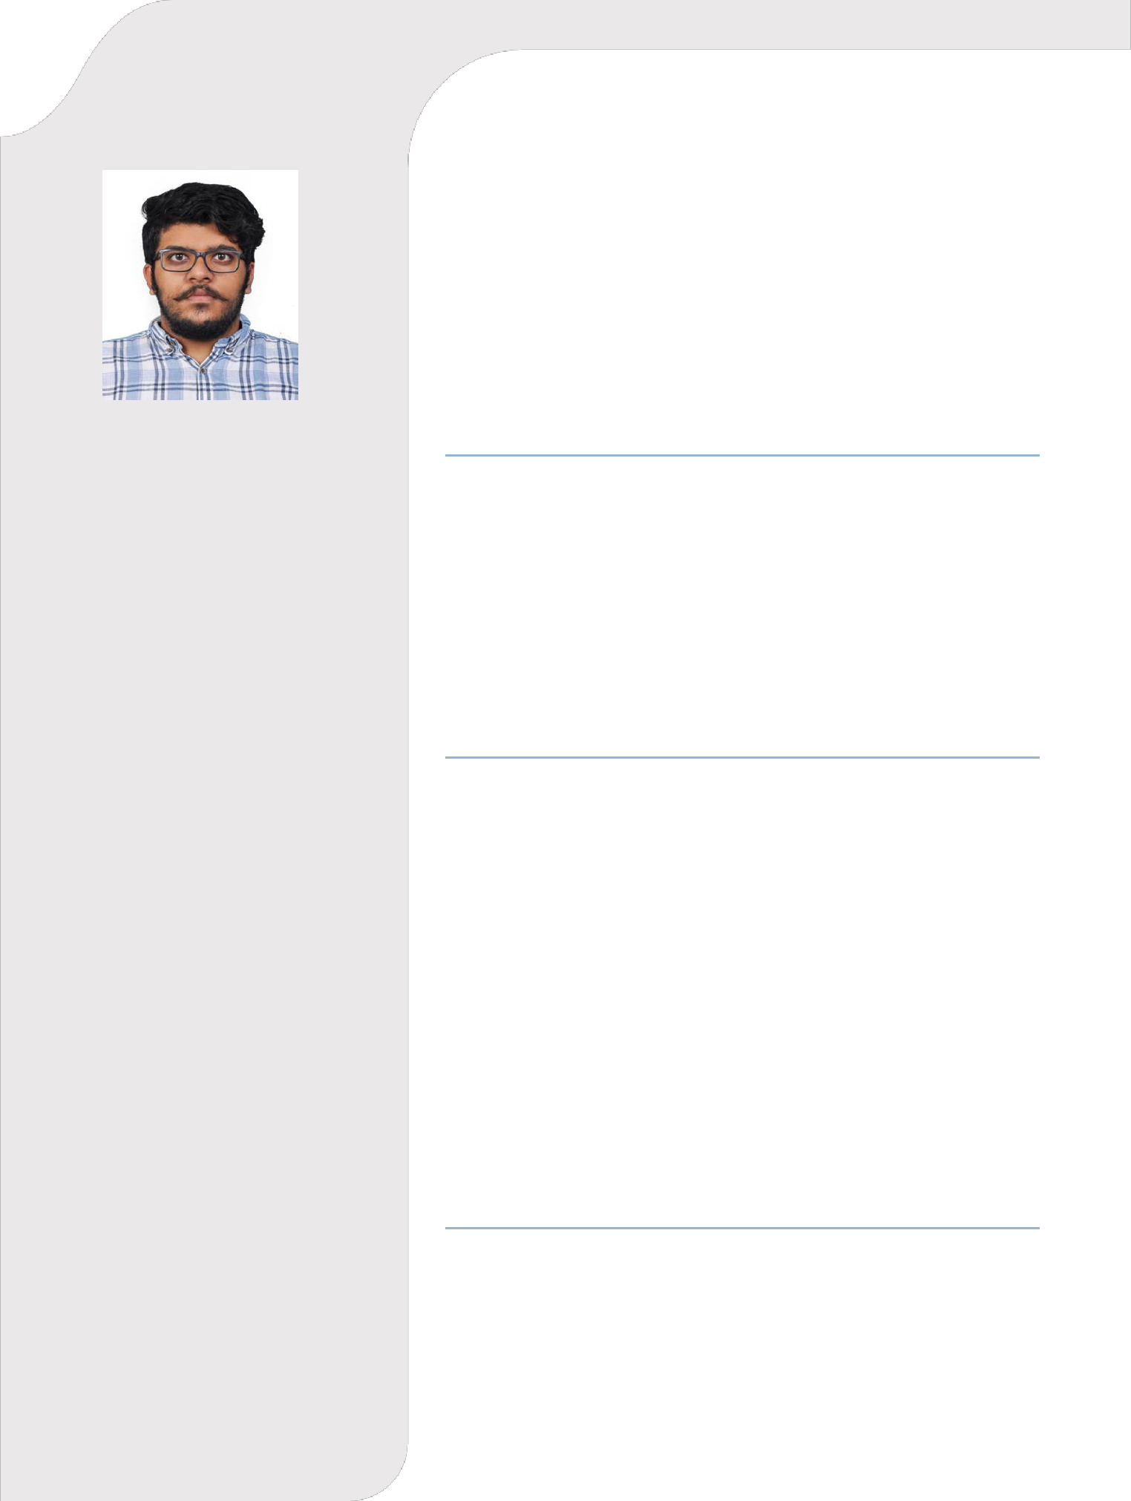

EDUCATION

High Schooling at MGM Central Public School (CBSE), Trivandrum, India

  - Elected house captain (2012) and elected vice-head boy (2014)
  - Several accomplishments in cultural activities such as debate, advertisement making etc.

- Tech in Mechanical Engineering at Mar Baselios College of Engineering and Technology, Trivandrum (2015- 2019)

  - Runners up of Kerala start-up yatra and start-up India (2018)

  - Executive member of ASME and coordinated state level fest Crossroads.

WORK EXPERIENCE

Dubai, UAE (Mechanical Engineer)
(22nd January 2020- present)

Quantity estimation and administration. Trained under senior engineers to analyze plans and design fire safety equipment's.
-BYJU’S Think & Learn Pvt. Ltd (Business Development Associate),
Kochi, India
(15th July 2019- 21st November 2019)

Team leader of the sales division in-order to generate revenue for the company.
-Larsen & Toubro, Mysore, India (Intern)
(June 2018– July 2018)

Trained under an experienced team regarding business communication, six sigma, lean manufacturing, pneumatic circuits etc.
-Yamaha Motors I.T.I, Trivandrum, India (Intern)
(25th June 2016- 5th July 2016)

Training was done under experienced engineers regarding service mechanisms of automobiles.

PROJECT AND ACHIEVEMENTS

Developed a hybrid fuel consisting of plant-based components that has similar properties to that of diesel fuel.

-Approved by College authorities and CSIR, Trivandrum -Awarded best Idea by Start -Up India 2018

