CURRICULUM VITAE 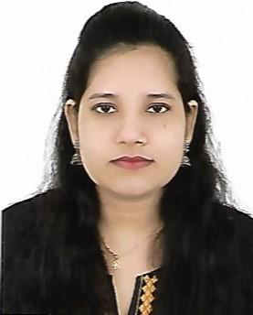
RUBY
Email: ruby-397850@gulfjobseeker.com
CAREER OBJECTIVE:
To enhance my working capacities, professional skills, business efficiencies and to serve my organization in best possible way with sheer determination and commitment.
PROFESSIONAL SUMMARY:
Attentive Front Office Executive providing exceptional customer service through diligent management. Adapt at encouraging more business through meaningful engagement and a commitment to managing guest and client relations. Committed to maintaining a positive attitude while delegating front office duties to ensure smooth operations.
UAE EXPERIENCE – HOTEL
ACCOUNTS MANAGER & GENERAL MANAGERMarch 2019 – January 2020
Roles &Responsibilities :
- Recruiting, training and supervising staff.
- Managing budgets.
- Maintaining statistical and financial records.
- Planning maintenance work, events and room bookings.
- Handling customer complaints and queries.
- Promoting and marketing the business.

MEDHA LANGUAGE THEATRE
MANAGER October 2015 – February 2019
Roles &Responsibilities :
- Outstanding front office abilities including handling guests and answering phone calls.
- Familiar with all MS Office applications including Word and Excel.
- Sound ability to resolve client or guest issues in timely courteous manner.
- Counselled students for career guidance.
- Maintained database of student registrations/records.
- Maintained database of accounts and prepared monthly reports.
- Managed staff roster and tracked staff schedules.
- Prepared and reviewed training schedules.

STRENGTHS :
- SELF CONFIDENCE
- GOOD TEAM WORK
- HELPFUL
- HARD WORKING
- HUMBLE AND FAST LEARNER
PERSONAL DETAILS
- DATE OF BIRTH: 02/08/1988
- NATIONALITY: INDIAN
- SEX: FEMALE
- RELEGION: MUSLIM
- MARITAL STATUS: SINGLE
- EDUCATION: DEGREE
- LANGUAGES KNOWN: ENGLISH, HINDI, TELUGU
- VISA STATUS: VISIT
- EXPERIENCE IN UAE: 9 MONTHS
EDUCATIONAL DETAILS :
Bachelor of Business Administration(BBA)- Vivekananda Degree College- Osmania Univesity-2010
DECLARATION
I hereby declare that the above written particulars are true to the best of my knowledge and belief.
CITY:
DATE: (RUBY)

