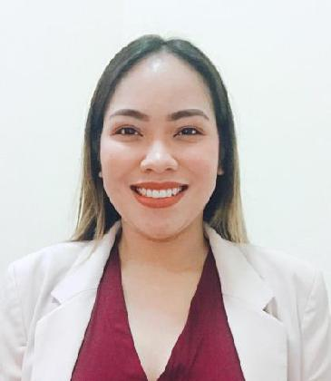
KASANDRA

Kasandra-397857@gulfjobseeker.com

JOB OBJECTIVE

To obtain a position that would best fit my qualification and develop my further talents and skills for continuous career development.

COMPETENT SKILLS

- Verbal Communication (Oral and Written English)

- Telephone Etiquette

- Teamwork
- Strong interpersonal skills

- Managing time efficiently

- MS Office Proficiency (MS Word, MS Excel, MS PowerPoint, and MS Publisher)

- Stenography Skills

- Ability to multi-task effectively

- Photography Skills

- Maintains professional and friendly demeanor.

- Possesses excellent organizational skills.

PROFESSIONAL EXPERIENCE (4 years experience in Secretarial)

- Administration/ Assistant Secretary/ Assistant Admission

Fujairah Sakamkam, Fujairah – UAE

2 years (January 2018- April 2020)

  - Answer all incoming & outgoing calls and handled caller's inquiries

  - The ability to work with student by helping them the procedures (e.g. rules and regulations of the school, the process of paying term fees, etc.)
  - Good administrative skills

  - The ability to keep sensitive information confidential
  - Filing or Compiling reports accurately and efficiently.

  - Maintaining student records and files.
  - Willingness to use own initiative
  - Sorts and distributes mail delivered to school office.

  - Contacts parents in the event of student illness or behavioral issues.

  - Uses computer database or filing system to update records as necessary.

  - Manages and updates school calendar.

  - Provides administrative support to principal or other upper level administrator as needed.
  - The ability to remain calm under pressure

  - Drafting and typing up official letters
  - Writing and distributing school bulletins

  - Dealing with queries and complaints
  - Updating records which relate to both pupils and staff members

  - Dealing with funds for bus passes and making sure the appropriate child is given the correct pass

  - Providing visitors with appropriate directions and helping them move around the school

- Secretary cum Accounts Assistant / Document Controller

Sinyar AI Khaleej Cont. L.L.C.
AI Nahda 2, Dubai -UAE
2 years (November 2015- November 2017)

- Projects:
  - Villa (48 Private Villas)- Mina AI Fajer, Dibba Fujairah

  - Fairmont Ajman (Swimming Pool)- Ajman, UAE

  - Fairmont Fujairah (City Wall and Fence & Swimming Pool)-Al Fiqait, Fujairah, UAE

  - Fairmont Fujairah (Beach Leisure Facility)- AI Fiqait, Fujairah, UAE
  - Hospital Thalassemia Center- Al Hudeeba, Ras Al Khaima

  - G+1 MAJLIS- Al Safouh Dubai

- Ability to coordinate the crew, supplies, and equipment is a great skill.
It’s beneficial for any superintendent or managerial position.
- Answer all incoming & outgoing calls and handled caller's inquiries

- Handled Receptionist (Greeting and assisting clients, etc.)
- Give and receive effective feedback
- Handling rejection in a positive way

- Perform requested duties beyond the expected requirements to maintain high personal standards

- Support someone else's work by handling or supervising office duties.

- Coordinating the needs and demands of multiple people in order to create a workable schedule.

- Provided word-processing and clerical support

- Maintained the common filing system (letters, submittals, drawings and other important documents)

- Coordinate the repair and maintenance of office supplies
- Provided administrative services to the office manager

- Ability to disseminate detailed concepts into understandable ideas in both written and verbal communication.

- Manage time constraints and unpredictable schedules or tasks to achieve maximum efficiency.

- Work towards solutions with a flexible approach in the most direct and time efficient way possible.

- Track incoming and outgoing correspondence and coordinate the flow of paperwork around the office.

- Schedule/ Organize meetings, appointments, and travel arrangements to the Manager

- Transferring e-mail, calls, and important documents to the Manager and in the Administration

- Troubleshoot conflicts among office personnel and works with sub-contractors to ensure that LPO are fulfilled as requested, invoices are paid, and refunds or exchanges are processed.

EDUCATIONAL ATTAINMENT

Tertiary Bachelor of Science in Office Administration Union Christian College (UCC) SY 2011-2015 Widdoes St. Brgy. 2, San Fernando City, La Union

Bachelor of Science in Nursing-
Ladderized Education Program SY 2008-2009

Widdoes St. Brgy. 2, San Fernando City, La Union

Primary Union Christian College (UCC) SY2000-2004 Widdoes St. Brgy. 2, San Fernando City, La Union

Christ the King College (CKC) SY1997-2000

Quezon Ave., San Fernando City, La Union

I, hereby confirm that the above information is true, accurate, and reliable to the best of my knowledge and belief, and I bear the responsibility for the correctness of the above-mentioned.

KASANDRA

Applicant

