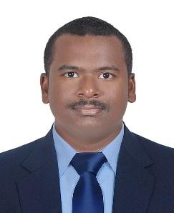
CURRICULUM VITAE

KIRAN

Career Objective
Aim to be associated with a good organization that gives me scope to update my knowledge and skill in accordance with the latest trends and to put best efforts in pursuance of the education’s goals and aspirations through hard

Work Experience:

INDIA
Organization : Vajra Harithanirman Pvt. Ltd. Vishakhapatnam (India)
Department : Construction & Civil
Designation : Site supervisor
Duration : July 2015 to May 2017.

Job Role

- Manpower controlling
- Safety (WH&S)
- Site supervising.
- Quality controlling.
- Quantity survey & etc.

DUBAI
- Department : Waste Collection Management
- Duration : July 2017 to Present
- Designation : Operations Assistant

Job Role
- Scheduling Employees Duties
- Manpower controlling
- Documents reports maintaining
- Trips details data entering
- Coordinating with clients & sub-contractors ana etc

UAE Driving License: In progressing

Educational Qualification

Examination | Institution & Board/University | Div./Grade | Passing Year
Diploma (Civil) | M.R.K. Polytechnic, Veeravasaram. | 63.2 % | 2015
SSC | Z.P.P. High School, Chintaparru (A.P) | 59 % | 2011

Software Skill

- Office Application :Microsoft office (2003,2007)- MS Word, MS Excel,
and Internet browsing and mailing.

Strengths
- Capable of working successfully in a team.
- Ability to manage multiple tasks simultaneous.
- Strong ability to network with people across all levels.
- Flexible and result-oriented attitude.

Personal Information
Date of Birth : 19th February 1996
Marital Status : Single
Sex : Male
Nationality : Indian
Languages known : Telugu, Hindi and English.

Personal Contact : kiran-398567@2freemail.com
Reference : Mr. Anup P Bhatia, HR Consultant, Gulfjobseeker.com 0504973598

Declaration

- I hereby declare that the information furnished above is true to the best of my knowledge and belief.

Yours Sincerely
KIRAN

