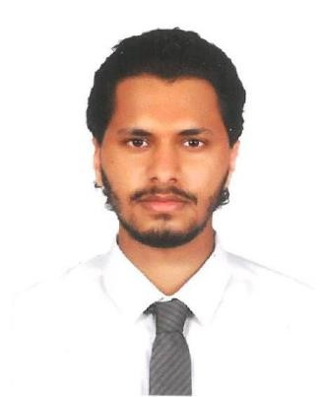
RAED

“Active, Punctual, Adaptive person& excellentacclimate”

PROFILE

To pursue a challenging job with a progressive organization in order to utilize my knowledge, skills and extensive educational background for the growth of the organization while providing me with opportunity to learn and grow over time.

PERSONAL INFORMATION
Date of Birth: 02July1996.

Place of Birth: Abu Dhabi.

Driving License: Light Vehicle, United Arab Emirates.

Marital Status: Single.

WORK EXPERIENCE
May 2019–July 2019
Intern Media Production Team in MBC Group

Exposed to different aspects of the production and broadcasting industry.
I was in four departments the media management, editing, the crew and gallery.

October 2018

Leader of graduating project in HELP University

Directing a team to shoot a documentary on autism.
I was in charge of a team of students to shoot a documentary for a school project.

May 2017- August 2018

part time independent stuff inBoost juice Malaysia

I was working there as a casher, inventory cashier and barista.
Learned the art of managing time between studying and maintaining to get good grades, punctuality and responsibility.

EDUCATION

HELP institution, Kuala Lumpur, Malaysia.

2015– 2019
Bachelor of Communication (Hons) (Media Studies) with a CGPA of 2.9. I graduate with Second Class Honors Upper Division.

AL Safa High School, Dubai, United Arab Emirates.

2013 –2014
The secondary study in the Science stream.

SKILLS

Computer skills: Ability to use MS Office as well as, mastering theInternet. Design skills in Adobe software: Photoshop, Illustrator and InDesign.
Editing skills in videos: Premiere Pro and Sony Vegas.

Directorial and camera man skills. Ability to work as a team.
Ability to produce technical reports. Social skills and time management. Ability to take initiative.
Behavior and moral discipline.

LANGUAGES

And I am interesting to learn new languages like Spanish and chinses.

Arabic (Fluent) English (Perfect) French (Poor)

ACTIVITIES

Photography

I am into photography and it was my favorite subject in school I had a very good teacher back then and he Taught me a lot of things about DSLR cameras and on how it works from the inside and on how to use it like A Professional camera man.

Charity Activities

I am an extremely people-oriented person. Being a people-oriented person, I am very outgoing and extrovert. Always volunteering in any event that aims to give back to the community such as blood donations, feeding the homeless, visiting old folks home, beach-cleaning and many other charity-like activities. By playing a part in these sorts of activities, I developed a more caring personality and try to behave ethically right at all time.

CONTACTS

Personal Contact : raed-398602@2freemail.com
Reference : Mr. Anup P Bhatia, HR Consultant, Gulfjobseeker.com 0504973598
Email: feedback@gulfjobseeker.com

